
SPEAR

Surveying and Planning through Electronic Applications and Referrals



SCFF Instructions:
Exporting to DXF
MAGNET Office

SCFF Instructions (MAGNET Office): Exporting to DXF
The information below is provided to assist surveyors in producing and exporting an SCFF from MAGNET Office. These instructions have been developed in collaboration with Topcon Positioning Systems and Aptella. For further support on the export process please contact Aptella support using one of the following options: email cadsupport@aptella.com or phone 1300 867 266.

What are Point features used for in the SCFF file? | Points are a feature type which are required in the SCFF file, and used in certain layers to define survey related data such as Primary Cadastral Marks (PCMs), Permanent Marks (PMs), occupation points, reference marks and traverse points.
Point feature layers in SCFF should not contain symbology. | Point Marks and Point Symbols (known as block references in AutoCAD) are not supported by ePlan.  ePlan expects only the point reference in the relevant point feature layers, without the associated symbology.  If the layer contains unexpected feature types the system will present the following SCFF Validation error:  “Unexpected feature types found in layer ‘POINT-LAYER-NAME’. Please utilise feature type(s) of ‘Point’ in this layer”
Ensuring Points are exported correctly from MAGNET Office | 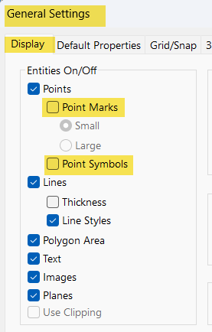  In MAGNET Office, by default, Points will be exported together with Point Marks and Point Symbols, into the same layer.  To ensure the Point Marks and Point Symbols are not included in the point layer, users are required to export the data with the Point Marks and Point Symbols OFF (unchecked) in the General Settings > Display settings (aka Hot button settings) during Export.  This will ensure that the DXF file passes SCFF validation in the ePlan Portal.
CAD format | The SCFF CAD format must be DXF version 2010.
Exporting DXF 2010 format from MAGNET Office | To export the .mjo job file to DXF 2010, use the File > Export, and select  AutoCAD DXF 2010 (*.dxf) format under ‘Save as Type’.    This is the SCFF accepted file format.
Export DXF 2010 Settings | 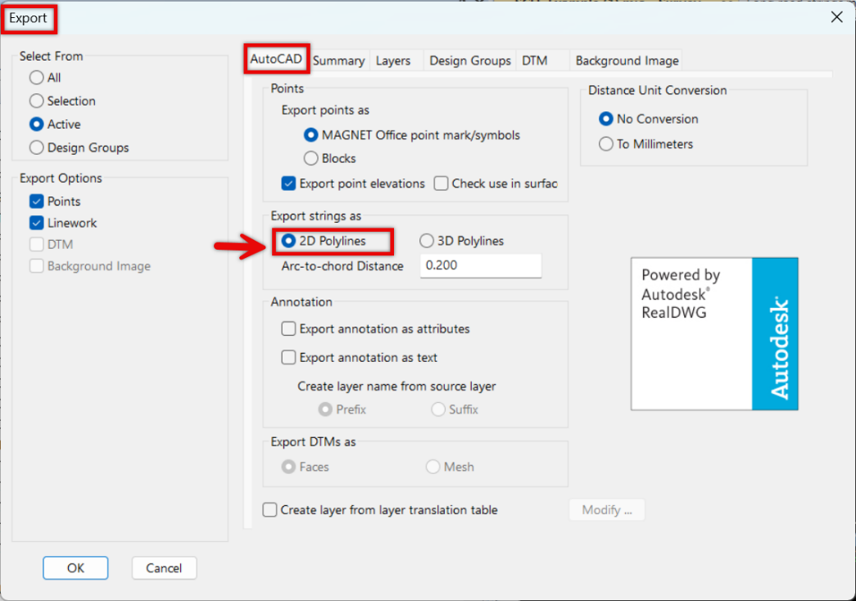  During export to DXF 2010 format, in the AutoCAD tab of the Export dialog, make sure to tick the checkbox for  “Export Strings as”  to “2D Polylines”,  as the SCFF data is 2D.

