
9
SPEAR

Surveying and Planning through Electronic Applications and Referrals



ePlan Release Notes

Release 4.2.0

ePlan Release 4.2.0 focuses on improvements that reduce manual effort, improve data quality and make title comparisons more reliable for ePlan users (LUV staff, Applicant Contacts, Service Desk and external users). This release groups five primary themes:
- Support the creation of a 0 SPI Lot to define the perimeter of part or whole of an ePlan that contains parcels above or below each other (which require a cross section in the PDF plan)
- Add Parent SPIs in the ePlan Editor instead of capturing cancelled parcels in SCFF (only applicable to ePlans which are not reliant on VET)
- Improve the title comparison tool
- Improve support for building boundaries
- Hide or show parcel misclose data

The following functional changes to ePlan have been included in Release 4.2.0:
 | Feature | Description
 | Support the creation of a 0 SPI Lot to define the perimeter of part or whole of an ePlan that contains parcels above or below each other. | Users can now optionally show part or whole of an ePlan that contains parcels above or below each other (and therefore require a cross section in the PDF plan) as a perimeter parcel.  In the ePlan, parcels requiring cross sections are represented by:  - perimeter geometry of all parcels defined by cross section in the PDF plan, and  - information about the parcels defined by cross section in the PDF plan without their individual geometry.  The perimeter geometry of parcels requiring cross sections in the plan can be captured in the SCFF as a created lot parcel with a ‘0’ SPI. The parcel polygon should be under the LOT-CREATED layer, and the parcel should have ‘0’ as its identifier in the TEXT-LOT-ID layer. For detailed information, please refer to the ‘0 SPI lot for parcels requiring cross sections’ section in the SCFF Guidance Notes.  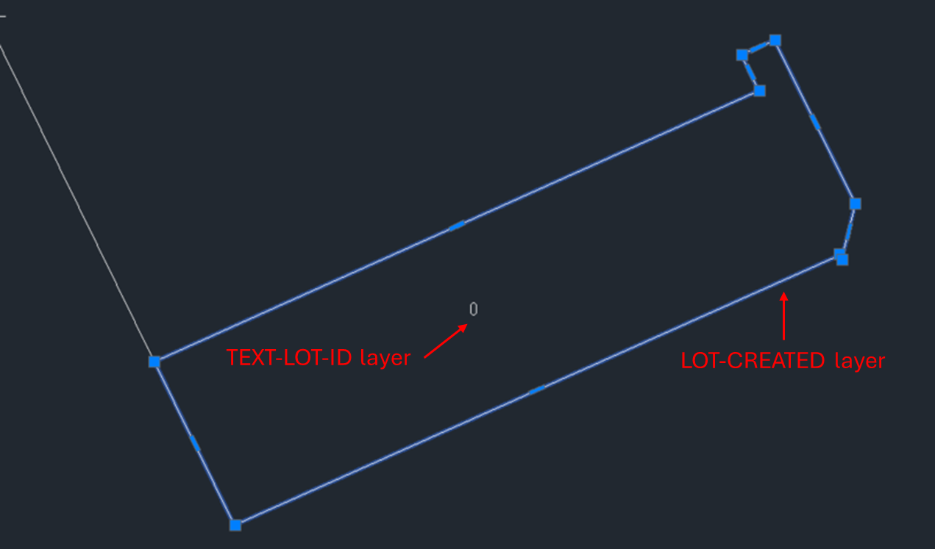  Note: A created lot with a 0 SPI is used to denote the perimeter of the parcels requiring cross section in the plan (at site level). It will not be counted as a created lot for the purposes of lodgement fee calculation.  The information about specific parcels contained within the 0 SPI perimeter must be created as text-only parcels in the ePlan Editor after the SCFF is converted to ePlan. To assist with this, users can now create multiple text-only parcels in a single action using the ‘Add Multiple’ tool. This tool is useful for parcels with sequential identifiers, automatically creating multiple text-only parcels for a user-defined range. In this tool, users can:  - Select the parcel class and specify the start and end values as parcel identifier for each group of parcels being created.  - Validate the entered ranges to ensure duplicate or incorrect parcel identifiers cannot be created. For more details, please refer to the Validation Rules page on the SPEAR website.  - Preview of text-only parcels generated based on the entered range, helping to prevent unwanted parcels from being created.  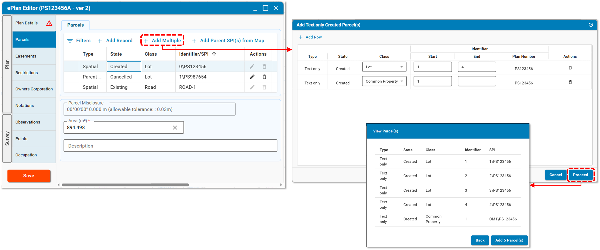  Note: Any unwanted parcels generated in your ePlan Editor using this tool will not be saved in your ePlan as long as you do not click the ‘Save’ button in the ePlan Editor.
 | Add parent SPIs in the ePlan Editor instead of capturing cancelled parcels in SCFF | The geometry of cancelled parcels is no longer required to be captured in SCFF for new ePlans. Users wishing to omit the geometry of the cancelled parcels will instead add any cancelled/parent parcels as text-only parcels once the SCFF has been converted to ePlan. This is done using the new ‘Add Parent SPI(s) from Map’ tool which is available from the Parcels tab in the ePlan Editor.  IMPORTANT NOTE: Capturing geometry of cancelled parcels in SCFF will be still mandatory for all in-flight ePlans reliant on Visualisation Enhancement Tool (VET), otherwise the PDF visualisation process will fail.  Therefore, this new function is not applicable to in-flight ePlans (VET dependant).  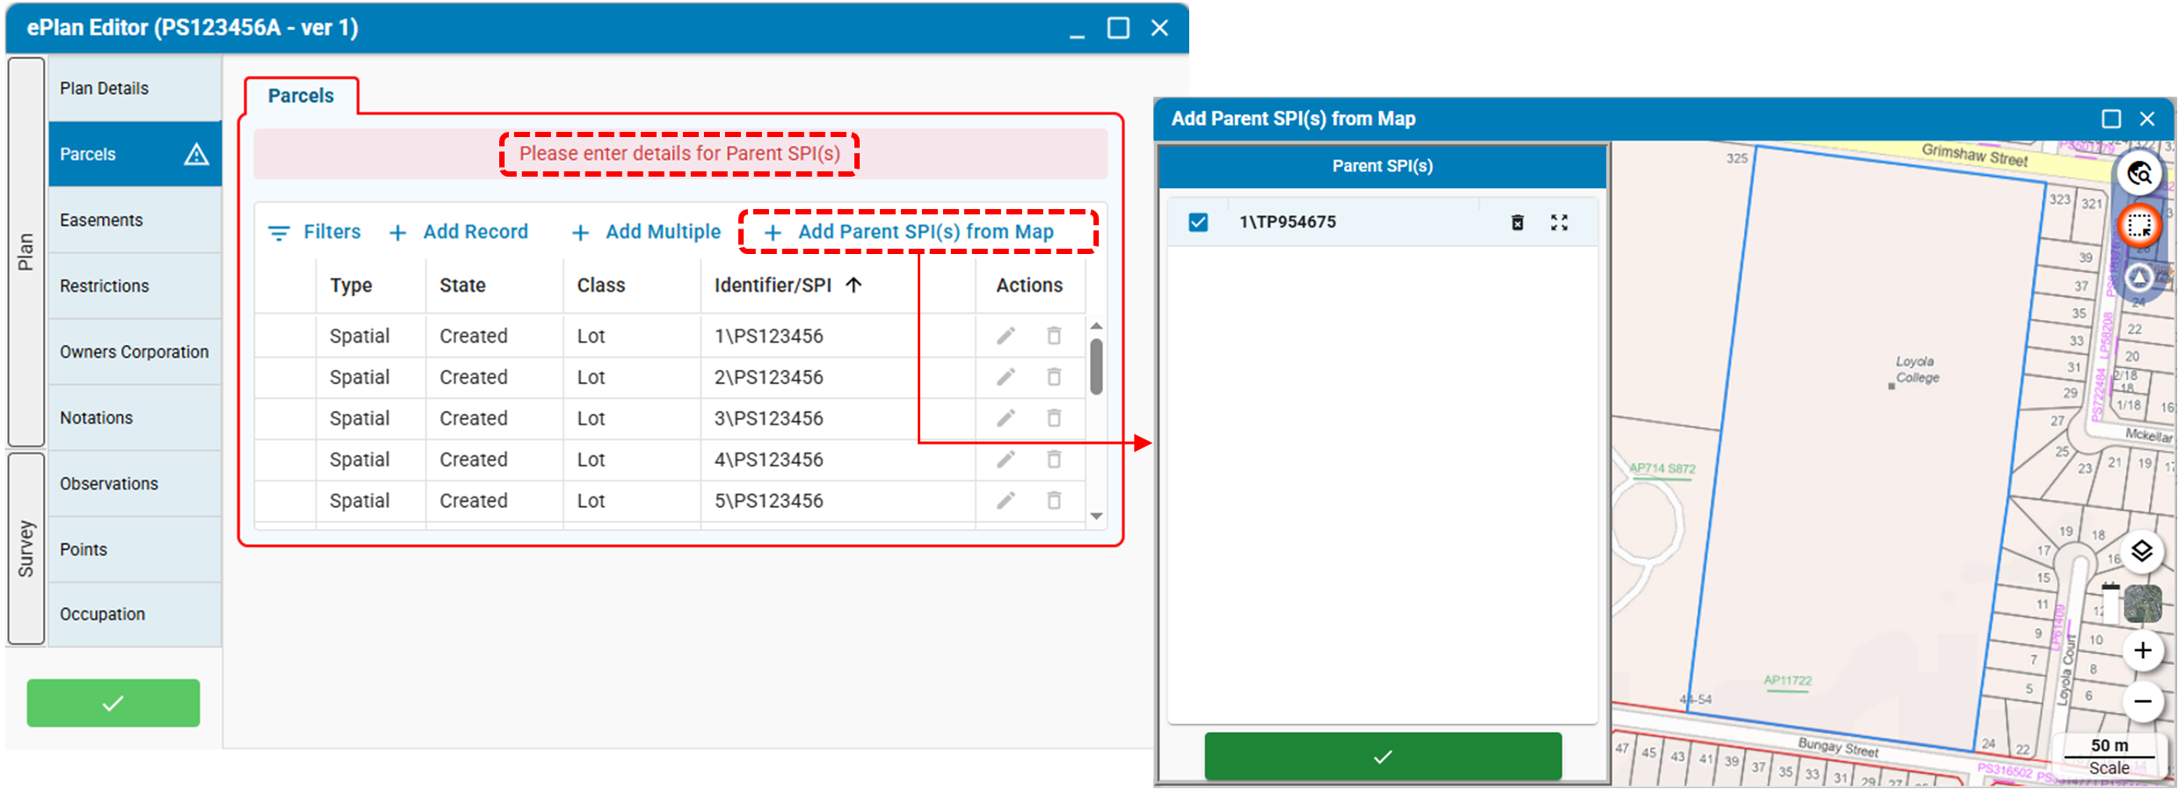  Once selected from the map, parcel attributes (e.g., Parent SPI parcel, LGA, Parish, Township, Vol/Fol, and Address) are automatically populated from relevant databases. The parcel class is determined based on naming conventions, but users should confirm this. The selected parcels are populated into the ePlan Editor accordingly.  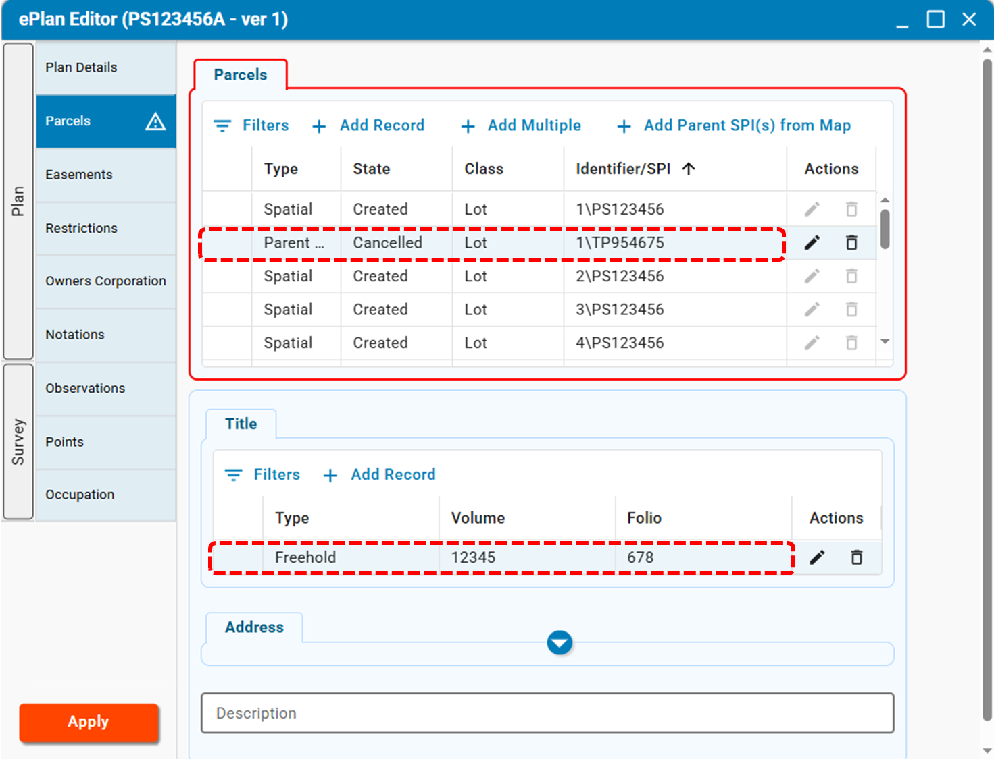
 | Improve the title comparison tool | The following improvements have been made to the title comparison tool:  - The tolerance for the centre point of an arc for the purposes of arc comparison has been increased from 1mm to 15mm  - Improved calculation of observations across multiple parent plans, and for plans containing external building boundaries
 | Improve support for building boundaries | A new Building Boundary Details section has been added to the ePlan Editor. This section includes a dedicated Building Boundary Description field, which is mandatory for all building boundaries with the type “Other” and is used to describe further details of the location of the building boundary (eg. ‘Face of unfinished concrete core walls’).  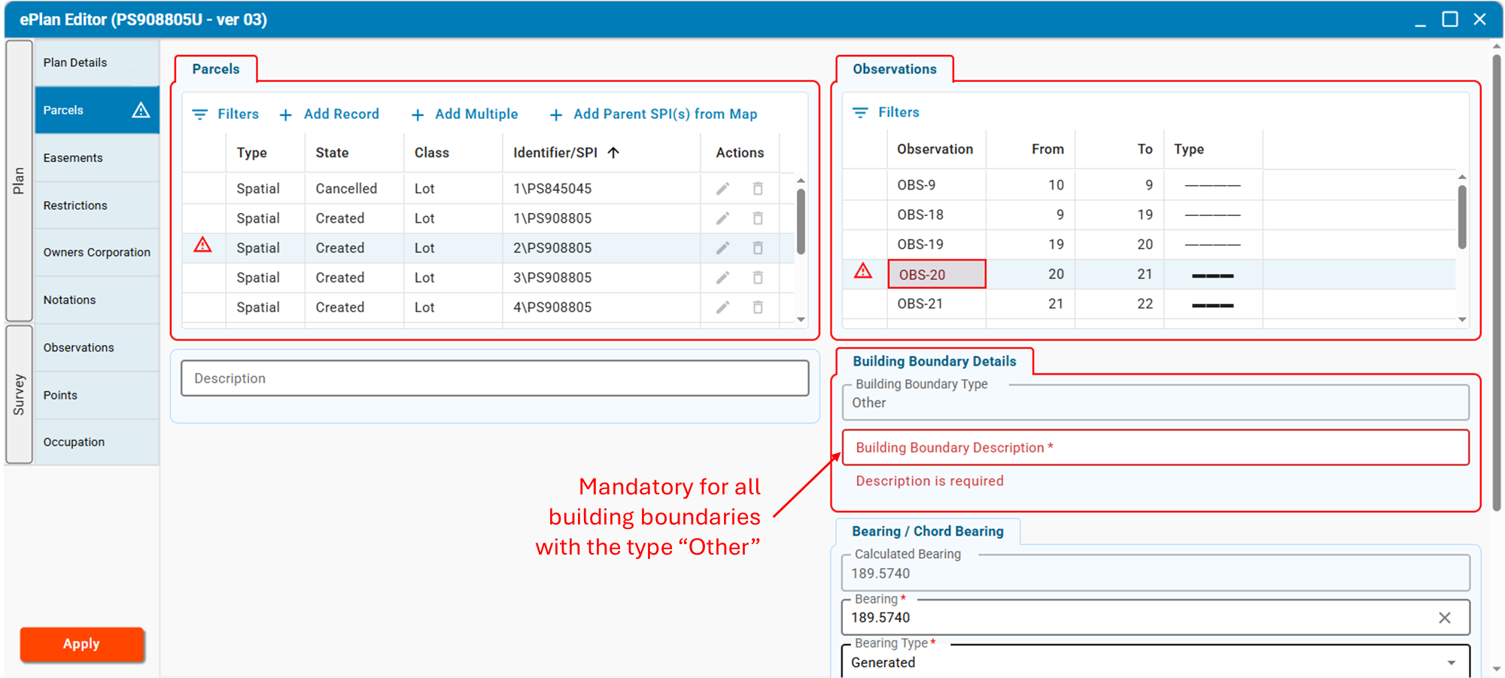  Some ePlan Validation Rules have also been updated to better support building boundaries and building returns.
 | Hide or show parcel misclose data | Users can now choose to show or hide all parcel misclose labels from the Layer pane within the ePlan Portal. When checked, parcel misclose labels for bearings and/or distances will be shown in red if they exceed the allowable tolerance, or black for those within tolerance.  