
9
SPEAR

Surveying and Planning through Electronic Applications and Referrals



ePlan Release Notes

Release 4.4.1

The following functional changes to ePlan have been included in Release 4.4.1:
 | Feature | Description
 | Survey Mark Identification enhancement | The Survey Mark Identification tool has been enhanced to give users improved access to survey mark information, associated documentation and linked plan data before importing a plan into the ePlan Portal.  Download SMES Sketch Plans and Reports  Available Sketch Plans and survey mark reports can now be downloaded directly from the Data Access section of the Survey Mark Identification window.  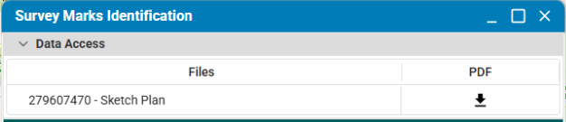  Additional Survey Mark Information  The Survey Mark Information section now displays additional information where available from SMES.  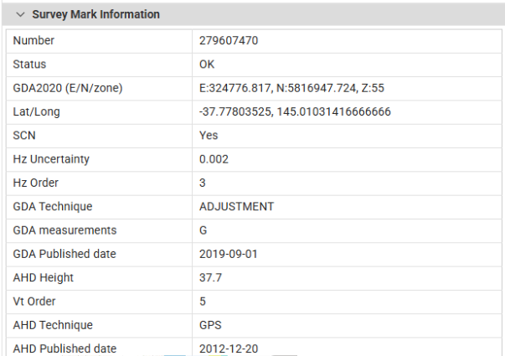  Linked plans and map preview  The tool now identifies linked plans that have used the selected survey mark.  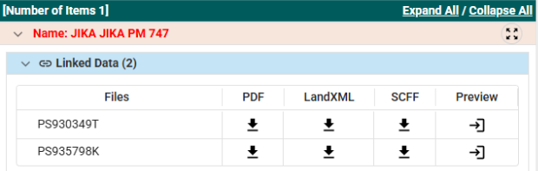  Selecting the linked plan row highlights the available polygonal extent and traverse lines for that file on the map. This gives users an indication of the plan location and its coverage before importing the plan in full.  