
9
SPEAR

Surveying and Planning through Electronic Applications and Referrals



ePlan Release Notes

Release 4.4.0

ePlan Release 4.4.0 focuses on improvements across the following key themes:
- Enhance ePlan creation service to handle large plans for applicant contact users
- Support uploading and visualisation of unnumbered Owners Corporation
- Pre-populate the MGA Coordinates (of approx. centre of land in plan)
- Enable ePlan Editor for Applicant Contacts on Imported LandXML Data
- Enhance the Loop Checker & Title Comparison tools
- New Survey Label Identification tool

The following functional changes to ePlan have been included in Release 4.4.0:
 | Feature | Description
 | Enhance ePlan creation service to handle large plans for applicant contact users | The ePlan creation service that converts SCFF files into ePlans has been enhanced to better support large and complex SCFF files and enable background processing for files that need additional time. This ensures that the service no longer times out when processing particularly large or complex SCFF files.  If converting an SCFF file takes longer than 30 seconds, a message will be displayed and the conversion will continue in the background. Users can return to the ePlan Dashboard and continue working on other ePlans while they wait for their conversion to complete.  NOTE: Users may notice a slight difference in processing times depending on the complexity of the plan  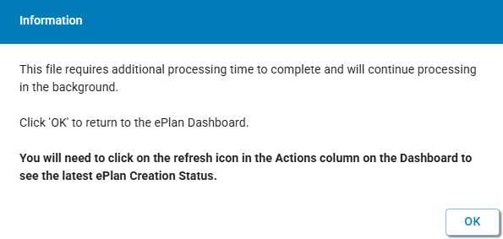  Users can view the status of their ePlan using the new ePlan Creation Status column shown on the ePlan Dashboard. Users waiting for a conversion to complete can refresh the status using the Refresh option under the Actions column.  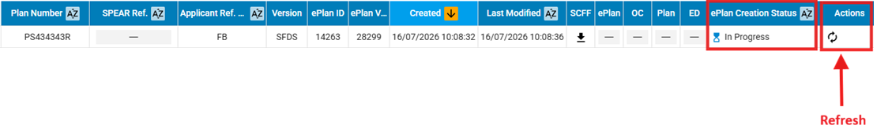
  The table below explains each ePlan Creation Status and the associated Actions available.
  NOTE: Only plans with an ePlan Creation Status of Complete can be opened or edited in the ePlan Portal.
  Status | Description | Actions available to applicant contact
   | The SCFF has been successfully converted to an ePlan | Open the created ePlan and complete it using the ePlan Editor.
   | The SCFF is in the process of being converted to an ePlan. |  Refresh - Check for the latest ePlan creation status.
   | User action is required to continue the conversion process (e.g. Matching ePlans when a new SCFF version is being processed) | Match ePlans - Proceed with data preservation by matching the new ePlan version with the previous version.
   | The SCFF returned a validation warning requiring user confirmation. | View SCFF validation report - View validation report and confirm to continue with ePlan creation.  Retry - Alternatively, upload a new SCFF to retry ePlan creation.
   | The SCFF file was not valid. | View SCFF validation report - View validation report to understand why the SCFF validation failed.  Retry - Once errors are rectified, upload a new SCFF to retry ePlan creation.
   | The SCFF conversion was not completed successfully. | View error message - View error details if SCFF Conversion has failed.  Retry – Once errors are rectified, upload a new SCFF to retry ePlan creation.
   | The SCFF conversion returns System Error. | View error message - View error details if SCFF Conversion returns System Error.  Retry - Upload a new SCFF after the error has been resolved.
 | Support uploading and visualisation of unnumbered Owners Corporation | An unnumbered Owners Corporation spreadsheet can now be supplied by an applicant contact in the ePlan Editor when amending an existing unnumbered Owners Corporation.  Validations have been introduced to avoid duplicate unnumbered Owners Corporations, or a combination of unnumbered and numbered Owners Corporations.  Unnumbered Owners Corporations are displayed consistently across ePlan data and services without an Owners Corporation number, including on the Owners Corporation schedule appended to the plan.
 | Pre-populate the MGA Coordinates (of approx. centre of land in plan) | The MGA coordinates (of approx. centre of land in plan) will now automatically be pre-populated, based on the parent SPIs defined by the applicant contact.  Users can also assign MGA coordinates by using the Select from Map button in the Plan Details tab of the ePlan Editor to assign coordinates directly from the map.  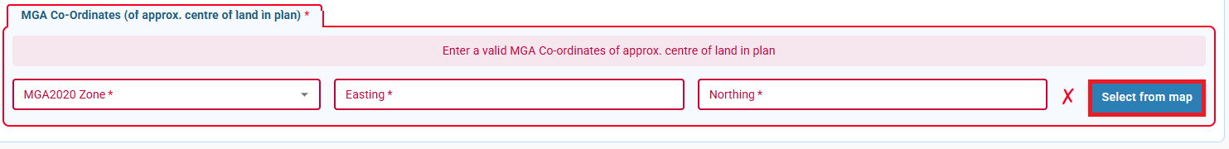  The existing option to manually enter MGA coordinates in the Plan Details tab of the ePlan Editor will also remain available.  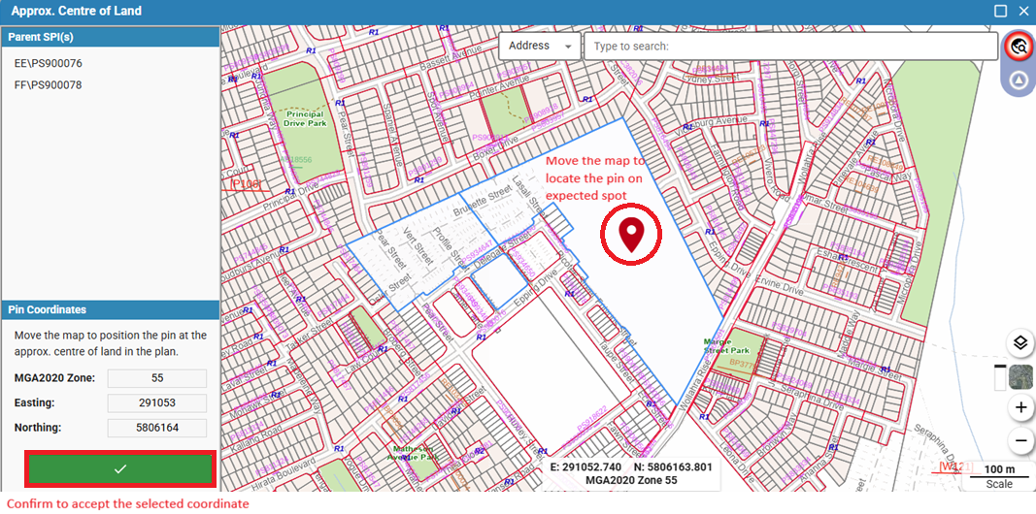
 | Enable ePlan Editor for Applicant Contacts on Imported LandXML Data | Applicant contact users can now access the ePlan Editor after opening a locally saved LandXML file in the ePlan Portal, or using the various tools to retrieve Vicmap Survey data. This limited-functionality version of the ePlan Editor allows applicant contacts to edit LandXML data and see the changes reflected in the ePlan Portal to assist with interrogating and resolving potential issues.  Applicant contacts can download a LandXML file containing their modifications, however changes will not be saved permanently in the ePlan Portal or Vicmap Survey.
 | Enhancement to the Loop Checker & Title Comparison tools | To assist users to more quickly determine which loops require investigation, the Loop Checker tool now groups its results into similar loops. The grouping is based on likely lines, observation sequence, and misclose distance, however the results can be expanded to view all loops in the plan. Additionally, the misclose distance is now displayed more prominently against each loop.  The Title Comparison tool logic has been enhanced to better support matching of parcels across imported plans, including:  - Parcels where the SPI has a Parish Plan reference – e.g. 1\PP1234  - Parcels with a zero SPI reference – e.g. 0\PS123456
 | Enhancement of Survey Label Identification | 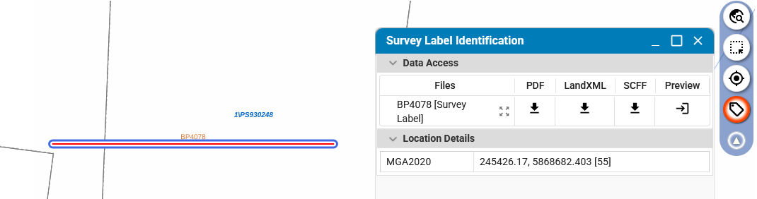  A ‘Survey Label’ search option has also been added to the Search for a Parcel tool to allow users to easily locate a particular survey label.  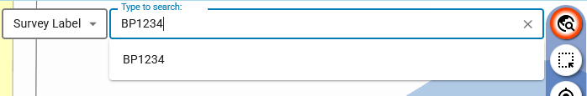
  A new Identify Survey Labels tool has been added to the ePlan Portal. This enables users to click on survey labels on the map to open a new Survey Label Identification window, displaying the location and details of the label.  Additionally, any available PDF, LandXML or SCFF file associated with the label will be able to be downloaded or imported into the ePlan Portal from this window. This includes digital data for labels such as AP and BP surveys, which were not previously available in digital format. | 