SPEAR

Surveying and Planning through Electronic Applications and Referrals

SCFF Instructions:
Set up files and exporting to DXF
LISCAD

SCFF Instructions (LISCAD): Set up files and exporting to DXF

The information below is provided to assist surveyors in producing and exporting an SCFF from LISCAD. The following files are referenced in these instructions and are available from the ePlan section of the SPEAR website, under ‘Getting Started: Training Resources’, SCFF Plan Preparation & Instructions:
- SCFF-Code Table.ctb
- SCFF-Parameter File.cpf
- SCFF-Prototype Drawing.dwg
Importing Code Table and Parameter file to LISCAD | - Ensure that the LISCAD file being created is using a ‘Plane Bearing’ projection type and that ground distances are being used.  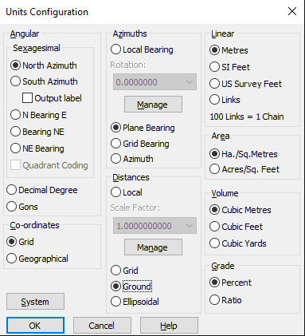  NOTE: If you are working on a different projection type (other than plane), please ensure that ‘Ground’ is selected as the distance in the ‘Units Configuration’ menu, from the ‘Configure’ tab, as shown in the image herein :  - Download the ‘SCFF-Code Table.ctb’ and ‘SCFF-Parameter File.cpf’ from the SPEAR website  - Navigate to your “…LISCAD\Release\UK folder” directory and paste the ‘SCFF-Code Table.ctb’ and ‘SCFF-Parameter File.cpf’ to this location.  NOTE: If you are not sure where this folder is, then you can find your LISCAD User Folder directory by navigating to ConfigureàFolders and copy the location in the user folder directory. This can then be pasted into Windows File Explorer to access the LISCAD directory.  - Return to LISCAD and ensure that Task is set to Utilities,  - Go to Code tableàOpen and select SCFF Code Table and press ok.  - SCFF layers will now be shown in the dropdown boxes for point, line, polygon, and text.
Exporting DXF from LISCAD | - In the Task menu select ‘CAD Output’  - From the Settings menu hover over ‘Parameter File’ and then select the ‘open…’ option  - Select the ‘SCFF-Parameter File’ and click ‘ok’  - Ensure that in the Settings menu ‘CAD System’ is set to ‘AutoCAD’  - Click on the ‘Output!’ menu to open the ‘AutoCAD’ save window  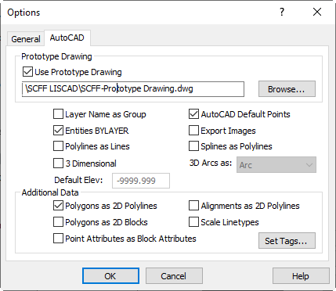  - Click ‘Options’ and from the AutoCAD tab, ensure the following:  - ‘Use Prototype Drawing’ is ticked  - Browse and select ‘SCFF-Prototype Drawing.dwg  - ‘Entities BYLAYER’ is ticked  - ‘AutoCAD Default Points’ is ticked  - ‘Polygons as 2D Polylines’ is ticked  - Click ‘OK’ to close the Options window  - Back in the ‘AutoCAD’ save window, ’Ensure scale is set to 1:1 and file type is ‘AutoCAD 2010/2011/2012 (*.dxf)  - Click OK to generate a .dxf file ready for SCFF validation
Additional LISCAD Notes | - If you are using LISCAD 2022 or older version and have a PM/PCM that requires the inclusion of the 9 figure number texts, you will need to snap the text to the PM/PCM properly in CAD environment  - If there is a polyline that consists of both line and arc, this will have to be done in CAD environment using “JOIN” command. LISCAD won’t join arc and line together  - If there is a polyline that consists of only two points, this will have to be done in CAD environment using “PEDIT” command. LISCAD won’t export a polyline with only two points. A polyline exported from LISCAD must consist of at least three points  - It is suggested to use a non-standard SCFF point and line layers to have the base linework in LISCAD, such as DEFAULT. The base linework on non-standard SCFF layers will get exported to a non-standard SCFF layer in the file, and as such will not be validated  - Polygon text labels are derived from their polygon descriptions. Ensure that polygon description/IDs follow SCFF naming conventions, as they will be exported as the text on their respective layers.

