
SPEAR

Surveying and Planning through Electronic Applications and Referrals



Single CAD Format File (SCFF)
Guidance Notes and Instructions

Single CAD Format File (SCFF) - Guidance Notes and Instructions
This document aims to provide instruction and guidance in preparing your Single CAD Format File (SCFF) and should be read in conjunction with:
- SCFF List of Layers document
- SCFF drawing instructions for Subdivision Act 1988 primary dealing types

CONTENTS:
What does the SCFF support? 3
CAD format 3
Defined standard CAD layers 3
Adding non-standard CAD layers 3
CAD preparation (computed plan) 3
Coordinate system / Connection to MGA 4
Parcels (fully closed polygons) and connections / abutting roads 4
Incorporation of intermediary points into parcel’s geometry 5
‘State’ of a parcel 6
0 SPI lot for parcels requiring cross sections 7
Easements / Crown Land Services 9
Restrictions 11
Fixing Easements and Restrictions to the Title Boundary 11
Textual Information 11
Offsets 11
Splay corners 12
Building boundaries, natural boundaries, and unsurveyed boundaries 14
Building returns 15
PM/PCM 16
Snapping points 17
Title Connections 18
Capturing Road Connections 18
Adding or removing vertices 19
Drawing donut parcels 20
Drawing Radiation lines using Occupation Point 21
Appendix 1: Naming Convention for SCFF Text Layers 23

What does the SCFF support? | All cadastral plans that do not require cross sections are supported by the SCFF. Plans with parcels located above or below each other are also supported through the capture of perimeter geometry of all parcels requiring a cross section in the PDF. Refer to ‘0 SPI lot for parcels requiring cross sections’ section of this document for more information.  SCFF drawing instructions for Subdivision Act 1988 primary dealing types are available on the SPEAR website: SCFF Plan Preparation & Instructions
CAD format | The SCFF CAD format must be DXF version 2010. Further information about how the CAD file can be exported to DXF in AutoCAD, MicroStation CONNECT and LISCAD, can be found on the SPEAR website : SCFF Plan Preparation & Instructions  .
Defined standard CAD layers | The SCFF defines 74 standard cadastral CAD layers which cover the main cadastral plan drawing requirements and connections to MGA.  SCFF layers must have only the expected feature types, being point, line, arc, text, unclosed polyline, and closed polyline (polygon).  This defined structure ensures that the SCFF will be compatible for updating Vicmap. If the SCFF is not structured correctly, validation errors or loss of data through the ePlan Creation Service are expected.
Adding non-standard CAD layers | There is provision to include other layers in addition to the 74 standard layers in the SCFF, these are referred to as ‘non-standard’ layers.  Non-standard layers can be added to supplement your own internal uses or to define cadastral information not defined in the SCFF (e.g. symbols, occupation other than offsets and building returns, and plan dimensions).    NOTE: Additional data supplied in non-standard layers will not be processed/validated by the ePlan Creation Service which produces the ePlan LandXML file. Please ensure all relevant plan/survey information is primarily defined in the standard layers.
CAD preparation (computed plan) | The SCFF must be drawn in ‘model space’ (computed plan) at 1:1 scale without enlargements, exaggerations, or road truncations.    Tip: Enlargements, exaggerations and truncations must be added to the plan (PDF plan or ePlan visualisation), and not included in the model space.
Coordinate system / Connection to MGA | If the plan can satisfy survey exemption requirements outlined on the Land Use Victoria website understanding plans of subdivision and consolidation (land.vic.gov.au), then an abstract of field records (AFR) will not be required, and the ePlan can be based on the ‘Local’ coordinate system rather than MGA. The ePlan Portal supports the creation, validation and visualisation of both Local and MGA ePlans.  If the plan does not satisfy AFR exemption requirements, while initial versions of the SCFF may be on a local coordinate system, the expectation is that the final version of the SCFF/ePlan will be connected to MGA. In the case of a partial survey subdivision, the appropriate datum should be used, in accordance with the Victorian Cadastral Surveys Practice Directives.  Surveyors must ensure that the survey data in their latest version of an ePlan (in SPEAR) is consistent with the survey information shown on the abstract of field records (PDF).  MGA connection must be reflected using the appropriate survey related CAD layers, i.e. control marks, reference marks, traverse points, traverse lines, and radiations.  MGA connection will assist in streamlining the Vicmap Property and Digital Cadastre update process.  MGA connection should be undertaken, as follows:  - Capture one of the PMs or PCMs using its true MGA coordinates (from SMES)  - Capture other geometries based on ground distances and bearings oriented to MGA (if applicable)  NOTE: Transformation to grid is not allowed.
Parcels (fully closed polygons) and connections / abutting roads | - All parcels including lots, stage lots, common properties, roads, reserves, crown allotments, crown portions, easements, crown land services, and restrictions must be fully closed and drawn as individual polygons (i.e. not as individual line segments with no parcel misclosure).  - Where a parcel contains a misclosure, surveying methodology must be applied, and the geometries of the parcel adjusted to close.  - Depending on the methodology used, the dimensions on the visualised plan are to display the dimensions as maintaining title or adjusted accordingly.  NOTE: Connections and abutting roads must be drawn as unclosed polylines.
Incorporation of intermediary points into parcel’s geometry | Intermediary points are where the boundaries of a parcel intersect with those of its adjacent parcels without the introduction of bends along boundary observations.  The incorporation of intermediary points into the geometry of parcels establishes the complete topological relationships between adjacent parcels, facilitating:  - labelling of observation dimensions by the ePlan Visualisation Service  - updating of the digital cadastre through the automatic adjustment service using ePlan data.  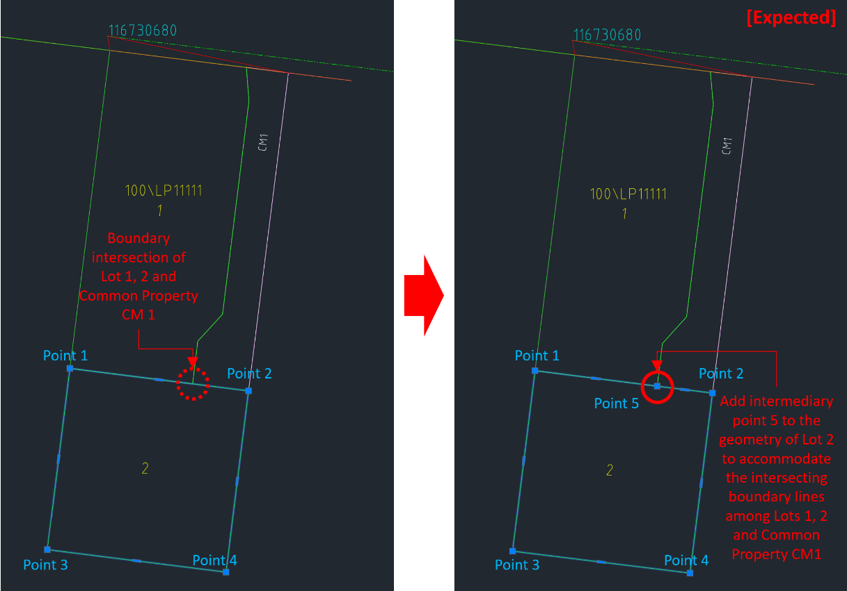  Example 1:  - Created Lot 2 is adjacent to Created Lot 1 and Created Common Property CM1  - A boundary intersection exists between Lot 1 and CM1 on the boundary of Lot 2 (between Points 1 and 2).  - Although there is no bend between Points 1 and 2, Created Lot 2 geometry should include an intermediary point at the boundary intersection, shown as Point 5.  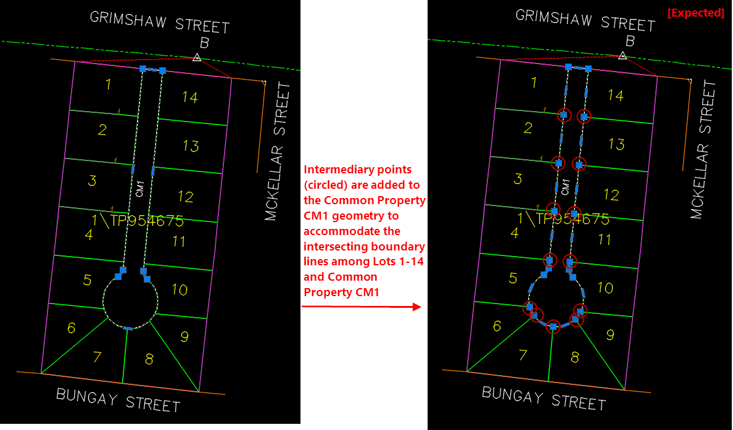  Example 2:  - Intermediary points (shown circled in red) have been incorporated into the geometry of created Common Property CM1 geometry  - Points along the eastern boundary of Lots 2-4, northern boundary of Lots 6-9 and western boundaries of Lots 11-13 are part of the created CM1 geometry even though there are no bends at these points.
‘State’ of a parcel | All parcels (polygons/polylines) in the SCFF must be associated with a ‘state’ description.  The state of parcels is defined as follows:  - Created: A new parcel being created in a plan (e.g. (PS) plan of subdivision; (OP) original plan)  - Existing: A parcel that exists on the cadastre and the boundaries are not affected  - Encroached: An existing parcel encroached by a new boundary adoption from an abutting parcel  - Affected: An existing parcel subject to amendment due to new boundary adoption from an abutting parcel  - Cancelled: An existing parcel subject to cancellation  - Removed: A restriction subject to removal.  NOTE: The state for an Easement parcel should be set in the ePlan Editor, as SCFF supports only one layer for easement geometry regardless of state.  Example:  A plan of subdivision creating 5 new Lots, 2 Reserves and a Road  All 8 new parcels must be defined using the ’Created’ state.  NOTE: Cancelled parcels (parent parcels subject to the new subdivision) are not required in SCFF, if the ePlan is not reliant on Visualisation Enhancement Tool (VET) for rendering the plan PDF. If the geometry of these cancelled parcels is omitted from the SCFF, the details of those parcels must instead be captured in ePlan Editor as Text Only parcel data.
0 SPI lot for parcels requiring cross sections | Where parcels in a plan are located above or below each other, cross sections are required to define the upper and lower boundaries of those parcels. While height data related to upper and lower parcel boundaries cannot be captured in ePlan, the perimeter of those parcels shown in cross-sections on the PDF plan can be represented by:  - Defining the perimeter geometry of all parcels defined by cross section using 0 SPI parcel, and  - Supplying information about the parcels defined by cross section in the PDF plan without capturing their individual geometry.  Only the perimeter geometry of parcels requiring cross sections is captured in SCFF, which could be the whole or part of the plan. Information about the specific parcels within the 0 SPI perimeter must be created in the ePlan Editor as ‘Text-Only’ parcels using the ‘Add Record’ or ‘Add Multiple’ buttons after creating ePlan from the SCFF.  The perimeter geometry must be captured in SCFF as single or multi part Lot with ‘Created’ state, represented as a closed polygon in the LOT-CREATED layer. It should have ‘0’ as its identifier in the TEXT-LOT-ID layer. This created lot, representing the perimeter of the parcels requiring cross section, is referred to as the 0 SPI parcel.  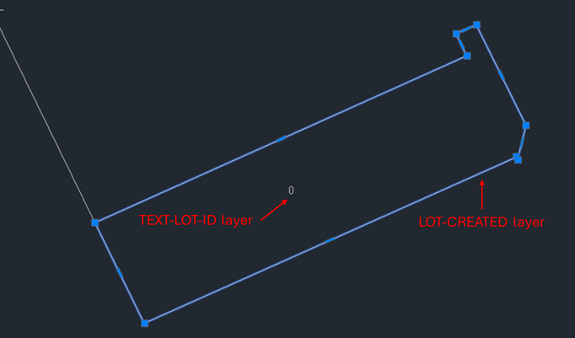  Example 1: Plan with all parcels requiring cross section  A plan includes 3 new Lots and 1 new Common Property that are located above and below one another:  - Create a single polygon for ‘Created’ Lot in LOT-CREATED layer that outlines the perimeter of all created lots and common property,  - This polygon must have an identifier label of ‘0’ in TEXT-LOT-ID layer.  Example 2: Plan with only some parcels requiring cross section  A plan includes created Lots 1 to 6 and Common Property Number 1. These lots are laid out such that:  - Lot 2, 3 and Common Property Number 1 require cross sections in one part of the plan,  - Lot 5 and 6 require a cross section in a separate part of the plan,  - Lot 1 and 4 are unlimited in height and depth and do not require a cross section.  For SCFF purposes, this can be represented in two ways:  - Multi parts of a single 0 SPI parcel,  - A single 0 SPI parcel that contains the combined perimeter of all parcels in the plan.  Option 1 - Multiple parts of a single 0 SPI parcel  - Create a part parcel of 0SPI by creating a Lot in the LOT-CREATED layer  - Ensure that the closed polygon of the created 0 SPI lot outlines the perimeter of Lot 2, Lot 3 and Common Property Number.1 within the first part of the plan.  - Assign this polygon an identifier of ‘0-p1’ in the TEXT-LOT-ID layer.  - Create another part parcel of 0SPI parcel by creating a Lot in the LOT-CREATED layer  - Ensure that the closed polygon of the created 0 SPI lot outlines the perimeter of Lot 5 and Lot 6 within the second part of the plan.  - Assign this polygon an identifier of ‘0-p2’ in the TEXT-LOT-ID layer.  - Create two closed polygons for Lot 1 and Lot 4 in the LOT-CREATED layer, with identifier labels ‘1’ and ‘4’ in the TEXT-LOT-ID layer, respectively.  Option 2 - Single 0 SPI parcel containing perimeter of all parcels in the plan  - Create a single 0 SPI parcel by creating a Lot in the LOT-CREATED layer  - Ensure that the closed polygon of the created 0 SPI lot outlines the perimeter of Lot 1 to 6 and Common Property Number.1  - Assign this polygon an identifier of ‘0’ in the TEXT-LOT-ID layer.  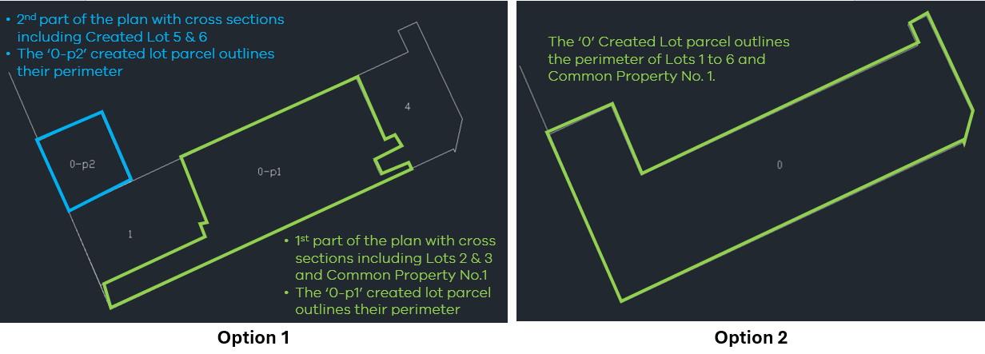
Easements / Crown Land Services | Easements and Crown Land Services parcels must be captured in SCFF as closed polygons using layers EASEMENT and CROWN-LAND-SERVICE.  The label identifier for these parcels must be:  - Positioned completely within the subject polygon, and  - Captured in the relevant text layer i.e. TEXT-EASEMENT-ID or TEXT-CROWN-LAND-SERVICE-ID  Other textual information associated with easements/crown land services descriptions must be drafted on the PDF plan or entered in the ePlan Creation Service user interface (i.e. ePlan Editor).  NOTE: All easements or crown land services must be drawn in their entirety and labelled accordingly within the relevant text layers in SCFF.  For simple scenarios of overlapping easements, the ePlan Creation Service may be able to automatically generate a separate geometry for the overlapping part, provided:  - The overlapping easements are made of simple geometries,  - The overlapping easements do not include curves,  - The overlapping portion is not multi part,  - There is an identifier (e.g. E3) within the overlapping portion in the relevant text layer.  Example:  Where easements E1 and E2 overlap, the overlapping easement is E3:  - E1 must be drawn as a complete geometry (Geometry 1) including overlapping portion, and labelled as a single parcel (E1).  - E2 must be drawn as a complete geometry (Geometry 2) including overlapping portion, and labelled as a single parcel (E2).  - The geometry of E3 should not be drawn; however, its label (E3) must be placed within the overlapping area between Geometry 1 and Geometry 2.  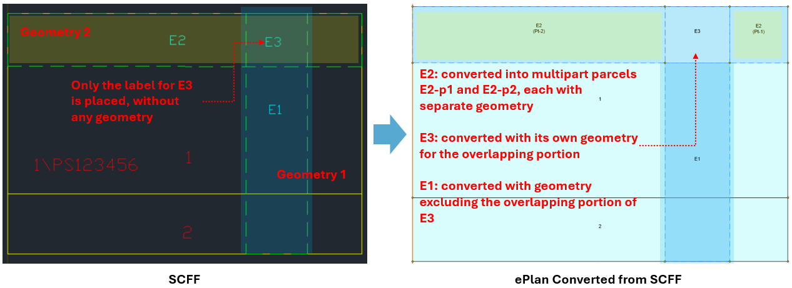  NOTE: Encumbering easements (Road) are created with the following four conditions:  - The geometry of the easement must be captured using EASEMENT layer.  - The easement identifier in TEXT-EASEMENT-ID layer must follow the naming convention “R#” (e.g. R1).  - An identical geometry which is the same as encumbering easement must be created on top of the easement as a Road in the corresponding layer (i.e. ROAD-CREATED) within SCFF.  - The road identifier must be created for the road geometry within TEXT-ROAD-ID layer, and it must match the encumbering easement identifier (e.g. R1).  Example:  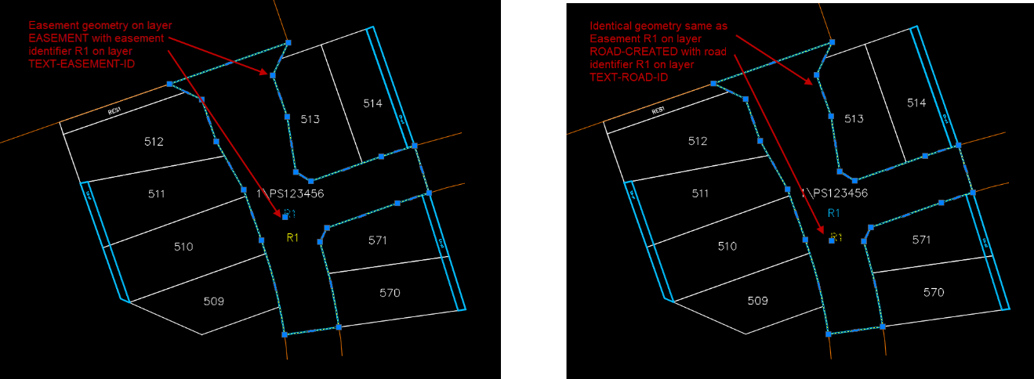
Restrictions | Surveyors must follow section 12 and schedule 6 of the Registrar's Requirements for Conveyancing Transactions regarding the creation of restrictions in plans.  Restriction parcels must be captured in the SCFF using layers RESTRICTION-AFFECTED, RESTRICTION-CREATED, RESTRICTION-EXISTING, and RESTRICTION-REMOVED, along with their corresponding identifiers using layer TEXT-RESTRICTION-ID based on the expected naming conventions.  Text-based restrictions must be captured manually in the ePlan Editor.
Fixing Easements and Restrictions to the Title Boundary | Easements and restrictions should be fixed to title boundary using one of the following means:  - Connection to a point in the primary subject parcel (using LINE-CONNECTION layer)  - Fix to a primary subject parcel using at least 2 offsets (using LINE-OFFSET layer)  - Abut at least one primary subject parcel  - Fix to the corner of a primary subject parcel  - Share a corner or boundary with another existing easement or restriction that is connected via one of the above methods.
Textual Information | The SCFF must contain all textual information within the appropriate CAD layers, for all parcel ID’s and PM/PCM identifiers:  - PMs and PCMs must be labelled with their corresponding 9 figure number  - Text layers must follow the associated ‘Naming Convention for Text Layers’ as outlined in Appendix 1  - Each closed parcel must have only one corresponding identifier label in its relevant text layer (positioned within the subject polygon).  - Where easements / crown land services overlap, the overlapping part must have only one corresponding identifier label in its relevant text layer  NOTE: Other textual information associated with parcels such as easements, restriction descriptions and any plan/survey notations must be defined in the ePlan Creation Service (ePlan Editor).
Offsets | Offsets must be drawn with line geometry instead of being defined by an offset distance. The offset line geometries must be defined in LINE-OFFSET layer.  Typically, offsets will be used in the SCFF to define the width of easements/roads, or to relate the location of an easement/restriction to a parcel boundary.  TIP: If there are sufficient geometries to establish the width of an easement or the width can be described on the easement table of the plan, the use of offsets is not required.
Splay corners | Splay corners must be captured when practical, using two lines/arcs defined in the LINE-CONNECTION layer. Make sure splay corners are included in their respective road parcels, ensuring that all the nodes for splay corners exist in the structure of their corresponding parcels.  Example 1:  Created roads R1 and R2 are connected, and splay corners are defined, as shown:  - The closed polygon for R1 includes points 1, 2, 3, 4  - The closed polygon for R2 includes points 1, 2, 3, 4, 5, 6  - Points 1, 2, 3, and 4 are common between the R1 and R2 polygons.  - Road splay corners between the two roads are defined by capturing lines between points 1-2, points 2-5, points 3-4, and points 3-6 in layer LINE-CONNECTION.  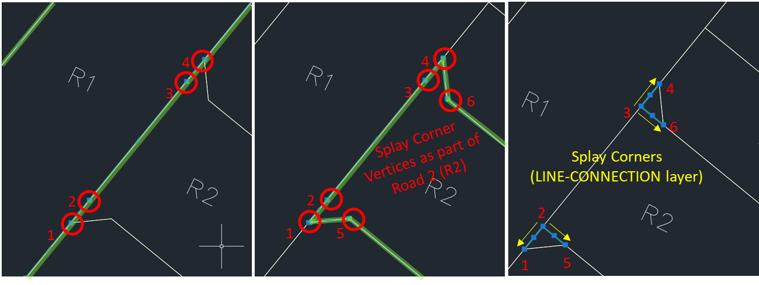  Example 2:  Existing roads R3 and R4 are connected, and splay corner is defined, as shown:  - The unclosed polyline for R3 includes point 1  - The unclosed polyline for R4 includes point 2  - The road splay corner between two roads is defined by capturing lines between points 1-3, and points 2-3 in layer LINE-CONNECTION.  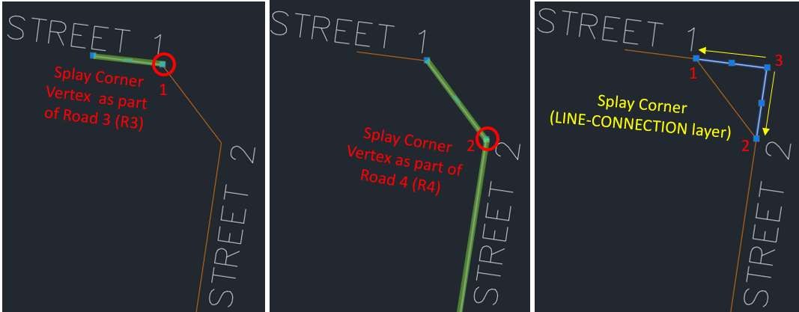  Example 3:  Roads connected to each other without the splay corner should share common points:  - Closed polygons for created roads R1 and R2 without the splay corner have shared points 1 and 2.  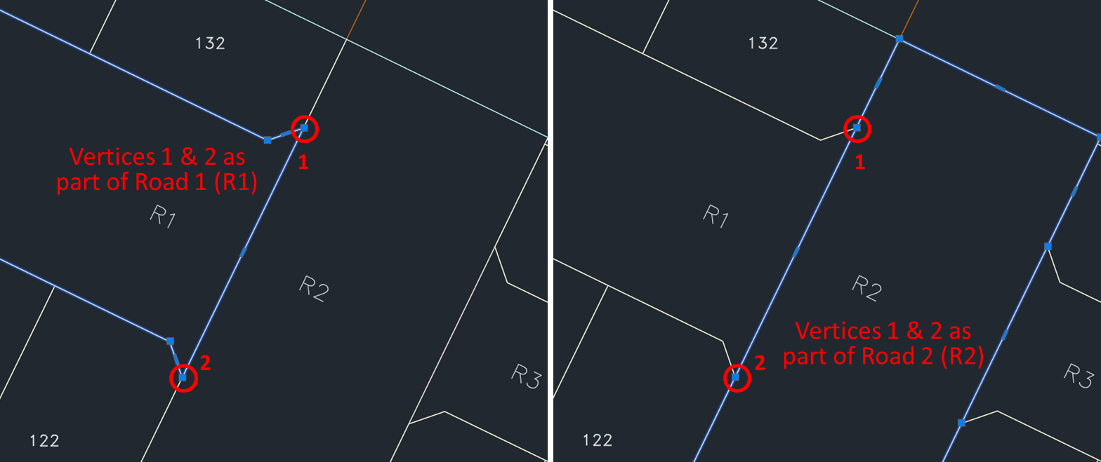
Building boundaries, natural boundaries, and unsurveyed boundaries | Building boundaries (line/arc), natural boundaries (line), and unsurveyed boundaries (line/arc) must be captured in their specific layers: LINE-BUILDING-BOUNDARY-EXTERIOR, LINE-BUILDING-BOUNDARY-INTERIOR, LINE-BUILDING-BOUNDARY-MEDIAN, LINE-BUILDING-BOUNDARY-OTHER, LINE-NATURAL-BOUNDARY, LINE-UNSURVEYED-BOUNDARY.  These boundaries must also be included in their respective parcels. All the nodes for these boundary lines must exist in the structure of their corresponding parcels.  Example:  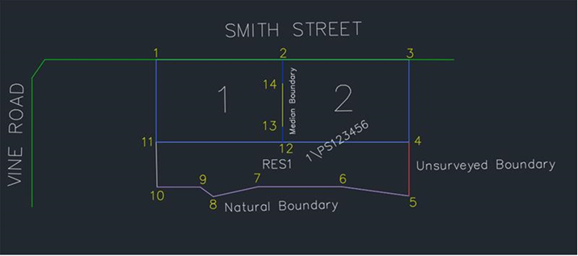  - In this example, the cancelled lot is shown as Lot 1\PS123456 and is defined in layer LOT-CANCELLED. It is being re-subdivided into two created lots and one created reserve. The new parcels have been created in layers: LOT-CREATED and RESERVE-CREATED.  - Lots 1 and 2 share a median building boundary  - The median building boundary line between points 13 and 14 is defined in layer LINE-BUILDING-BOUNDARY-MEDIAN  - The polygon for Lot 1 is defined by the points 1, 2, 14, 13, 12, 11, and 1.  - The polygon for Lot 2 is defined by the points 2, 3, 4, 12, 13, 14, and 2.  - As shown, points 13 and 14 are common between the Lot 1 and 2 polygons.  - The polygon for Reserve 1 (RES1) is defined by the points 11, 12, 4, 5, 6, 7, 8, 9, 10, and 11.  - RES1 consists of an unsurveyed boundary and a natural boundary.  - The unsurveyed boundary line between points 4 and 5 is defined in layer LINE-UNSURVEYED-BOUNDARY.  - The natural boundary lines between points 5, 6, 7, 8, 9, and 10 are defined in layer LINE-NATURAL-BOUNDARY.  TIP: To capture natural boundaries, avoid using spline, and use line instead.  TIP: The natural boundary points can be defined by digitally tracing straight lines over the natural boundary, thus forming line from the start to end (shown as points 5 to 10).
Building returns | - Building returns should be captured as a ‘line/arc’ features within the LINE-BUILDING-RETURN layer.  - Ensure that Building return is connected to a boundary point of a building boundary.  - Building returns may connect to building boundaries directly or indirectly through other building returns (see Example 1).  - Building returns must not overlap with parcel boundaries. This means that neither end of a building return should connect to parcel boundary points (see Example 2). If there is an overlap with parcel boundaries, ePlan validation errors may be experienced (such as VR096).  Example 1: Correct connection technique  Three building returns are connected to boundary points of building boundaries:  - Building return1: Directly connected to building boundary 1  - Building return 2: Directly connected to building boundary 2  - Building return 3: Indirectly connected to building boundary 2 through building return 2.  Example 2: Incorrect connection  Building returns must not overlap with parcel boundaries. In this example, Lot 3 contains a median building boundary, and two building returns which overlap with parcel boundary. The following scenarios should be avoided:  - Building return 1: Is incorrectly shown connected to a building boundary at Point 1 and Point 2.  - Building return 2: Is incorrectly shown connected to boundary points Point 2 and 3  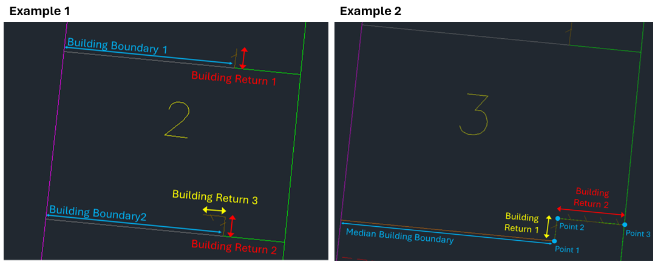  NOTE: For ePlans that still require the Visualisation Enhancement Tool (VET) for PDF Plan visualisation:  Once the SCFF is converted into an ePlan, the ePlan Visualisation Service will display hatching for the building returns in accordance with the direction of ‘line/arc’ feature in the SCFF. The ePlan Visualisation Service also supports the visualisation of mirrored (fishbone) hatching for ‘median’ building boundaries, when building returns are superimposed over the building boundaries in the SCFF. If required, VET allows a change of direction of hatching.
PM/PCM | PMs and PCMs must be labelled with their corresponding 9 figure number. The 9 figure numbers are available from the PM Sketch plan which can be obtained from SMES.  Example:  The insertion point of the PM/PCM label in the SCFF should be as follows:  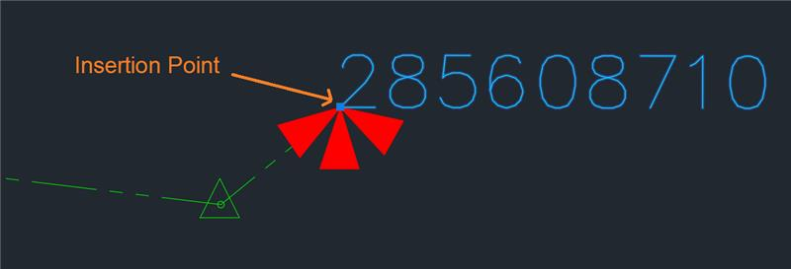  - The lower left corner of the text label (9 figure number) must be positioned exactly on the PM/ PCM point coordinates  - The actual PM/PCM Mark Name (e.g. PM 871) is not required, as this will be automatically retrieved from SMES using the 9 figure number (in the ePlan Creation Service).  Example:  The 9 figure number for KEELBUNDORA PM871 is compiled as follows:  Typically, a zero, unless the mark is an eccentric to the primary mark  PM Number  Parish code
Snapping points | Points defining parcel boundaries should be appropriately snapped to avoid validation issues.  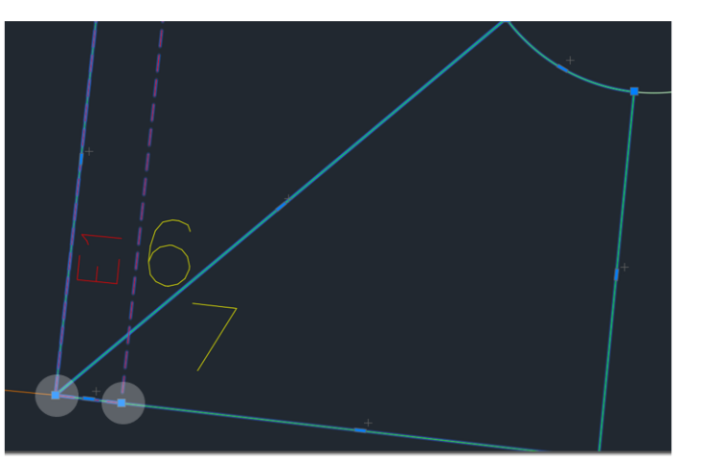  Example:  This is an example of correct snapping for points of parcels 6, 7, and E1, which are snapped and created at the correct location.  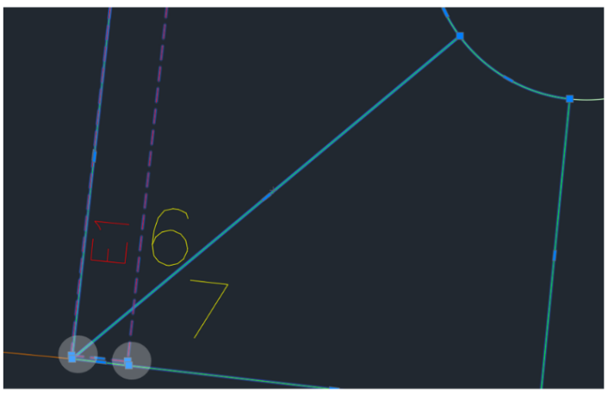  Example:  In this example, points for E1 are not properly snapped.
Title Connections | Acceptable title connections are:  - Standard connection – One of the points used in the subject parcel is connected to the intersection point of two existing roads.  - Corner lot – One of the points used in the subject parcel is identical to the intersection point of two existing roads.  - Bend in road alignment – One of the points used in the subject parcel is connected to a bend in a road.  - Tangent point in road alignment – One of the points used in the subject parcel is connected to a tangent point in a road.  - Crown Allotment connection – One of the points used in the subject parcel is connected to the intersection point of an existing road and an existing Crown Allotment parcel.  - Crown Allotment abuttal – One of the points used in the subject parcel is identical to the intersection point of an existing road or Crown Allotment parcel.  - Natural boundary abuttal – One of the points used in the subject parcel is identical to the intersection point of an existing natural boundary and an existing road, reserve, Common Property or Crown parcel.
Capturing Road Connections | The road alignment in a plan should be defined by connecting it through the parcel boundary points that intersect or are coincident with the road.  This is required so that road connections can be determined and displayed on the plan visualisation. At a minimum, the outer corners of the subject land, which abut the road should be used to define the road alignment, together with the road polyline (or polygon).  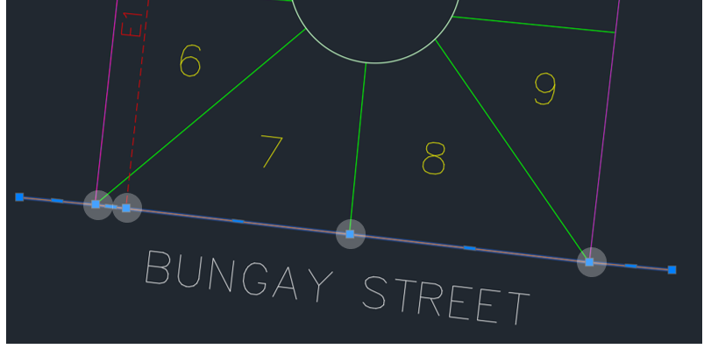  Example 1:  This example depicts a correct road connection which shares 4 points with the subject parcel.  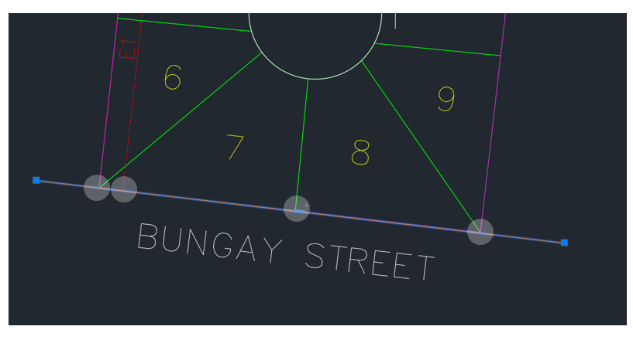  Example 2:  This example depicts an incorrect road connection which does not share any point with the subject parcel:
Adding or removing vertices | When you need to add new vertices to the parcel geometry, make sure that the sequence of points forming the parcel is still correct.  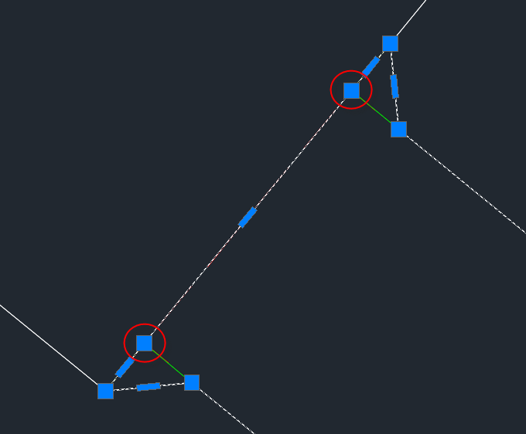  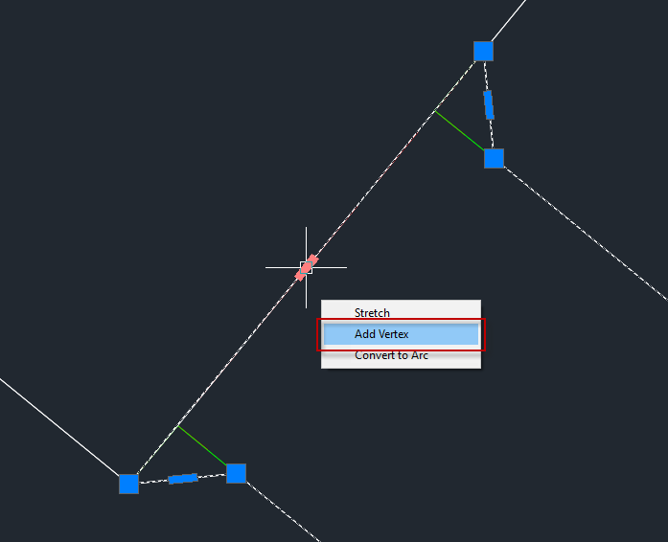  You can do this easily in AutoCAD by hovering over the midpoint of the segment where you would like to add a vertex and click on the corresponding button. Note that this must correspond to the segment where the vertex is to be added so that the polygon remains in order and does not repeat itself.  Vertices are also able to be removed by hovering over the vertex that you would like to remove and clicking the corresponding button.  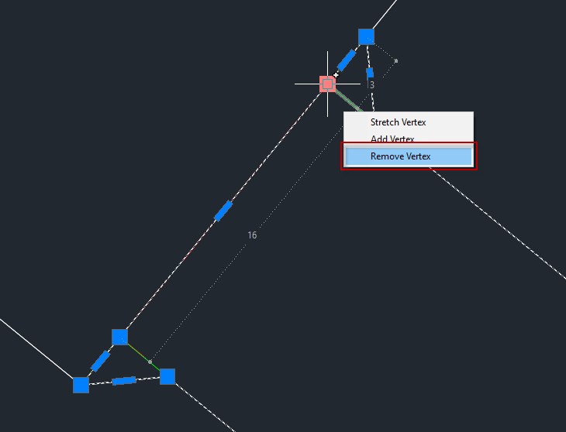
Drawing donut parcels | Donut parcels are polygons that contain internal holes, commonly used when common property surrounds another parcel. In these scenarios:  - The outer ring and inner ring of the donut should be captured together as a continuous single polygon.  - The start point of the first line element must be the same as the end point for the last line element.  - Every line’s start point must be the same as the end point of the previous line element.  - This approach requires adding a "double line" to connect the inner ring to the outer ring.  NOTE:  - Direction matters when capturing the inner ring of the donut parcel. It should go in a different direction to the outer ring.  - The double line placement to fix the inner ring, is user determined.  - The double line will be visualised as a connection between the inner and outer ring on the visualise PDF plan.  Example:  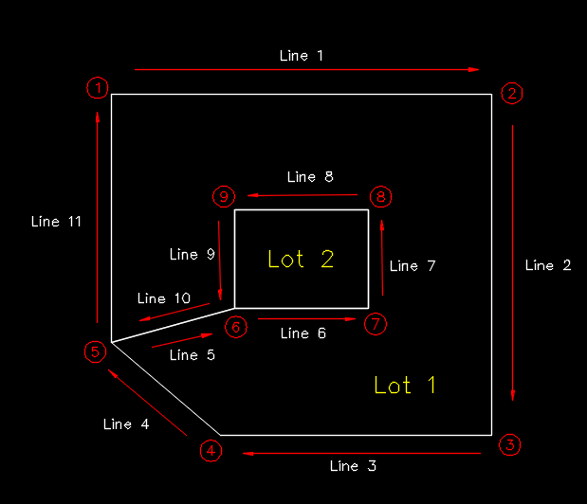  - In this example, Lot 2 sits within Lot 1. This means that Lot 1 needs to be captured as a donut parcel.  - The polyline for Lot 1 starts from point 1 in a clockwise direction to capture the outer ring.  - The connection between the outer and inner ring has been determined to be between points 5 and 6.  - The “connection line” from point 5 to point 6 continues on to capture the inner ring in an anticlockwise direction.  - When the inner ring is captured and back to point 6 again, the line is continued on to point 5 in order to connect back to outer ring. This creates the “double line” shown as line 5 and line 10.  - The parcel is completed, in a clockwise direction by capturing the outer ring back to the starting positions (point1).
Drawing Radiation lines using Occupation Point | Radiation lines as part of survey information in an SCFF file could end at either to a boundary point or at an occupation point (e.g. brick).  Occupation points can be created with a geometry type of Point within the POINT-OCCUPATION layer.  The monuments attached to each occupation point can be added later in the Points tab in the ePlan Editor by adding monument(s) for each occupation point.  Example:  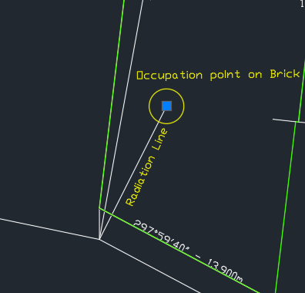  - In this example, a radiation line ends at an occupation point with monument type of Brick.  - The highlighted point in the image is the occupation point created within POINT-OCCUPATION layer.

Appendix 1: Naming Convention for SCFF Text Layers
SCFF Text Layer | Naming Convention ('#' represents a number and '%' represents a numeric or alphabet character)
TEXT-COMMON-PROPERTY-ID | Single Parcel  CM[#]\Plan Number, e.g. CM1\PS123456  For non-created parcel only: CM\Plan Number, e.g. CM\PS123456  Part Parcel  [Prefix][#]–p[#]\[Plan Number], e.g. CM1-p1\PS123456  For non-created parcel only: [Prefix]–p[#]\[Plan Number], e.g. CM-p1\PS123456  Notes:  - Where the parcel exists already, the description needs to be fully recited, e.g. CM1\PS123456, CM\PS123456.  - Where the parcel is being created, the description need only be recited with the parcel identifier, e.g. CM1.  - Where a Not-Fully-Surveyed common property (created or affected) exists in a Partial Survey plan, its label identifier must follow the naming convention provided above. This parcel will be identified as not fully surveyed within the ePlan Editor by checking the ‘Not Fully Surveyed’ checkbox in the Parcel tab.
TEXT-CROWN-ALLOTMENT-ID | Single Parcel  [Allotment %]~[Section %]\PP[Parish or Township Code], e.g. 31~2\PP5509 or 31~2\PP5509A  Part Parcel  [Prefix]–p[#]\PP[Parish or Township Code], e.g. 31~2-p1\PP5509 or 31~2\PP5509A  Notes:  - If there is no Crown Section, [Allotment %]\PP[Parish or Township Code], e.g. 31\PP5509 or 31\PP5509A.  - Where the parcel exists already, the description needs to be fully recited, e.g. 31~2\PP5509, 31\PP5509 or 31~2\PP5509A, 31\PP5509A.  - Where the parcel is being created, the description need only be recited with the parcel identifier, e.g. 31.
TEXT-CROWN-LAND-SERVICE-ID | Single Parcel  Encumbering Crown Land Service: E[#], e.g. E1  Appurtenant Crown Land Service: A[#], e.g. A1  Part Parcel  [Prefix][#]–p[#], e.g. E1-p1, A1-p1
TEXT-CROWN-PORTION-ID | Single Parcel  [Portion %]~[Section %]\PP[Parish or Township Code], e.g. 1~C\PP4568 or 1~C\PP4568A  Part Parcel  [Prefix]–p[#]\PP[Parish or Township Code], e.g. 1~C-p1\PP4568 or 1~C-p1\PP4568A  Notes:  - If there is no Crown Section, [Portion %]\PP[Parish or Township Code], e.g. 1\PP4568 or 1\PP4568A.  - Where the parcel exists already, the description needs to be fully recited, e.g. 1~C\PP4568, 1\PP4568 or 1~C\PP4568A, 1\PP4568A.  - Where the parcel is being created, the description need only be recited with the parcel identifier, e.g. 1.
TEXT-EASEMENT-ID | Single Parcel  Encumbering Easement: E[#], e.g. E1  Appurtenant Easement: A[#], e.g. A1  Encumbering Easement (Road): R[#], e.g. R1  Part Parcel  [Prefix][#]–p[#], e.g. E1-p1, A1-p1, R1-p1
TEXT-LOT-ID | Single Parcel  [#]\[Plan Number], e.g. 1\PS123456  [%]\[Plan Number], e.g. A\PS123456, AA\PS123456  [#][%]\[Plan Number], e.g. 1A\PS123456  [%][#]\[Plan Number], e.g. G101\PS123456  A, E, R and S are not acceptable as % when % is followed by a number (e.g. A1).  Non-created Consolidated Lot: [Plan Number starting with PC/CP], e.g. PC123456  Created Consolidated Lot: 1  Part Parcel  [Prefix][#]–p[#]\[Plan Number], e.g. 1-p1\PS123456  Part non-created Consolidated Lot: [Plan Number starting with PC/CP]-p[#], e.g. PC123456-p1  Part created Consolidated Lot: 1-p[#], e.g. 1-p1  Notes:  - Where the parcel exists already, the description needs to be fully recited, e.g. 1\PS123456, PC123456.  - Where the parcel exists already, and there is no SPI for it, name it as NOSPI–[#] e.g. NOSPI-1.  - Where the parcel exists already, and it is Not in Subdivision, name it as NIS–[#] e.g. NIS-1.Where the parcel is being created, the description need only be recited with the parcel identifier, e.g. 1.  - Where a Not-Fully-Surveyed Lot (created or affected) exists in a Partial Survey plan, its label identifier must follow the naming convention provided above. This parcel will be identified as not fully surveyed within the ePlan Editor by checking the ‘Not Fully Surveyed’ checkbox in the Parcel tab.
TEXT-POINT-CONTROL-ID | e.g. 220902960
TEXT-RESERVE-ID | Single Parcel  Reserve: RES[#]\[Plan Number], e.g. RES1\PS123456  Part Parcel  [Prefix][#]–p[#]\[Plan Number], e.g. RES1-p1\PS123456  Notes:  - Where the parcel exists already, the description needs to be fully recited, e.g. RES1\PS123456.  - Where the parcel is being created, the description need only be recited with the parcel identifier, e.g. RES1.  - Where a Not-Fully-Surveyed reserve (created or affected) exists in a Partial Survey plan, its label identifier must follow the naming convention provided above. This parcel will be identified as not fully surveyed within the ePlan Editor by checking the ‘Not Fully Surveyed’ checkbox in the Parcel tab.
TEXT-RESTRICTION-ID | Single Parcel  RST[#]\[Plan Number], e.g. RST1\PS123456  Part Parcel  [Prefix][#]–p[#]\[Plan Number], e.g. RST1-p1\PS123456  Notes:  - Where the parcel exists already, the description needs to be fully recited, e.g. RST1\PS123456.  - Where the parcel is being created, the description need only be recited with the parcel identifier, e.g. RST1.
TEXT-ROAD-ID | Single Parcel  Road: R[#]\[Plan Number], e.g. R1\PS123456  Part Parcel  [Prefix][#]–p[#]\[Plan Number], e.g. R1-p1\PS123456  Notes:  - Where the parcel exists already, the description needs to be fully recited, e.g. R1\PS123456.  - Where the parcel is being created, the description need only be recited with the parcel identifier, e.g. R1.  - Where a Not-Fully-Surveyed road (created or affected) exists in a Partial Survey plan, its label identifier must follow the naming convention provided above. This parcel will be identified as not fully surveyed within the ePlan Editor by checking the ‘Not Fully Surveyed’ checkbox in the Parcel tab.
TEXT-STAGE-LOT-ID | Single Parcel  S[#]\[Plan Number], e.g. S1\PS123456  Part Parcel  [Prefix][#]–p[#]\[Plan Number], e.g. S1-p1\PS123456  Notes:  - Where the parcel exists already, the description needs to be fully recited, e.g. S1\PS123456.  - Where the parcel is being created, the description need only be recited with the parcel identifier, e.g. S1.  - Where a Not-Fully-Surveyed stage lot (created or affected) exists in a Partial Survey plan, its label identifier must follow the naming convention provided above. This parcel will be identified as not fully surveyed within the ePlan Editor by checking the ‘Not Fully Surveyed’ checkbox in the Parcel tab.

