This table outlines minimum data requirements for ePlans created by Surveyors and submitted to Land Use Victoria (LUV)
For data elements marked 'Optional', where the system permits, and the information is known, LUV recommends these data elements to be included. These data elements will be mandated in the future, including them as soon as practically possible facilitates a smoother transition, provides a greatly enriched data set, and assists the Department in making improvements to the system.

Data to be provided | Required at 'Submitted to Council' status | Required at 'Released for Lodgment' status | Comments
PLAN INFORMATION
Plan number | Mandatory | Mandatory | As per PDF
Surveyors Reference Number and Version | Mandatory | Mandatory | As per PDF
Primary Dealing Type | Mandatory | Mandatory | As per PDF
Coordinate System | Mandatory | Mandatory | Local can be nominated at submitted to council status if a verified connection to MGA2020 is yet to be made.
Surveyor and Firm Details | Mandatory | Mandatory | As per PDF
Council | Mandatory | Mandatory | As per PDF
Land description (Crown description, parent parcels, depth limitation) | Mandatory | Mandatory | As per PDF
Parent parcel information | Mandatory | Mandatory | As per PDF. Text only parent parcel SPI/s to be added for ePlans supporting PDFs re. Vol Fol reference pre-populated.
Road/Reserve Vesting | Mandatory | Mandatory | As per PDF
General plan notations (i.e. notation panel) | Optional | Optional | Optional to add as per PDF.
Additional purpose of plan (i.e. secondary dealing type) | Optional | Optional | Optional to add as per PDF.
Date of Survey | Optional | Mandatory | For Survey/Partial Survey, leaving this blank will result in validation error which can be ignored if not provided at submitted to council status #
MGA2020 Co-ordinates | Mandatory | Mandatory | As per PDF
Survey Type | Mandatory | Mandatory | Survey/Prior Survey/Partial Survey/Non-Survey
PARCELS
Parcel geometry | Mandatory | Mandatory | As per CAD/System requirements - (parent/cancelled parcel geometry required for ePlans utilising VIS/VET, parent/cancelled parcel geometry is not required for PDF plans supported by an ePlan)
Parcel Identifiers/Type | Mandatory | Mandatory | As per PDF
Road names (created and abuttal) | Mandatory | Mandatory | As per PDF
Bearing and Distance values | Mandatory | Mandatory | As per CAD- minor differences due to rounding between PDF and CAD, provided it is within tolerance is allowed. Cadastral intent must be preserved in bearings (i.e. alignments, boundary extent). Note for non-survey plans, bearings and distances should be adjusted in ePlan Editor to accord with PDF/Title where there is an existing misclosure.
Building boundaries | Mandatory | Mandatory | As per PDF - ensure correct boundary location is entered
Building returns | Mandatory | Mandatory | As per PDF - check for correct orientation.
Natural boundaries | Mandatory | Mandatory | As per CAD - typically a series of straights (not a spline if used for the PDF plan)
Area | Mandatory | Mandatory | As per CAD- minor differences due to rounding between PDF and CAD, provided it is within tolerance is allowed. Note for non-survey plans, area should be adjusted in ePlan Editor to accord with PDF/Title where there is an existing misclosure. Not required where areas aren't shown on the PDF.
EASEMENTS
Easement table information | Optional | Optional | Optional to add as per PDF. To become mandatory at future date TBA and subject to future system enhancements as some limitations currently exist.
Easement geometry | Optional | Optional | Optional to add as per PDF. To become mandatory at future date TBA and subject to future system enhancements as some limitations currently exist.
Easement notations (eg. 12(2)/Qualifications) | Optional | Optional | Optional to add as per PDF. To become mandatory at future date TBA and subject to future system enhancements as some limitations currently exist.
RESTRICTIONS
Restriction information | Optional | Optional | Optional to add as per PDF. To become mandatory at future date TBA and subject to future system enhancements as some limitations currently exist.
Restriction geometry | Optional | Optional | Optional to add as per PDF. To become mandatory at future date TBA and subject to future system enhancements as some limitations currently exist.

#NOTE: Applicant contacts can still submit a SPEAR application to the responsible authority where the ePlan has failed validation. For example, indicating that a plan is based on survey, but leaving the survey date blank until known or omitting survey data until later. Validation errors like these can be corrected by a subsequent version of the plan or justified by the surveyor prior to lodgement at Land Use Victoria.

Data to be provided | Required at 'Submitted to Council' status | Required at 'Released for Lodgment' status | Comments
SURVEY INFORMATION
*Traverse and radiation lines to PMs, PCMs and Datum points | Optional | Mandatory | Minimum connection to PMs, PCMs, Datum (including those datum points that are occupation points) and adopt radiations requirements from AFR.
All other traverse and radiation lines | Optional | Optional | All traversing and radiations to control, reference or other survey marks as per AFR to become mandatory at future date TBA.
*Survey Mark points (survey control and datum connection) | Optional | Mandatory | Minimum amount of PMs, PCMs and Datum point (including those that are occupation points) requirements from AFR.
Survey Mark points (all other) | Optional | Optional | All survey marks as per AFR to become mandatory at future date TBA.
*Survey Mark - monument information (survey control and datum connection) | Optional | Mandatory | All mark information for PMs, PCMs and Datum point (including those that are occupation points) requirements from AFR.
Survey Mark - monument information (all other) | Optional | Optional | All mark information as per AFR to become mandatory at future date TBA.
Survey Mark - origin survey (survey control and datum connection) | Optional | Mandatory | All origin information for PMs, PCMs and Datum point requirements from AFR.
Survey Mark - origin survey (all other) | Optional | Optional | All mark origin information as per AFR to become mandatory at future date TBA.
*Survey Marks - state and condition (survey control and datum connection) | Optional | Mandatory | All mark information for PMs, PCMs and Datum point (including those that are occupation points) requirements from AFR.
Survey Marks - state and condition (all other) | Optional | Optional | All mark information as per AFR to become mandatory at future date TBA.
Boundary point marking (pegs or other) | Optional | Optional | As per AFR to become mandatory at future date TBA.
Datum Labels | Optional | Mandatory | As per AFR and LS report, provided it is not occupation measured by chainage and offset.
Occupation points | Optional | Optional | Radiations to occupation points are optional to add as per PDF, unless it is a Datum point measured by radiation.
Occupation lines | N/A | N/A | Not available in current ePlan format. Future enhancement required.
Chainages and Offsets | N/A | N/A | Not available in current ePlan format. Future enhancement required.
OWNERS CORPORATION
Owners corporation schedule | Mandatory | Mandatory | Added to ePlan using existing spreadsheet process.

*NOTE: Existing requirements: The ePlan must include the minimum number of permanent marks, primary cadastral marks and datum points required by the Surveying (Cadastral Survey) Regulations 2025.

Below is a mark-up of a plan with AFR showing the expected mandatory and optional information to be included in your ePlan file.
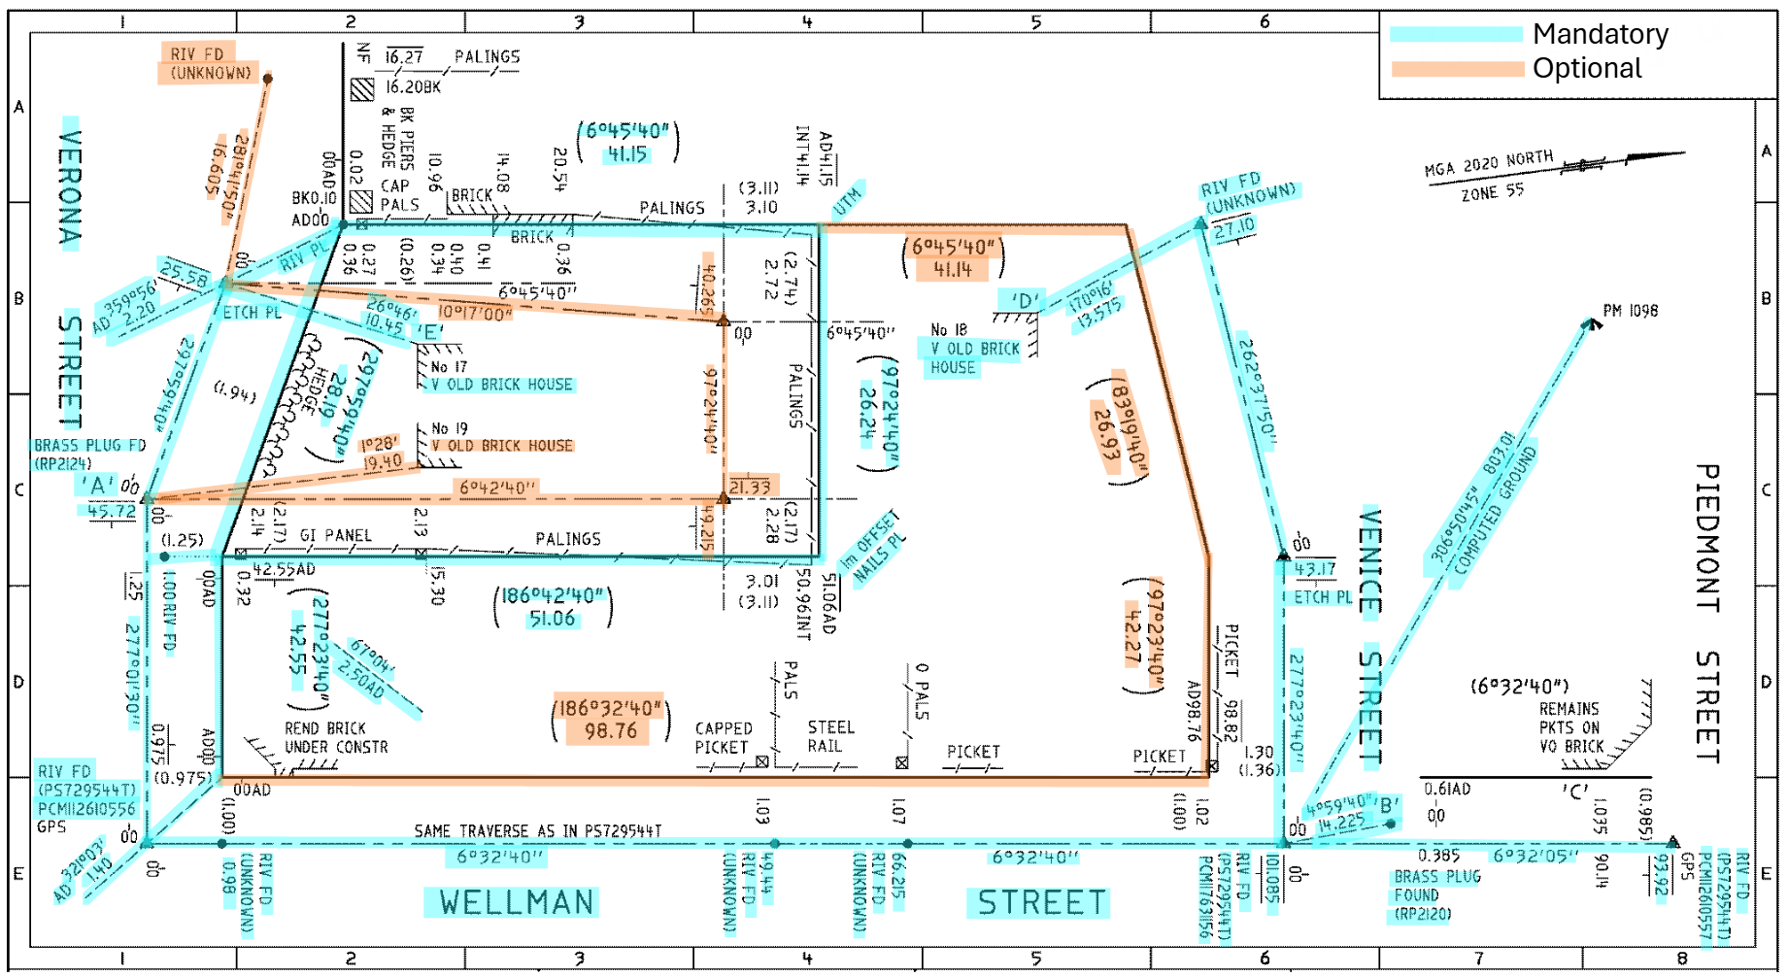
Note that fence/occupation lines and chainage and offset measurements are currently not available in ePlan and are not highlighted in the mark-up.

