
SPEAR

Surveying and Planning through Electronic Applications and Referrals



SCFF Instructions:
Set up files and exporting to DXF
LISCAD

SCFF Instructions (LISCAD): Set up files and exporting to DXF
The information below is provided to assist surveyors in producing and exporting an SCFF from LISCAD. The following files are referenced in these instructions and are available in the zip file from the ePlan section of the SPEAR website, under ‘Getting Started: Training Resources’, SCFF Plan Preparation & Instructions:
- SCFF-CodeTable-Oct2025.ctb
- SCFF-ParameterFile-Oct2025.cpf
- SCFF-PrototypeDrawing-Oct2025.dwg
Importing Code Table and Parameter file to LISCAD | Ensure that the LISCAD file being created is using a ‘Plane’ projection type:  - From the ‘Configure’ tab > ‘Units Configuration’ tab, ensure that:  - ‘Plane Bearing’ selected in the ‘Azimuths’ section  - ‘Ground’ is selected in the ‘Distances’ section.  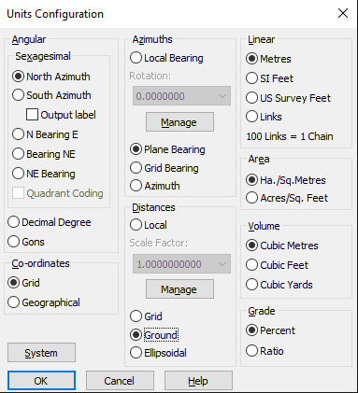  NOTE:  If you are working on a different projection type (other than plane), then ensure that:  - Ground’ is selected in the ‘Distances’ section..  - Download the zipped file that contains ‘SCFF-CodeTable-Oct2025.ctb’ and ‘SCFF-ParameterFile-Oct2025.cpf’ from the SPEAR website, and then extract the zipped file.  - Navigate to your “…LISCAD\Release\UK folder” directory and paste the ‘SCFF-CodeTable-Oct2025.ctb’ and ‘SCFF-ParameterFile-Oct2025.cpf’ to this location.  NOTE: If you are not sure where this folder is, then you can find your LISCAD User Folder directory by navigating to ConfigureFolders and copy the location in the user folder directory. This can then be pasted into Windows File Explorer to access the LISCAD directory.  - Return to LISCAD and ensure that Task is set to Utilities,  - Go to Code tableOpen and select SCFF Code Table and press ok.  - The code dropdowns for point, line, polygon and text will display codes that are equivalent to the SCFF layers. The parameter file ensures that these codes are mapped to the correct SCFF layers in the DXF output file. Please use these codes when entering related data.
Exporting DXF from LISCAD | - In the Task menu select ‘CAD Output’  - From the Settings menu hover over ‘Parameter File’ and then select the ‘open…’ option  - Select the ‘SCFF-Parameter File-Oct2025’ and click ‘ok’  - Ensure that in the Settings menu ‘CAD System’ is set to ‘AutoCAD’  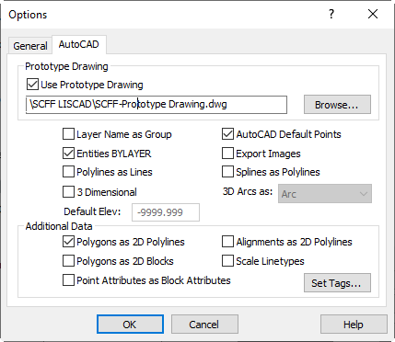  - Click on the ‘Output!’ menu to open the ‘AutoCAD’ save window  - Ensure scale is set to 1:1 and file type is ‘AutoCAD 2010/2011/2012 (*.dxf)  - Click ‘Options’ and from the AutoCAD tab, ensure the following:  - ‘Use Prototype Drawing’ is ticked  - Browse and select ‘SCFF-PrototypeDrawing-Oct2025.dwg  - ‘Entities BYLAYER’ is ticked  - ‘AutoCAD Default Points’ is ticked  - ‘Polygons as 2D Polylines’ is ticked  - Click ‘OK’ to close the Options window  - Click OK to generate a .dxf file ready for SCFF validation
Additional LISCAD Notes | - LISCAD 2023 (or a later version) will allow you to properly snap the nine-figure number text to the PM/PCM point. If you are using an earlier version of LISCAD, you will have to snap the text to the PM/PCM in the CAD environment  - LISCAD will not join an arc and line together. If there is an unclosed polyline that consists of both a line and arc, the workaround is to create an alignment in LISCAD.  NOTE: The alignment must be configured in the settings to ensure it exports to the correct SCFF layer. In the CAD Output SettingsAlignment, click the ‘Set’ button alongside ‘Alignment Description’ and put down the SCFF layer name that the polyline should be exported onto. Do not tick the box for ‘Alignment Description’. Tick the box of ‘Alignment as 2D polyline’ in the Options window in step 7 above. Alternatively, the polyline can be created in the CAD environment using the ‘JOIN’ command.  - When creating cadastral boundaries (via lines and points), use the DEFAULT code and DEFAULT group. This ensures that the cadastral lines and associated points are exported to non-standard SCFF Layers and will be ignored during SCFF validation. The data (points and lines) created in ‘default’ code and group should form the basis for the creation of other features within codes that will be verified during the SCFF validation.  - There are two options for exporting the required parcel identifiers into the SCFF from LISCAD:  - Export the polygon description as the parcel identifiers. This requires the polygon description to be set using the naming convention outlined in SCFF Defined CAD Layers. The polygon description will be exported as text on to their respective layers to be used as identifiers. This has been set up in the parameter file contained in the zip file. This method requires no Text feature to be created in LISCAD.  - Use Text code to create text as parcel identifiers. Disable the polygon description exporting in SCFF-Parameter file and use the correct Text code to create identifiers within the polygon.  - NOTE: The parameter file might not be compatible with some older versions of LISCAD. Users might have to upgrade to a newer version of the software.

