|  |
| --- |
| ePlan Fact Sheet |
| ePlan: providing a faster, more efficient and more reliable way for surveying organisations to submit 2D plans in SPEAR |

ePlan supports 2D subdivisions, consolidations, easements, reserves and acquisition plans lodged under the Subdivision Act 1988.

## What is in an ePlan?

ePlan facilitates the capture, exchange and presentation of cadastral plan, survey and administrative information. The data contained in an ePlan includes:

* survey measurements and parcel dimensions
* easement, road and reserve information
* land parcel descriptions and identifiers
* administrative information
* owner’s corporation schedules, and more.

## ePlan Benefits

ePlan improves data quality, minimises duplication, and paves the way for end-to-end digital data workflows throughout the lifecycle of a plan. This enables streamlining and automation of existing manual processes for faster, reliable and consistent plan registration.

Key benefits of ePlan include:

* data pre-population and re-use of data from authoritative cadastral systems, reducing manual entry and processing times
* automatic data validation, achieving higher quality plans, reduced requisitions and faster registrations
* visualisation of plans in compliance with the Registrar’s Requirements and the Victorian Cadastral Survey Practice Directives 2021

Producing a SCFF compliant DXF is the only pre-requisite required to create an ePlan.

* high integrity updating of cadastral databases, including the Victorian Online Titles System, the digital cadastre, and the survey control network
* targeted for registration of 5 business days.

## ePlan and the SCFF

The Single CAD Format File (SCFF) is the primary building block for creating an ePlan. There are 73 standard layers in the SCFF, which are used to define boundary, textual and survey information. Most CAD drawings only require a small subset of these layers.

Applying the SCFF layering requirements enables a licensed surveyor to create an ePlan!

The SCFF is validated and uploaded to the ePlan Portal and additional data is pre-populated and supplied through the ePlan Editor to satisfy the remaining components of an ePlan.

## Submitting ePlans in SPEAR

In SPEAR, the ePlan Portal provides a suite of ePlan services that allow a licensed surveyor to create, validate and visualise an ePlan.

Features of the ePlan Portal and its services include:

* ePlan creation, file management and versioning through the ePlan Dashboard
* validations of data contained in both the SCFF and ePlan files
* automated visualisation of an ePlan into a PDF plan
* Visualisation Enhancement Tool (VET) functions, which cater for a range of plan presentation requirements, including key sheets and enlargements for large estate subdivisions.

Once an ePlan is finalised, it can easily be fitted to a new or existing SPEAR application by selecting it from the ePlan Dashboard.

The selected ePlan is attached to SPEAR in its visualised PDF format, and digitally signed in-line with current SPEAR plan processes.

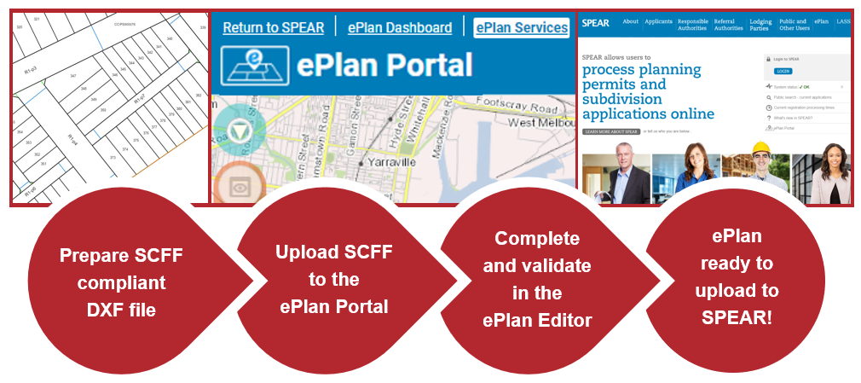

## Support and training

SPEAR Service Desk staff are available to assist with SCFF adoption questions, ePlan training and support matters.

ePlan information sessions, workshops and training are regularly hosted to showcase current ePlan processes, developments and to seek user feedback on their experience.

Keep an eye out for future training sessions that will cover ePlan Portal functionality, including navigating the ePlan Dashboard, ePlan Editor and the Visualisation Enhancement Tool (VET).

Licensed Surveyors are eligible for FPET points for attending these sessions!

Our aim is to support the surveying industry seamlessly transition to ePlan through support, training and provision of online training resources.

## Online ePlan resources

Visit the SPEAR website to explore the range of ePlan and SCFF resources, including:

* [SCFF templates and guidance notes](https://www.spear.land.vic.gov.au/spear/pages/eplan/scff/scff-layers-examples-templates.shtml)
* [SCFF list of layers (DOCX 60KB)](https://www.spear.land.vic.gov.au/spear/documents/eplan/scff/SCFF_Defined_CAD_Layers-v5.docx)
* [SCFF CAD example (DXF 830KB)](https://www.spear.land.vic.gov.au/spear/documents/eplan/scff/SCFF_SamplePlan_DXF2010.dxf)
* [SCFF FAQs](https://www.spear.land.vic.gov.au/spear/pages/eplan/scff/faqs.shtml)
* [ePlan video tutorials](https://www.spear.land.vic.gov.au/spear/pages/eplan/eplan-portal/video-tutorials.shtml)

|  |  |
| --- | --- |
| © The State of Victoria Department of Environment, Land, Water and Planning 2023  LogoThis work is licensed under a Creative Commons Attribution 4.0 International licence. You are free to re-use the work under that licence, on the condition that you credit the State of Victoria as author. The licence does not apply to any images, photographs or branding, including the Victorian Coat of Arms, the Victorian Government logo and the Department of Environment, Land, Water and Planning (DELWP) logo. To view a copy of this licence, visit http://creativecommons.org/licenses/by/4.0/  Disclaimer  This publication may be of assistance to you but the State of Victoria and its employees do not guarantee that the publication is without flaw of any kind or is wholly appropriate for your particular purposes and therefore disclaims all liability for any error, loss or other consequence which may arise from you relying on any information in this publication. | Accessibility  If you would like to receive this publication in an alternative format, please telephone the DELWP Customer Service Centre on 136186, email [customer.service@delwp.vic.gov.au](mailto:customer.service@delwp.vic.gov.au), or via the National Relay Service on 133 677 [www.relayservice.com.au](http://www.relayservice.com.au). This document is also available on the internet at [www.delwp.vic.gov.au](http://www.delwp.vic.gov.au). |

For more information or assistance getting started on your ePlan journey, contact the SPEAR Service Desk

T: (03) 9194 0612 (press 2 for ePlan)

E: [spear.info@delwp.vic.gov.au](mailto:spear.info@delwp.vic.gov.au)

W: [www.spear.land.vic.gov.a](http://www.spear.land.vic.gov.a)u > ePlan