# User Guide 61

# Vicmap Survey: Inserting and joining additional plans

## Purpose of this User Guide

The purpose of this User Guide is to provide information to Applicant Contact users of the SPEAR system, on using the data analysis features of Vicmap Survey that are available through the ePlan Portal in [SPEAR](https://www.spear.land.vic.gov.au/spear/index.shtml).

## Who should read this?

Primary audience: Registered users of the SPEAR system who have the Applicant Contact (surveying organisation) user role

## Introduction

Vicmap Survey provides unadjusted digital plan and survey information georeferenced to [Geocentric Datum of Australia 2020](https://www.land.vic.gov.au/surveying/geodesy/geocentric-datum-of-australia). It allows users to identify possible survey differences and cadastral re-establishment issues by providing access to both [digitised DCM data](https://www.land.vic.gov.au/surveying/projects-and-initiatives/digital-cadastre-modernisation/early-data-release), and survey information from Abstract of Field Records. :

The ePlan Portal offers Vicmap Survey tools and features for data analysis which provide the ability to visualise digital survey data, investigate potential cadastral issues, search parent plan information, view surrounding parcel data and local survey information, link surveys through common survey marks in the data.

## Opening and importing second or subsequent plan file

The ePlan portal has the ability to open, view and manipulate multiple digital plan and survey files in a session. This enables the user to undertake measurements and comparisons using the data from several files that have been joined at nominated points.

Second and subsequent files can be imported as outlined in “How to open and import digital plans and surveys”, with the following options:

* Using the search for a plan/import function
* Performing a ‘Parcel Identify’ search and importing the file from the Parcel Identification dialog
* Clicking on a plan file listed in the ‘Linked Plans’ dialog
* Drag and dropping a landXML file.

## Using Point Matching to Connect Plans

When inserting a second or subsequent digital plan file, upon clicking continue in the preview screen the user is taken to the “Point Matching' screen. The “Point Matching' screen enables the user to select points on two digital plan files to denote as ‘common’ points.

The user can select one or two points common between the files to align them. Upon selecting two points, the system calculates the measurement between the points on each plan using each plan’s observation values. If the calculated bearing and distance are within a set tolerance, the system will allow the file to be imported.

Upon selecting two points, the system calculates the measurement between the points on each plan using each plan’s observation values. If the calculated bearing and distance are within a set tolerance, the system will allow the file to be imported.

Note: The background mapbase opacity can be toggled on/off with the slider to help orient the user if required.

The portal will then visualise the plans relevant to each other by ‘snapping’ any other points in the files that are within 0.05m once the file co-ordinates are recalculated.

When a comparison function (see ‘Comparison Tools’) is run, the snapped points are shown highlighted in cyan and are treated as being ‘common’ between files. However, this does not change the values of observations in the file, nor calculated co-ordinates.

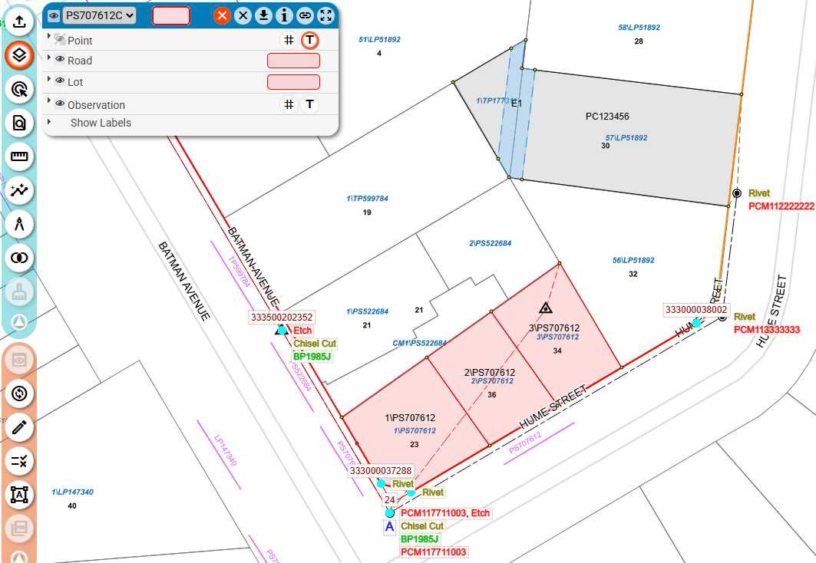

The result of the joined files is the ability to undertake comparisons and calculations through these ‘common’ points using the original measurement observations in each file.

If there is more than one file already open in the portal, the active plan or ‘primary file’ can be switched by clicking on the plan number:

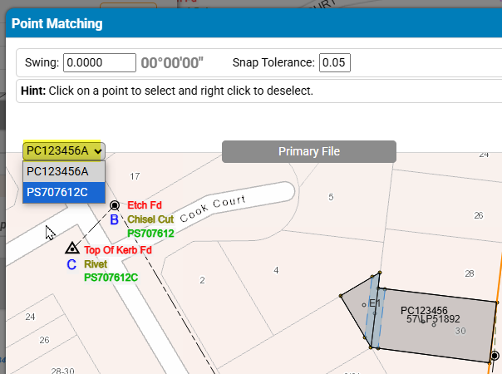

Point matching is not limited to survey marks only. Common boundary points can also be used to match files.

If there is a bearing datum swing between the files, it will be applied to the visualisation of the plan being inserted. Upon selecting two common points the swing is calculated by the system (if applicable).

If only one point is selected, the bearing swing can be manually entered.

## Switching between active plans

If multiple plans have been imported, the plan currently selected (shown) in the layer pane is referred to as the ‘Active Plan’. Changing any of the layer options outlined above will only affect the Active Plan

To switch between imported plans, click the drop down arrow and select the ‘Active Plan’

## Removing plans

When multiple files have been opened, clicking the clear cross at the top of the layer pane will remove the active plan.

To remove **all** imported files, click the orange cross.

