# User Guide 60

# Vicmap Survey: Loop and Misclose checks

## Purpose of this User Guide

The purpose of this User Guide is to provide information to Applicant Contact users of the SPEAR system, on using the data analysis features of Vicmap Survey that are available through the ePlan Portal in [SPEAR](https://www.spear.land.vic.gov.au/spear/index.shtml).

## Who should read this?

Primary audience: Registered users of the SPEAR system who have the Applicant Contact (surveying organisation) user role

## Introduction

Vicmap Survey provides unadjusted digital plan and survey information georeferenced to [Geocentric Datum of Australia 2020](https://www.land.vic.gov.au/surveying/geodesy/geocentric-datum-of-australia). It allows users to identify possible survey differences and cadastral re-establishment issues by providing access to both [digitised DCM data](https://www.land.vic.gov.au/surveying/projects-and-initiatives/digital-cadastre-modernisation/early-data-release), and survey information from Abstract of Field Records. :

The ePlan Portal offers Vicmap Survey tools and features for data analysis which provide the ability to visualise digital survey data, investigate potential cadastral issues, search parent plan information, view surrounding parcel data and local survey information, link surveys through common survey marks in the data.

## Automatic Loop Check

Upon importing a digital plan/survey file, an automatic check is run across all closed loops of observations in a file for any miscloses greater than the default tolerance (0.05m). Loops containing a misclose are referred to as a ‘Loop Error’.

If the plan contains any loop errors upon importing, a pop-up dialog box is displayed. A green coloured line shows the path taken for the loop check. A purple-coloured line indicates the ‘likely line’ of the source of the misclose.

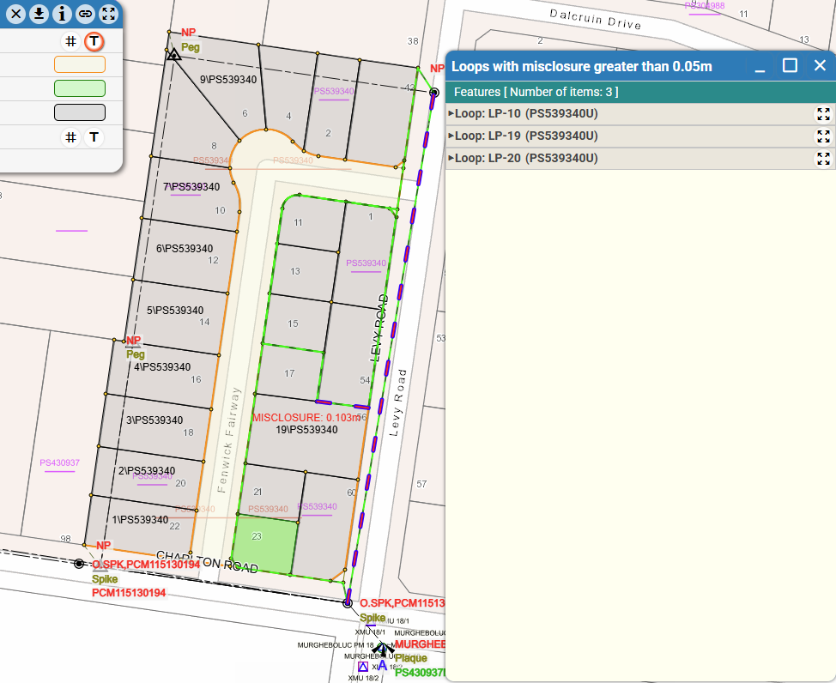

Clicking the arrow next to the identified loop in the features dialog box will expand the entry to show more information.

The ‘Points Sequence’ within the loop entry outlines the order of points passed through in that loop check.

The ‘Observation Sequence’ within the loop entry outlines the order of observations passed through in that loop check. Hovering over any of the observations listed will highlight that observation line.

The ‘Loop misclosure’ gives the bearing and distance of the misclose vector.

The likely lines for misclosures gives the most likely observation the source of the misclosure exists in. Hovering over the observations listed will highlight the observation line.

## Parcel Misclose Display

Parcels in digital plan files will have a misclose calculated based on the observation values of the parcel boundaries.

Where a parcel contains a misclose value over the default tolerance, the misclosure figure is shown in red within the specific parcel(s).

To display detailed information on the parcel misclose, click on the ‘Identify ePlan features’ tool and then click on any of the parcels to open a dialog box containing information relating to the parcel. Clicking on the arrow in the dialog box next to the parcel ID will give further details about the misclose.

Note that using the ePlan features identification feature will display misclose information on any parcel, regardless of tolerance.

## Manual Loop Check

A manual loop check can be run on the active plan by selecting the icon ‘Display loop errors’:

Once selected the user can run the loop check at any tolerance specified in the dialog box which appears

Clicking OK runs the loop check function and displays any identified loops with miscloses above the user’s specified value.

## Disabling Automatic Loop Check

The automatic loop check function can be switched off in the ePlan Dashboard settings.

In the ePlan Dashboard landing page select the ‘Portal Import Settings’ icon and then click the slider to ‘off’ to turn off the automatic loop check.

