User Guide 17 Victorian Civil and Administrative Tribunal
Purpose of this User Guide
The purpose of this User Guide is to provide information on how the Victorian Civil and Administrative Tribunal (VCAT) processes are handled in SPEAR when an Application for Review is lodged against a SPEAR application by a registered applicant.
Who should read this?
Primary audience: VCAT
For Information: Applicant Contacts and Responsible Authorities
Introduction
The Planning and Environment List is part of VCAT, an independent Tribunal, which hears and decides applications by permit applicants, objectors, and others in an informal, expeditious manner and upon their merits. The Planning and Environment List hears and determines:
- Applications to review decisions made by Responsible Authorities (Local Government Authorities) under several Acts of Parliament,
- Applications for enforcement orders, applications to cancel or amend permits and applications for declarations relating to the use and/or development of land under the Planning and Environment Act 1987.

Currently, VCAT can perform the following actions in SPEAR:
- Add a VCAT reference number
- Maintain Application for Review details
- Add correspondence or other documents into SPEAR (for viewing by other parties)
- add one or multiple VCAT orders to each Application for Review
- Set and clear the VCAT flag in SPEAR
- Process multiple Applications for Review to the one permit application (either simultaneously or separately).
NOTE: SPEAR currently supports the online lodgement of Applications for Review by the Applicant Contact for a range of Application for Review types only. See User Guide 49 for details. All other review types MUST continue to be submitted to VCAT in paper.
The following VCAT Application for Review types are handled in SPEAR:
- Refusal to grant a planning permit (s.77)
- Requirement to give notice of an application for permit (s.78(a))
- Requirement of the Responsible Authority for more information (s.78(b))
- Failure to grant a permit within the prescribed time (s.79)
- Conditions in a permit (s.80)
- Refusal to extend time on a permit by the Responsible Authority (s.81 (a))
- Failure to extend time on a permit by the Responsible Authority (s.81(b))
- Refusal of the Responsible Authority to extend time in which to provide information (s.81(2))
- Decision to grant a permit (s.82 (1))
- Decision to grant a permit under sec 82b (s.82b),
- Application for Review (s.149).

VCAT has a unique role to play within SPEAR, and as a result of this, VCAT is the only user of the SPEAR system able to search for, and view details of, all applications which are either classified as ‘planning’ (use and development planning permits) or ‘joint’ (where a certification/statement of compliance application includes a subdivision planning permit).
17.1 VCAT options
To perform actions in SPEAR, you must first login. Open the SPEAR homepage at www.spear.land.vic.gov.au/SPEAR.
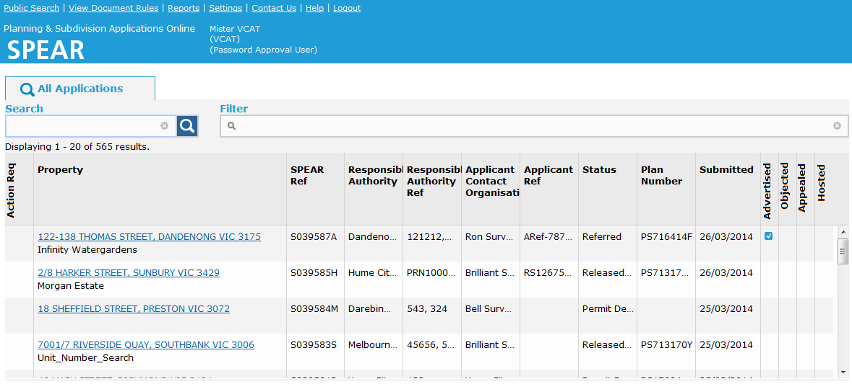When logged in, you will be presented with the permit Application List screen, shown below. From here you can search, sort and filter applications. To view the details of a particular permit application, click on the hyperlinked property address in the Property column.

All VCAT actions are initially located on the permit application Details screen. To view these actions, click on the VCAT section of the Details screen and select the task you wish to perform from the ‘Actions’ drop-down list. Once a review has been added, a new VCAT Reviews screen is generated, and future actions occur within that screen.
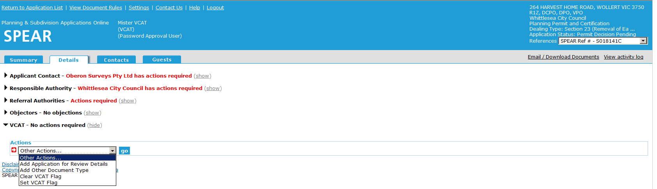
17.2 Maintain application for review details
Using SPEAR, a VCAT officer can identify and nominate the Application for Review type relevant to the permit application. Go to the Details screen, expand the ‘Actions’ drop-down list and select ‘Add Application for Review Details’.
A new screen will appear, showing a list of Application for Review types, as prescribed in the Planning and Environment Act 1987. If more than one Application for Review applies to the one permit application, the VCAT officer will be asked which Application for Review is being updated, as shown below.
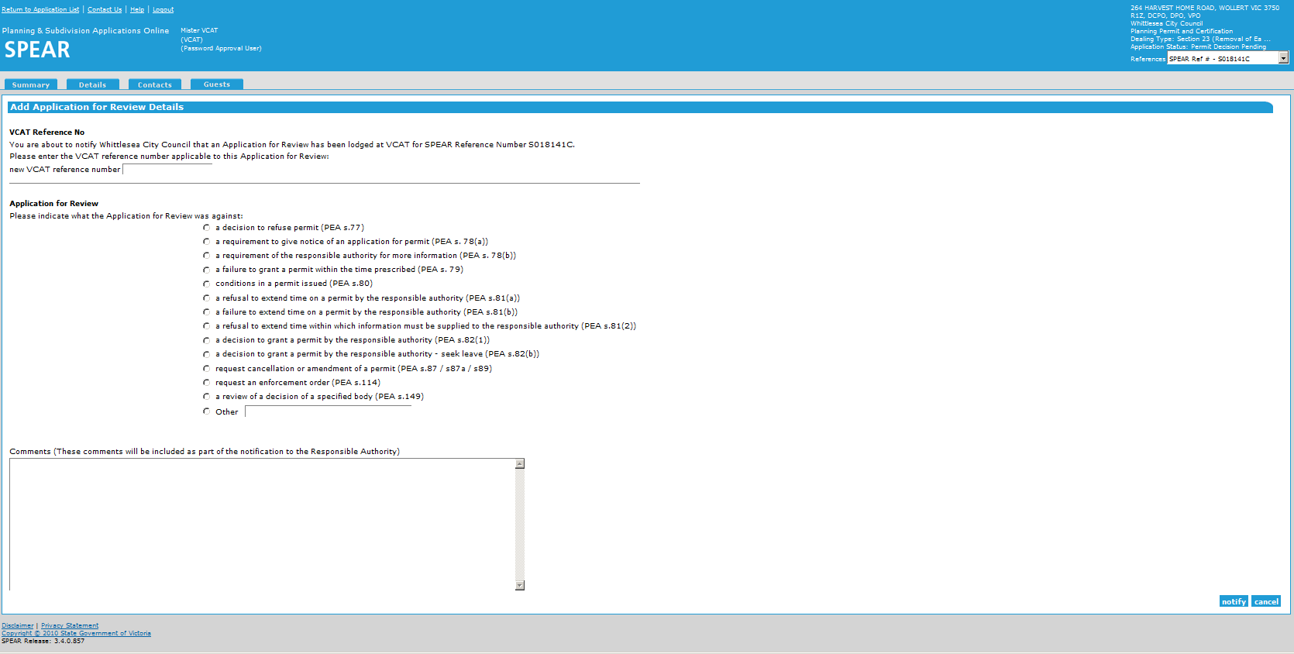

Authenticating this action will send an email notification advising the Responsible Authority that an Application for Review has been submitted and trigger the VCAT REVIEW flag to be set in SPEAR. The VCAT REVIEW Flag can be seen in red font on the Summary screen above the list of ‘Milestones’.
If a separate current Application for Review already applies to the permit application, the VCAT REVIEW Flag will have already been set by that application.

17.3 How do I add a document?
VCAT officers have the option to add PDF documents to a SPEAR application. This feature can be used when VCAT need to add an ‘Other’ document type relating to the Application for Review, or a Tribunal Instructions. A list of these uploaded documents will be shown under the VCAT section of the Details screen.
Go to the Details screen, expand the ‘Actions’ drop-down list and select ‘Add Other Document Type’ or ‘Add Tribunal Instructions’. This presents the following screen, which allows the VCAT officer to upload a PDF document into SPEAR and include a brief document description.

NOTE: Other parties to the application will not be notified that an ‘Other Document’ has been uploaded into SPEAR, although they will be able to view the documents.
17.4 Add a VCAT order
VCAT officers have the option to add a VCAT Order document to an application. More than one Order document can be uploaded to each application. This can be in the form of an attached PDF or by using the free form text box. Go to the Details screen, expand the ‘Actions’ drop-down list and select ‘Add VCAT Order’.
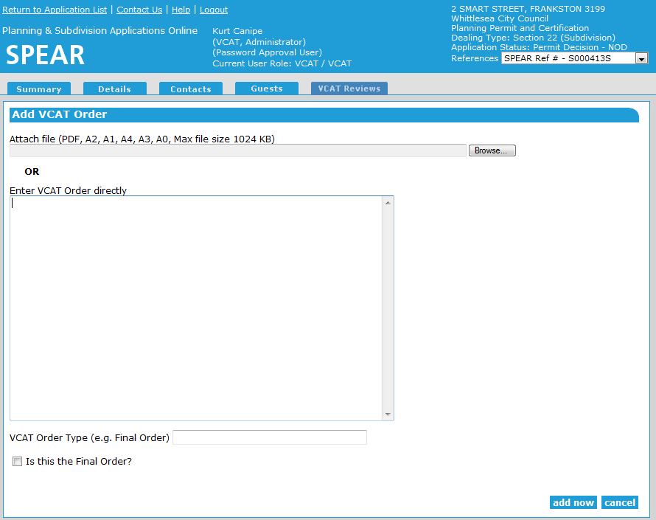The following screen will then appear, allowing the VCAT officer to upload the relevant Order document and describe the VCAT Order Type. Ticking the box ‘Is this the Final Order?’ will result in the VCAT REVIEW Flag being removed from the Summary screen (provided no other Application for Review applies to the permit application). Following authentication, the Responsible Authority will be advised they have an outstanding action to view the Order document.

17.5 Setting and removing the VCAT REVIEW Flag
The VCAT REVIEW flag in SPEAR appears on the Permit Application Summary screen, advising SPEAR users that the permit application is under review at VCAT.
The VCAT REVIEW Flag is set automatically when the VCAT Reference Number is added to SPEAR by a VCAT officer. It can also be set manually by a VCAT officer by selecting ‘Set VCAT Flag’ from the ‘Actions’ drop-down list on the Details screen. This may be necessary if ‘final order’ has been selected, but further correspondence occurs to continue the review.
Similarly, the VCAT REVIEW Flag can be cleared in two ways:
- It is automatically cleared when the ‘Final Order’ tick box is selected by a VCAT officer (see earlier section on ‘Add a VCAT Order’).
- It can be cleared manually by a VCAT officer by selecting ‘Clear VCAT Flag’ from the ‘Actions’ drop-down list on the Details screen.
Need more information?
Further information on this topic can be found by:
- Visiting the SPEAR website www.spear.land.vic.gov.au/SPEAR
- Contacting the SPEAR Service Desk on 8636 3049 or email spear.info@delwp.vic.gov.au
- Selecting the Help link in the relevant area of the system.

