Technical Note 4

Applicant Created Surveying Documents in SPEAR

October 2019

Table of Contents

Purpose of this SPEAR Technical Note 3
Who should read this? 3
Introduction 3
1. Digital signing requirements 4
2. Creating SPEAR-compliant digital documents (PDFs) 4
PDF version requirements 4
Image quality 4
File naming conventions 4
PDF file requirements 4
Page size 4
Sheet numbering 4
Page orientation 5
3. SPEAR dealing types 5
4. Templates.. 5
5. Phase in period for adopting templates 6
6. Need more information? 6
7. Related SPEAR resources 6
8. Document release information 6
APPENDIX 1: SPEAR Templates by document type 7
APPENDIX 2: Layout Requirements for all SPEAR documents 9
APPENDIX 3: Template Specifications 9
1 - ‘Plan for Certification – Front Sheet’ 10
2 - ‘Generic Plan – Subsequent Sheet (Portrait)’ 12
3 - ‘Generic Plan – Subsequent Sheet (Landscape)’ 14
4 - ‘Abstract of Field Records – Front Sheet’ 15
5 - ‘Abstract of Field Records – Subsequent Sheet’ 16
6 - ‘Other Plan – Front Sheet’ 17
7 - ‘Surveyor’s Report’ 19
Example A: Plan for Certification 20
Example B – Abstract of Field Records 26
Example C – Surveyor’s Report 30
Example D – Boundary Plan 32
Example E – Plan of Survey (TLA) 38
Example F – Plan of Crown Allotment 44
Example G – Title Plan 50
Example H – Record of Having Re-established a Cadastral Boundary 56
APPENDIX 4: Owners Corporation schedules 62

Purpose of this SPEAR Technical Note
This Technical Note has been prepared to facilitate the creation of digital documents by surveyors and applicants for use within SPEAR. This includes plans and other survey information that may be required to support land dealings / applications lodged at Land Use Victoria.

These notes are based on Land Use Victoria requirements for long-term storage and delivery of plan/title information and do not change the legislative requirement of these documents, as defined by other sources such as Acts, Regulations, Survey Practice Handbook, Surveyor General Victoria (SGV) Practice Directives, Land Use Victoria online examples, etc.

Who should read this?
Primary audience: Applicants, including surveyors.
For information: Responsible Authorities, Referral Authorities, Lodging Parties and Land Use Victoria.

Introduction
Applicants are ultimately responsible for ensuring that they provide appropriate documents suitable for the intended audience and purpose. Failure to create files that meet these guidelines could result in the application undergoing delays or requisitions if Land Use Victoria is not satisfied with the quality or presentation of the documents.

Unless they are submitting an ePlan, applicants must produce all plans and related survey information in PDF format (except for owners corporation (OC) schedules and digital survey geometry files).

This Technical Note details the presentation / layout requirements of specific documents. Appendix 1 outlines the specific requirements of individual document types according to their purpose (Act/Section). Further information and document examples are shown subsequently.

Digital signing requirements
All documents digitally signed in SPEAR will be watermarked to reflect the details of the signing event or decision. The watermarks are applied into designated spaces on the documents, replacing any content in these spaces.

The signing watermarks will provide information about who signed the document and their organisation. The decision watermarks will also provide information about the nature of the decision - e.g. certification and endorsement details.

It is important that documents subject to digital signing are presented on the correct templates. Applicants must maintain the exact placement and dimensions of the designated spaces outlined in this Technical Note.

Creating SPEAR-compliant digital documents (PDFs)
PDF version requirements
- SPEAR will only accept documents in PDF version 1 (1.2 or greater). PDF version 2 is not supported. Check the PDF version by opening the document in Adobe Acrobat Reader and clicking File à document properties.

Image quality
- Resolution must be set to a minimum of 300 dpi to provide for satisfactory image quality.
- All plan and survey documents must be produced in black and white in accordance with current practice. Colour and greyscale are not acceptable. Any colour and greyscale PDFs will be converted to black and white by Land Use Victoria which will result in a loss of quality.

File naming conventions
- SPEAR renames each document as it is uploaded, therefore organisations can continue to use their existing file naming conventions.

PDF file requirements
- Multi-page documents loaded into SPEAR must be collated into a single sequential file by the applicant.
- Security settings must not be applied to PDF documents as SPEAR may reject them. SPEAR enforces appropriate controls over who can modify or add new documents.

Page size:
- The PDF file must reflect the physical size of the equivalent paper document i.e. A4 or A3. SPEAR checks for the appropriate size and will not allow incorrectly sized documents to be loaded.
- All plans and abstracts are required to be supplied in A3 size. A4 plans are no longer permitted.

Sheet numbering:
- Plans and OC schedules are to be numbered separately - e.g. If a plan contains three diagram sheets and two OC schedules (five sheets in total), the front sheet of the plan should state Sheet 1 of 3 and the first OC Schedule should state Sheet 1 of 2.

Page orientation:
- All pages of the PDF file must be orientated to appear upright when viewed on screen. For example, a landscape sheet must not appear in portrait orientation (rotated 90 degrees). This will ensure the watermarks are applied in the correct locations.
- SPEAR provides applicants the ability to rotate plan sheets once they are uploaded to SPEAR (prior to authentication).

NOTE: Land Use Victoria will requisition plans that are orientated incorrectly.

SPEAR dealing types
Appendix 1 provides an overview of the basic requirements for each document relevant to the associated dealing type.
Plan examples and more detailed notes are shown in Appendix 3.
OC schedules are shown in Appendix 4.

Templates
All the templates shown in Appendix 3 are available from the SPEAR website. They are available in the following formats: AutoCAD (DWG), Liscad (LCD), Microstation (DGN), Terramodel (PRO), DXF and PDF.

Where text is displayed within angled brackets on the templates (e.g. Plan of <Subdivision>), applicants must remove the brackets and replace the text with relevant information – e.g. For a consolidation application, the text Plan of <Subdivision> would be changed to Plan of Consolidation.

The text <Leave blank> appears on some templates to assist applicants to identify areas designated for Land Use Victoria or council use only. This text can be removed.

NOTE: Minor changes to the templates are acceptable, provided that the location and size of the designated spaces for watermarking shown in Appendix 3 are not altered. Any documents that are lodged at Land Use Victoria that are compromised using incorrect or modified templates will be requisitioned at Land Use Victoria’s discretion.

Phase in period for adopting templates
New applications
All new applications created in SPEAR must use the templates and procedures described in this document.

Applications created before May 2015
Applications created in SPEAR before Release 4.1 in May 2015 will continue to be watermarked in the previously defined areas. For subdivisions, either the previous templates or the templates described in this document can be used for these applications until their registration. For other application types, the previous templates should continue to be used for existing applications until their completion.
Owners Corporation schedules
Applicants can supply OC schedules in XLSX format from SPEAR Release 4.2 in November 2015. This is currently optional, however Applicant Contacts are encouraged to begin using the spreadsheet for all new plans as it will become a requirement in a future release of SPEAR.

Need more information?
Further information on this topic can be found by:
- Visiting the SPEAR web site: www.spear.land.vic.gov.au/spear/
- Download the Adobe Acrobat Reader from: http://www.adobe.com/products/reader/
- Email the SPEAR Service Desk: spear.info@delwp.vic.gov.au
- Contacting the SPEAR Service Desk on 9194 0612

Related SPEAR resources
- User Guide 09: Releasing to Land Use Victoria
- User Guide 11: Lodging at Land Use Victoria

8. Document release information
Version | 10
Date released | January 2019
Authorised by | Mark Briffa, Manager Electronic Subdivisions Unit, Land Use Victoria

APPENDIX 1: SPEAR templates by document type

SPEAR will watermark known information directly on the PDF plan and survey documents as per the table below. Some information is captured in SPEAR such as certifications and signing details. Other information may be passed on from Land Use Victoria (LUV) systems, such as plan and dealing numbers. SPEAR documents must comply with the template formats to ensure this data can be applied to the documents.
Document Type | Dealings | Template Name and Number  See Corresponding Examples in Appendix 3 |  | Orientation | Page Size | SPEAR generated text applied to the document: Enhanced Watermarking
 |  |  |  |  |  | Plan / Dealing Number | Surveyor Signing | Surveyor Signed Declaration | Council Signed Certification | Council Signing | LUV / SGV  Signing, Approval or Registration
- Plan of Subdivision  - Plan of Consolidation  - Plan for Certification  - Plan of Creation /  Variation / Removal of  Easement / Restriction | Subdivision Act  - Sec 22  - Sec 23  - Sec 24A  - Sec 32  - Sec 32A  - Sec 32B  - Sec 35  - Sec 37  Transfer of Land Act  - Sec 98CA  - Sec 45  - Sec 72  - Sec 88(2) | 1 | Plan for Certification - front | portrait | A3 | Dealing Dependent | Signed - Subdivision Act and 98CA only | N/A | Signed Certification (except 98CA) | N/A | LUV Registration
 |  | 2 | Generic Plan - subsequent (portrait) | portrait | A3 | Dealing Dependent | Signed - Subdivision Act and 98CA only | N/A | N/A | Signed (except TLA)except TLA) | N/A
 |  | 3 | Generic Plan - subsequent (landscape) | landscape | A3 | Dealing Dependent | Signed - Subdivision Act and 98CA only | N/A | N/A | Signed  (except TLA) | N/A
- Abstract of Field Records  - Supplementary Abstract of Field Records | - multiple | 4 | Abstract - front | landscape | A3 | Dealing Dependent | N/A | Signed Declaration - Survey only | N/A | N/A | N/A
 |  | 5 | Abstract - subsequent | landscape | A3 | Dealing Dependent | Signed | N/A | N/A | N/A | N/A
- Surveyor’s Report | multiple | 7 | Surveyor’s Report | portrait | A4 | Dealing Dependent | Signed | N/A | N/A | N/A | N/A

Document Type | Dealings | Template Name and Number  See Corresponding Examples in Appendix 3 |  | Orientation | Page Size | SPEAR generated text applied to the document: Enhanced Watermarking
 |  |  |  |  |  | Plan / Dealing Number | Surveyor Signing | Surveyor Signed Declaration | Council Signing | Council Signed Certification | LUV / SGV  Signing, Approval or Registration
- Plan of Survey  - Boundary Plan  - Plan of Crown Allotment  - Title Plan (Crown Survey)  - Title Plan (TLA/LGA)  - Plan  - Record of Having  Re-Established a Cadastral Boundary* | Transfer of Land Act  - Sec 60  - Sec 99  - Sec 103  - Sec 15  - Sec 26P  Local Government Act  - 207D  - 207E  - Road Alignments  Subdivision Act  - Sec 38B  - Sec 38C  - Boundary Plans  Other  - Plan of Crown Allotment  - Re-Establishment  - Major Transport Projects Facilitation Act | 6 | Other Plan - front | portrait | A3 | Yes | Signed (dealing dependent) | Signed Declaration -Survey or Non-Survey  (dealing dependent) | N/A | N/A | SGV Signing / LUV Approval (dealing dependent)
 |  | 2 | Generic Plan - subsequent (portrait) | portrait | A3 | Yes | Signed (dealing dependent) | N/A | N/A | N/A | SGV Signing / LUV Approval (dealing dependent)
 |  | 3 | Generic Plan - subsequent (landscape) | landscape | A3 | Yes | Signed (dealing dependent) | N/A | N/A | N/A | SGV Signing / LUV Approval (dealing dependent)

*Note: The ‘Record of Having Re-Established a Cadastral Boundary’ template defined in Schedule 4 of the Surveying (Cadastral Surveys) Regulations 2015 cannot be used in SPEAR. The templates listed above must be used instead.

APPENDIX 2: Layout Requirements for SPEAR documents

Document Margin Requirements:
  - A 10mm margin must be reserved between the edge of the plan border and the paper edge for all documents.
- The same 10mm allowance applies to both A3 and A4 documents
Note: The example shown depicts the margin layout for an A3 page.

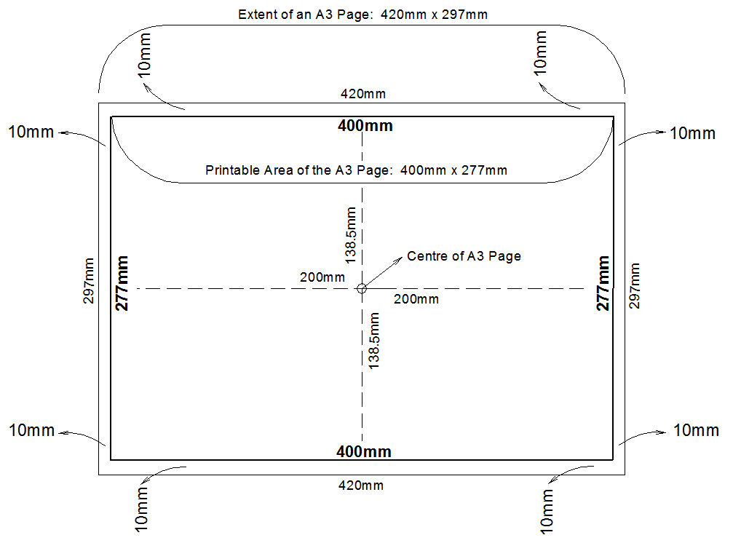

Designated Spaces for Watermarking
Designated spaces are detailed in Appendix 3. SPEAR will apply watermarks in these areas with information relevant to the plan/document.

For example, documents will be watermarked with:
- The certification and endorsement decision,
- Signing evidence for Licensed Surveyors, councils and the Surveyor-General,
- Land Use Victoria registration or approval details,
- Dealing numbers, where they are provided upon lodgement at Land Use Victoria,
- Licensed Surveyor declarations in accordance with the Surveying (Cadastral Surveys) Regulations 2015

SPEAR will automatically apply this additional information to the designated spaces when known. Text may be placed in these areas in accordance with Appendix 3, however SPEAR will remove this text by masking the area before watermarking the relevant information on top. As a result, Applicants should ensure text is not placed within 2mm of the border of any designated space.

Organisation Logo
A space of 97mm x 30mm has been allocated for the organisation logo on each sheet of the plan or abstract. Applicants should place their organisation logo in this area so that it appears on the plan or abstract PDF.
For PDFs visualised from an ePlan or Owners Corporation spreadsheet, SPEAR will apply the organisation logo.

APPENDIX 3: Template Specification 1 - ‘Plan for Certification – Front Sheet’

1

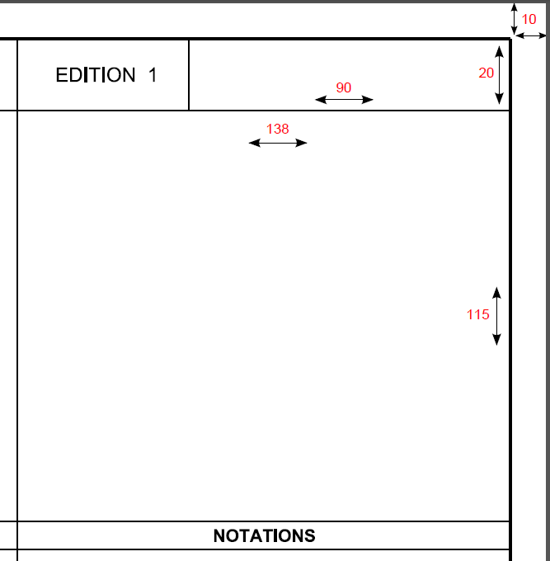
:

1

2

1. Plan / Dealing Number
A designated space of 90mm x 20mm must be allocated on the front sheet of the plan for the plan / dealing number.

The applicant must show the plan number in the designated space where known. This includes all new plan numbers and staged plans showing the stage number suffix (e.g. /S2)

NOTE: Stage 1 forms the master plan and should not include reference to /S1.
SPEAR will apply the Dealing number to the designated space for selected dealing types when lodged at Land Use Victoria, including:
- Subdivision Act - Sections 23, 24A (vesting only) and 32 (or any plan with a Section 32 component)
- Transfer of Land Act - Sections 45, 72 and 88(2). The below watermarks do not apply to these dealing types as they are not digitally signed. As a result, they will receive the dealing number watermark only.
NOTE: Edition 1 has been included in the template and should not be removed.

2
2. Certification and Endorsement
A designated space of 138mm x 115mm must be allocated on the front sheet of the plan for the Certification and Endorsement panel.
Prior to attaching the plan in SPEAR, the applicant must show the council name within the designated space on the PDF.

Once uploaded, SPEAR will add additional reference number details to this space (when known). SPEAR will subsequently apply the Certification Decision to the designated space when the plan is certified.
3. Surveyor’s Signature

3
A designated space of 90mm x 20mm must be allocated on the front sheet of the plan for the surveyor’s signature.

Prior to the plan being signed, the applicant must show the surveyor’s name and version number within the designated space on the PDF.

SPEAR will apply the digital signature and surveyor’s plan version number (entered into SPEAR by the applicant) to the designated space when the plan has been digitally signed.

NOTE: A space above the surveyor’s signature is available for the surveyor’s file reference, drawing number or any other relevant information the surveyor wishes to include.

- Land Use Victoria Registration

4
A designated space of 90mm x 20mm must be allocated on the front sheet of the plan for the Land Use Victoria registration details.

For plans without Owners Corporation schedules, this space should be left blank by the applicant on the PDF.

For plans with Owners Corporation schedules, the following statement should be included in this space (replace “X” with the total number of Owners Corporation sheets):
Owners Corporation schedules are appended to the back of this plan and are numbered sheet(s) 1 to X.

The Land Use Victoria registration details will be applied to the plan by SPEAR in the designated space when the plan is registered.

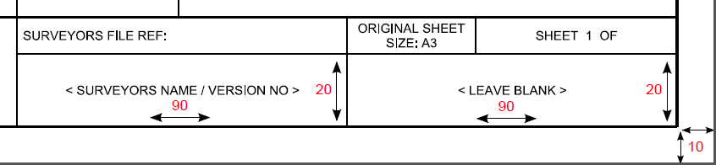

3

4

APPENDIX 3: Template Specification 2 - ‘Generic Plan – Subsequent Sheet (Portrait)’

1

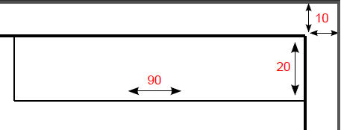

1

1. Plan / Dealing Number
A designated space of 90mm x 20mm must be allocated on each subsequent sheet of the plan for the plan / dealing number.

The applicant must show the plan number in the designated space where known. This includes all new plan numbers and staged plans showing the stage number suffix (e.g. /S2)

NOTE: Stage 1 forms the master plan and should not include reference to /S1.

SPEAR will apply the Dealing number to the designated space for selected dealing types when lodged at Land Use Victoria or accepted by Surveyor General Victoria, including:
- Section 23
- Section 24A (vesting order)
- Section 32 (or any plan with a section 32 component)
- TLA applications
- Boundary Plans
- Crown Survey applications
- Re-Establishments

The watermarks on the following page do not apply to the below dealing types as they are not digitally signed. As a result, these dealing types will receive the dealing number watermark only:
- Transfer of Land Act - Sections 45, 72-2 and 88-2
- Local Government Act applications
- Title Plan (TLA and LGA applications)
- Subdivision Act applications - Sections 38B and 38C
- Major Transport Projects Facilitation Act

2. Surveyor’s Signature

2
A designated space of 90mm x 20mm must be allocated on each subsequent sheet of the plan for the surveyor’s signature.

Prior to the plan being signed, the applicant must show the surveyor’s name and version number within the designated space on the PDF.

SPEAR will apply the digital signature and surveyor’s plan version number (entered into SPEAR by the applicant) to the designated space when the plan has been digitally signed.

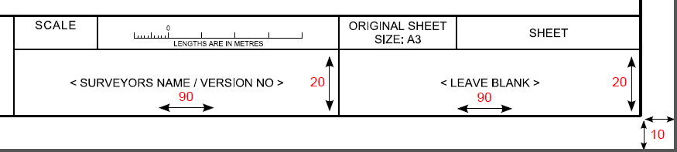

3. Land Use Victoria/Surveyor General Victoria/council

3
A designated space of 90mm x 20mm must be allocated on each subsequent sheet of the plan for the council, Land Use Victoria or Surveyor General Victoria.

This should be left blank by the applicant on the PDF.

For certification applications, SPEAR will apply the council name and SPEAR reference number to the designated space when the plan is uploaded. SPEAR will subsequently apply the council signature to the designated space when the plan is certified.

For Boundary Plan applications, SPEAR will apply the Land Use Victoria approval to the designated space when the Boundary Plan is approved.

For Crown Survey and Re-Establishment applications, SPEAR will apply the Surveyor General Victoria signing/acceptance details to the designated space when the plan is certified or accepted.

3

2

APPENDIX 3: Template Specification 3 - ‘Generic Plan – Subsequent Sheet (Landscape)’

All requirements for this template are as per APPENDIX 3: Template Specification 2 - ‘Generic Plan – Subsequent Sheet (Portrait)’ above.

APPENDIX 3: Template Specification 4 - ‘Abstract of Field Records – Front Sheet’

1

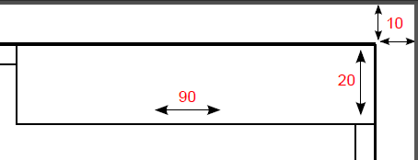

1

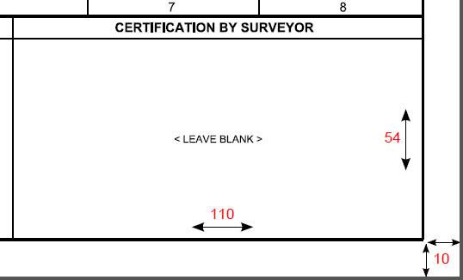
1. Plan / Dealing Number

2
A designated space of 90mm x 20mm must be allocated on the front sheet of the abstract of field records for the plan / dealing number.

The applicant must show the plan number in the designated space where known. This includes all new plan numbers and staged plans showing stage number suffix (e.g. /S2)

NOTE: Stage 1 forms the master plan and should not include reference to /S1.

SPEAR will apply the Dealing number to the designated space for selected dealing types when lodged at Land Use Victoria or accepted by Surveyor General Victoria, including:
- Section 32 (or any plan with a section 32 component)
- TLA and LGA applications
- Boundary Plans
- Crown Survey applications

2
2. Certification by Surveyor
A designated space of 110mm x 54mm must be allocated on the front sheet of the abstract of field records for the certification by surveyor.

This should be left blank by the applicant on the PDF.

SPEAR will apply the certification by surveyor text to the designated space when the relevant information has been collected in SPEAR.

APPENDIX 3: Template Specification 5 - ‘Abstract of Field Records – Subsequent Sheet’

1

1

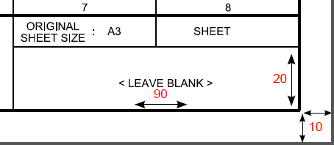

2

1. Plan / Dealing Number
A designated space of 90mm x 20mm must be allocated on the front sheet of the abstract of field records for the plan / dealing number.

The applicant must show the plan number in the designated space where known. This includes all new plan numbers and staged plans showing the stage number suffix (e.g. /S2)

NOTE: Stage 1 forms the master plan and should not include reference to /S1.

SPEAR will apply the Dealing number to the designated space for selected dealing types when lodged at Land Use Victoria or accepted by Surveyor General Victoria, including:
- Section 32 (or any plan with a section 32 component)
- TLA and LGA applications
- Boundary Plans
- Crown Survey applications

2
2. Surveyor’s Signature
A designated space of 90mm x 20mm must be allocated on each subsequent sheet of the abstract of field records for the surveyor’s signature.

This should be left blank by the applicant on the PDF.

SPEAR will apply the digital signature to the designated space when the abstract of field records has been signed.

APPENDIX 3: Template Specification 6 - ‘Other Plan – Front Sheet’

1

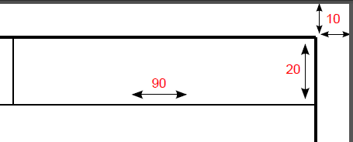

1

1. Plan / Dealing Number
A designated space of 90mm x 20mm must be allocated on the front sheet of the plan for the dealing number.

This should be left blank by the applicant on the PDF.

SPEAR will apply the Dealing number to the designated space for selected dealing types when lodged at Land Use Victoria or accepted by Surveyor General Victoria, including:
- TLA applications (except 98CA)
- Boundary Plans
- Crown Survey applications
- Re-Establishments

The watermarks on the following page do not apply to the below dealing types as they are not digitally signed. As a result, these dealing types will receive the dealing number watermark only:
- Local Government Act applications
- Title Plan (TLA and LGA applications)
- Subdivision Act applications - Sections 38B and 38C
- Major Transport Projects Facilitation Act

2. Certification by Surveyor

2
A designated space of 180mm x 30mm must be allocated on the front sheet of the plan for the certification by surveyor.

This should be left blank by the applicant on the PDF.

SPEAR will apply the certification by surveyor text to the designated space when the relevant information has been collected in SPEAR.

3
3. Surveyor’s Signature
A designated space of 90mm x 20mm must be allocated on the front sheet of the plan for the surveyor’s signature.

Prior to the plan being signed, the applicant must show the surveyor’s name and version number within the designated space on the PDF.

SPEAR will apply the digital signature and surveyor’s plan version number (entered in SPEAR by the applicant) to the designated space when the plan has been digitally signed.
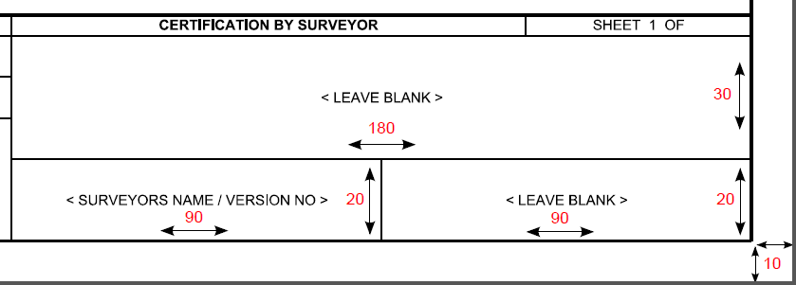

2

3

4

NOTE: A space above the organisation logo is available for the surveyor’s file reference, drawing number or any other relevant information the surveyor wishes to include.

4
4. Land Use Victoria/Surveyor General Victoria
A designated space of 90mm x 20mm must be allocated on the front sheet of the plan for Land Use Victoria or Surveyor General Victoria.

This should be left blank by the applicant on the PDF.

For Boundary Plans, SPEAR will apply the Land Use Victoria approval to the designated space when the Boundary Plan is approved.

For Crown Survey and Re-Establishment applications, SPEAR will apply the Surveyor General Victoria signing/acceptance details to the designated space when the plan is certified or accepted.

APPENDIX 3: Template Specification 7 – ‘Surveyor’s Report’
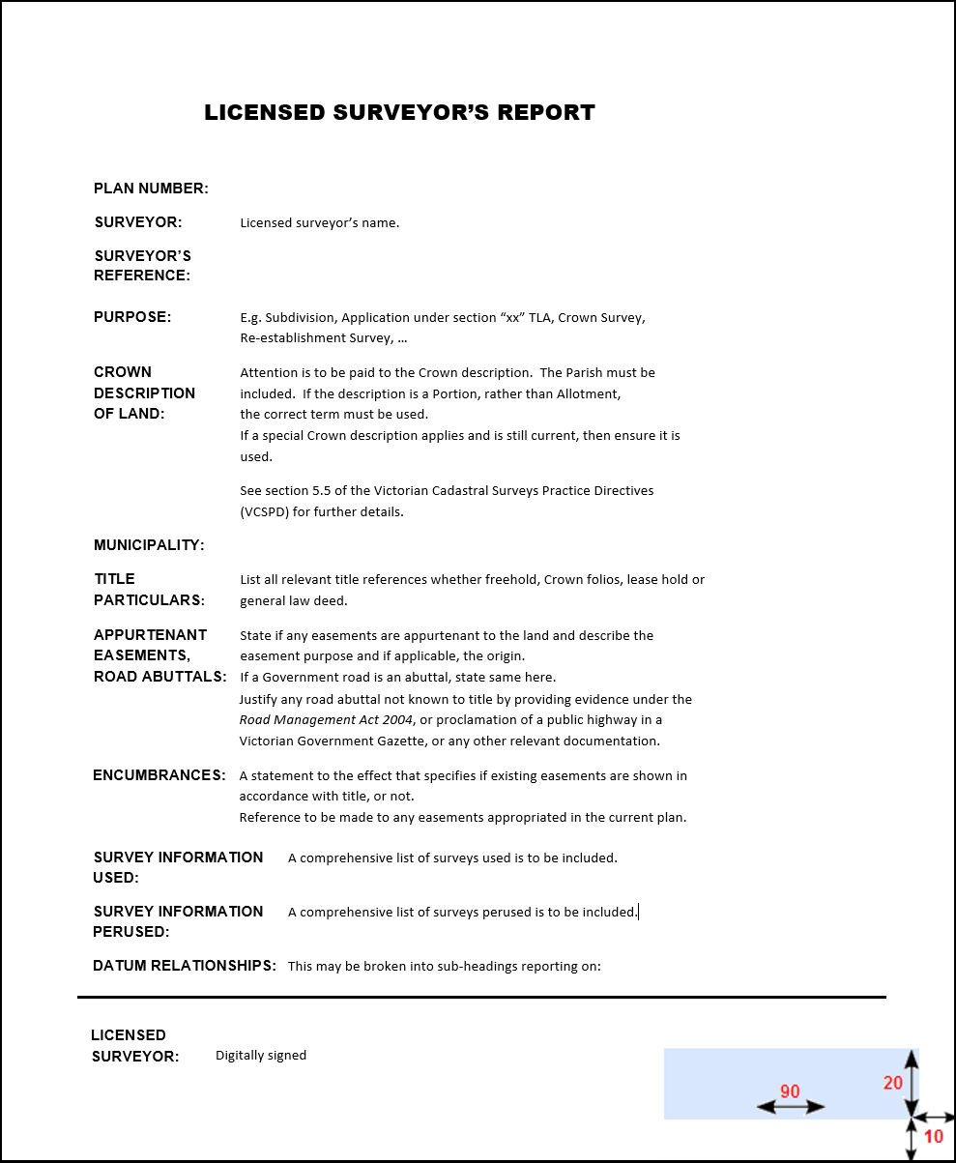

2

1

There is no standard template for the surveyor’s report, however it must meet the following requirements.

1
1. Digital Signature
SPEAR will apply the digital signature to the bottom 10mm margin on each page. Ensure that letterhead and organisation details do not obscure the margin area of the document.

2
1. Plan / Dealing Number
A designated space of 90mm x 20mm must be allocated on each sheet of the surveyor’s report for the plan / dealing number. Ensure that organisation logos, letterheads or details do not obscure the designated space on each page of the document.

The applicant must include the plan number on the surveyor’s report where known. This includes all new plan numbers, existing plan numbers (section 32) and staged plans showing the stage number suffix (e.g. /S2).

NOTE: Stage 1 forms the master plan and should not include reference to /S1.

SPEAR will apply the Dealing number to the designated space for selected dealing types when lodged at Land Use Victoria or accepted by Surveyor General Victoria, including:
- Subdivision Act - Section 32 (or any plan with a section 32 component), 38B and 38C
- TLA applications (except 98CA)
- Local Government Act applications
- Boundary Plans
- Crown Survey applications
- Re-Establishments

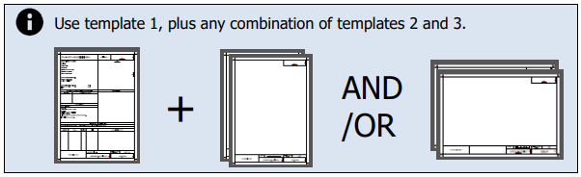
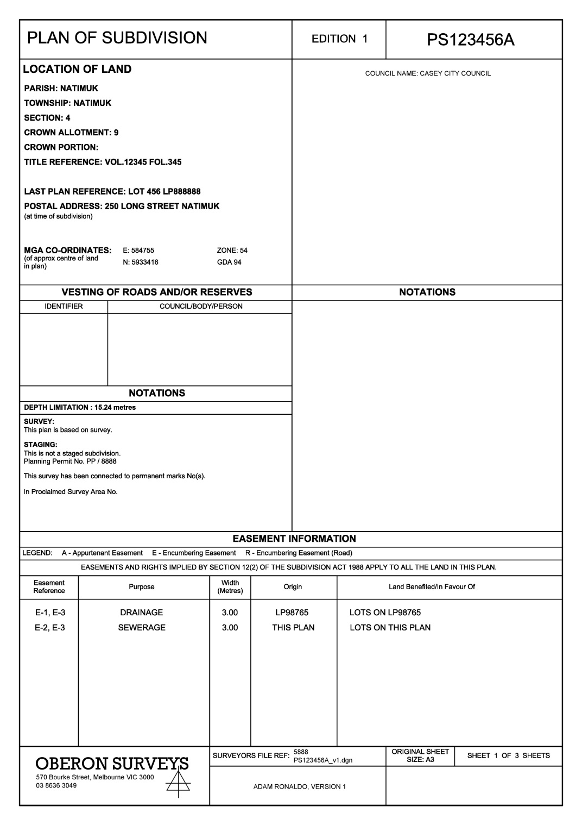
Example A: Plan of Subdivision (prepared)

Plan of Subdivision – Front Sheet (template 1)
The following has been prepared by the applicant prior to uploading the plan to SPEAR.

Plan Number - A new plan number is being used and has been shown by the applicant in the designated space.

Certification and Endorsement - The council’s name has been shown by the applicant in the designated space.

Plan Heading - The angled brackets in ‘Plan of <Subdivision>’ have been removed by the applicant. Note: The relevant Subdivision Act dealing type should also be included (except for Section 22 plans) – e.g. ‘under Section 35 of the Subdivision Act 1988.’

Organisation Logo - The organisation logo has been added by the applicant.

Surveyor’s Signature - The surveyor’s name and version number has been shown by the applicant in the designated space. Additional reference information has been added to the box above the designated space by the applicant and SPEAR will not apply a watermark over this.

Land Use Victoria Registration – As there is no Owners Corporation schedule, the designated space has been left blank by the applicant.
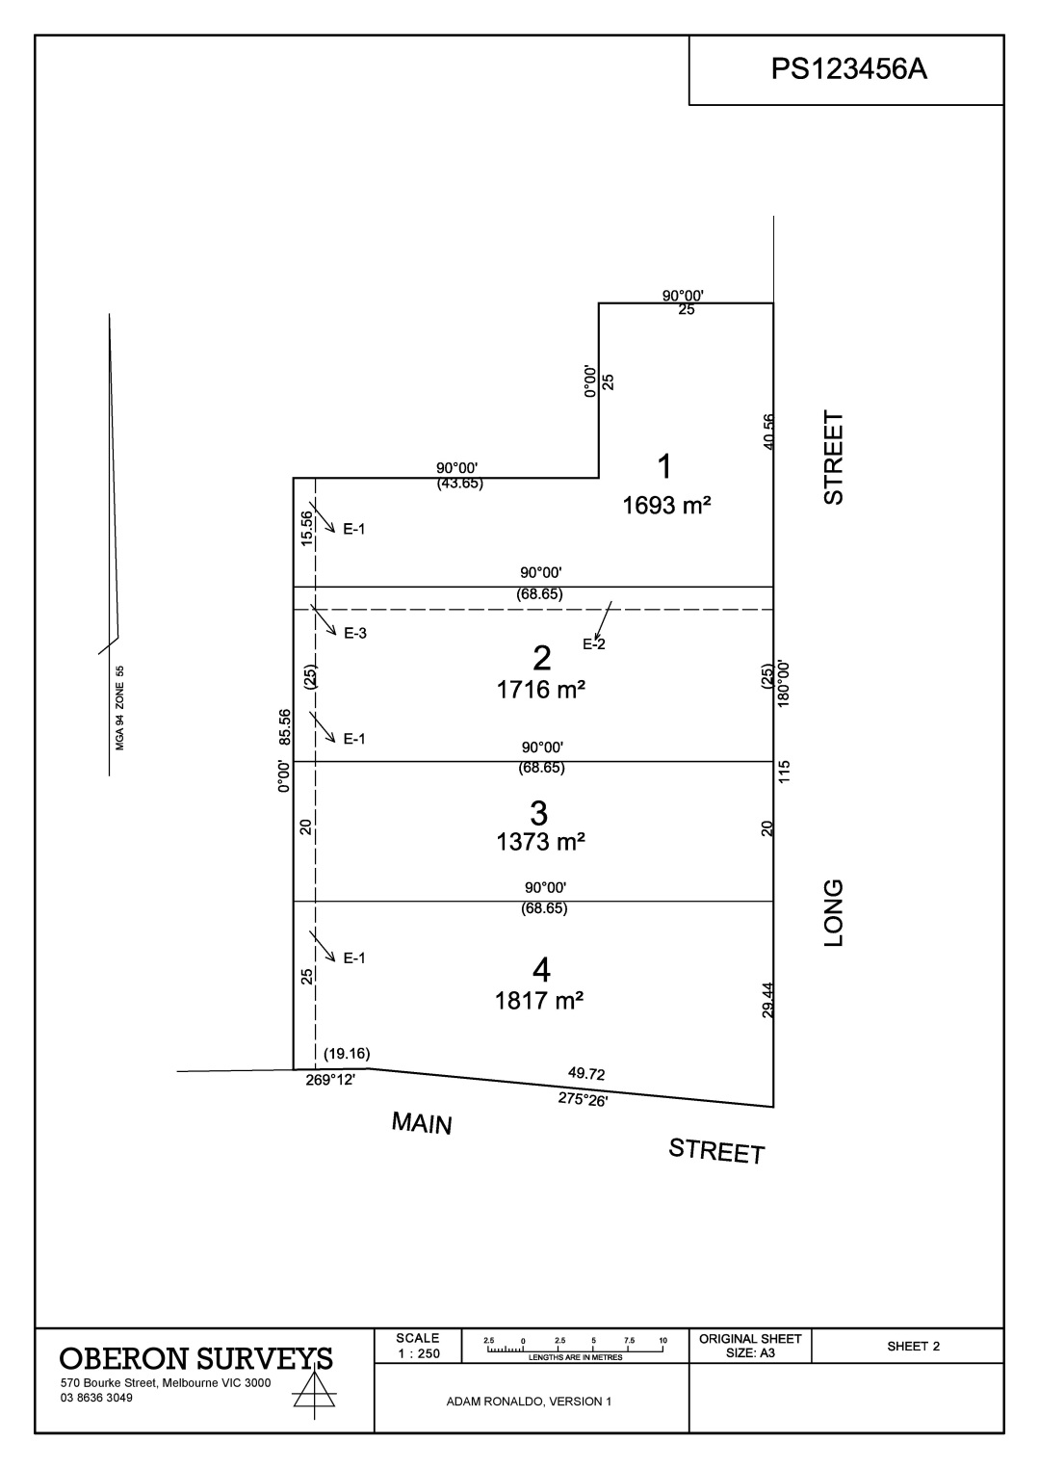

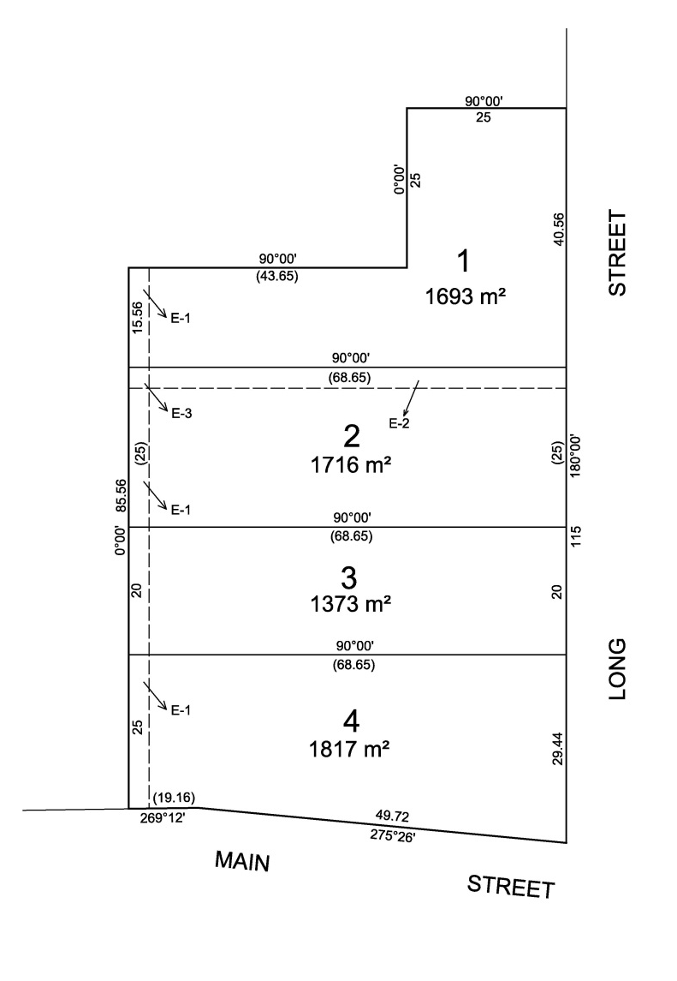

Plan of Subdivision – Subsequent Sheet (portrait - template 2)
The following has been prepared by the applicant prior to uploading the plan to SPEAR.

Plan Number - A new plan number is being used and has been shown by the applicant in the designated space.

Organisation Logo - The organisation logo has been added by the applicant.

Surveyor’s Signature - The surveyor’s name and version number has been shown by the applicant in the designated space.

Council Signature – The designated space has been left blank by the applicant.

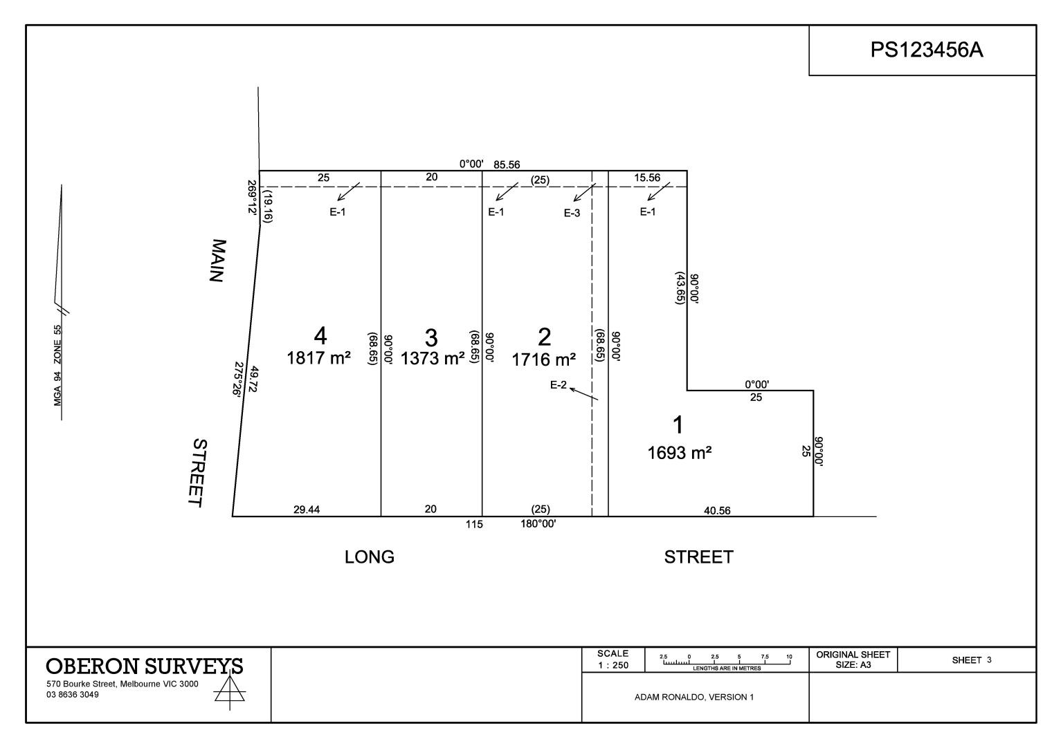

4

Plan of Subdivision – Subsequent Sheet (landscape – template 3)
The following has been prepared by the applicant prior to uploading the plan to SPEAR.

Council Signature – The designated space has been left blank by the applicant.

Plan Number - A new plan number is being used and has been shown by the applicant in the designated space.

Surveyor’s Signature - The surveyor’s name and version number has been shown by the applicant in the designated space.

Organisation Logo - The organisation logo has been added by the applicant.

Example A: Plan of Subdivision (completed)

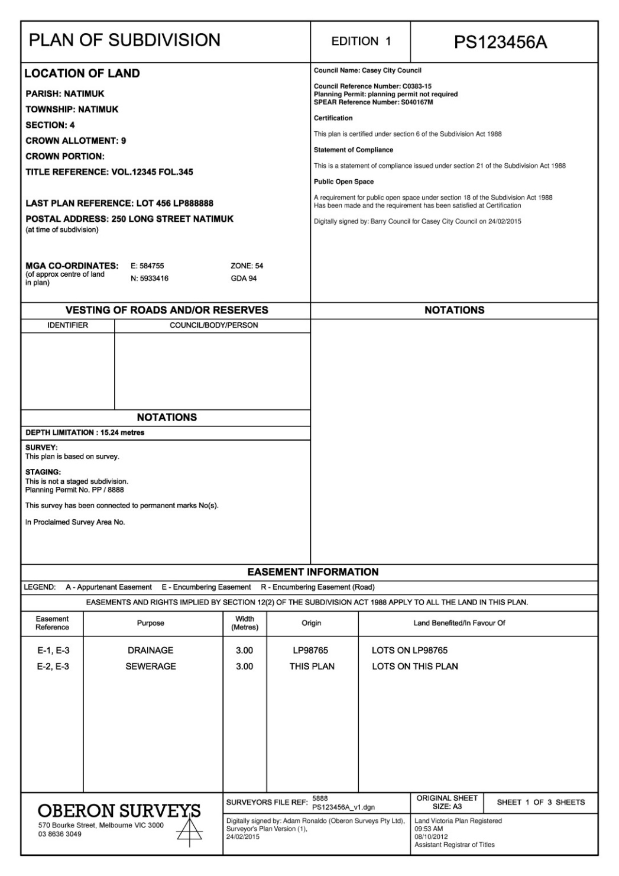

Plan of Subdivision – Front Sheet (template 1)
The following has been watermarked by SPEAR at or before registration of the plan.

Certification and Endorsement - SPEAR will apply the council reference numbers when the plan is uploaded. When certified, SPEAR will add the certification and endorsement information.
Surveyor’s Signature - SPEAR will apply the digital signature in the designated space when the plan is signed.

Land Use Victoria Registration - SPEAR will apply the Land Use Victoria registration details in the designated space when the plan is registered.

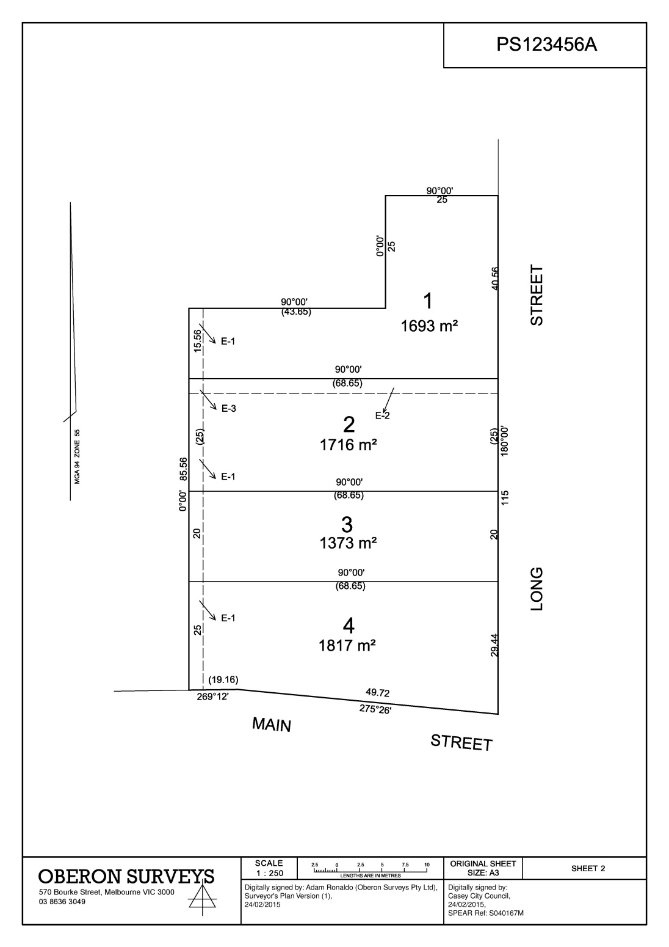

Plan of Subdivision – Subsequent Sheet (portrait – template 2)
The following has been watermarked by SPEAR at or before registration of the plan.

Surveyor’s Signature - SPEAR will apply the digital signature in the designated space when the plan is signed.

Council Signature - SPEAR will apply the council’s name and SPEAR reference number in the designated space when the plan is uploaded. When certified, SPEAR will add the council signature.

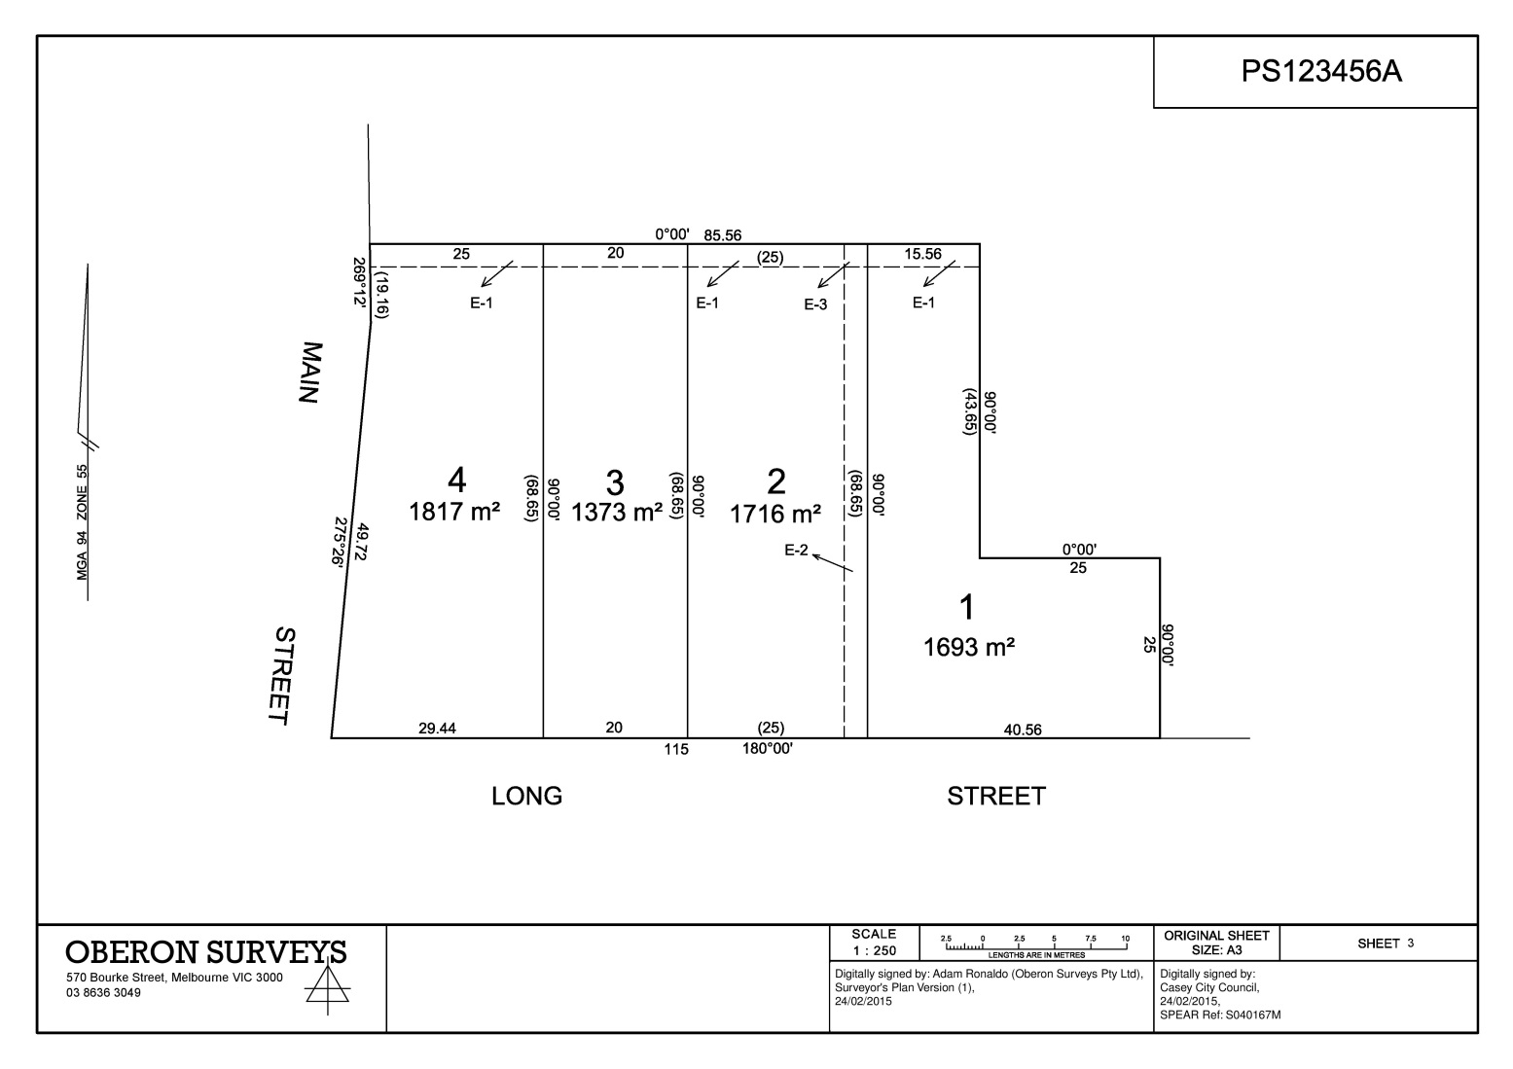

4

Plan of Subdivision – Subsequent Sheet (landscape – template 3)
The following has been watermarked by SPEAR at or before registration of the plan.

Council Signature - SPEAR will apply the council’s name and SPEAR reference number in the designated space when the plan is uploaded. When certified, SPEAR will add the council signature.

Surveyor’s Signature - SPEAR will apply the digital signature in the designated space when the plan is signed.

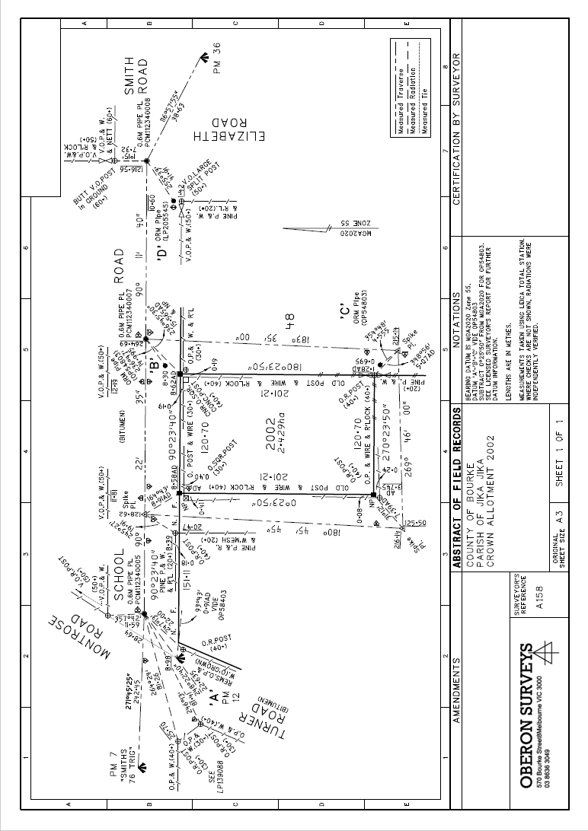
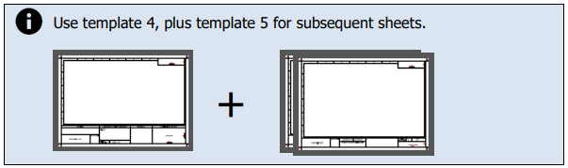
Example B – Abstract of Field Records (prepared)

PS123456A

Abstract of Field Records - Front Sheet (template 4)
The following has been prepared by the applicant prior to uploading the abstract of field records to SPEAR.

Certification by Surveyor – The designated space has been left blank by the applicant.

Plan Number - A new plan number is being used and has been shown by the applicant in the designated space.

Organisation Logo - The organisation logo has been added by the applicant.

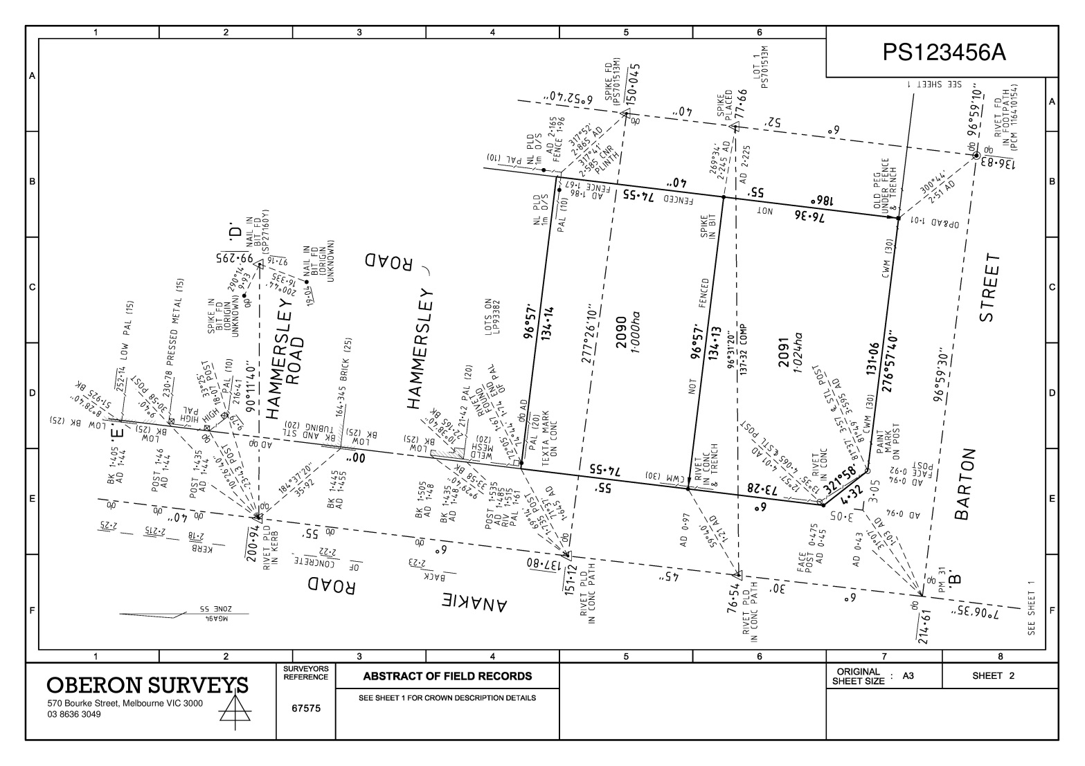
Abstract of Field Records - Subsequent Sheet (template 5)
The following has been prepared by the applicant prior to uploading the abstract of field records to SPEAR.

Surveyor’s Signature – The designated space has been left blank by the applicant.

Plan Number - A new plan number is being used and has been shown by the applicant in the designated space.

Organisation Logo - The organisation logo has been added by the applicant.

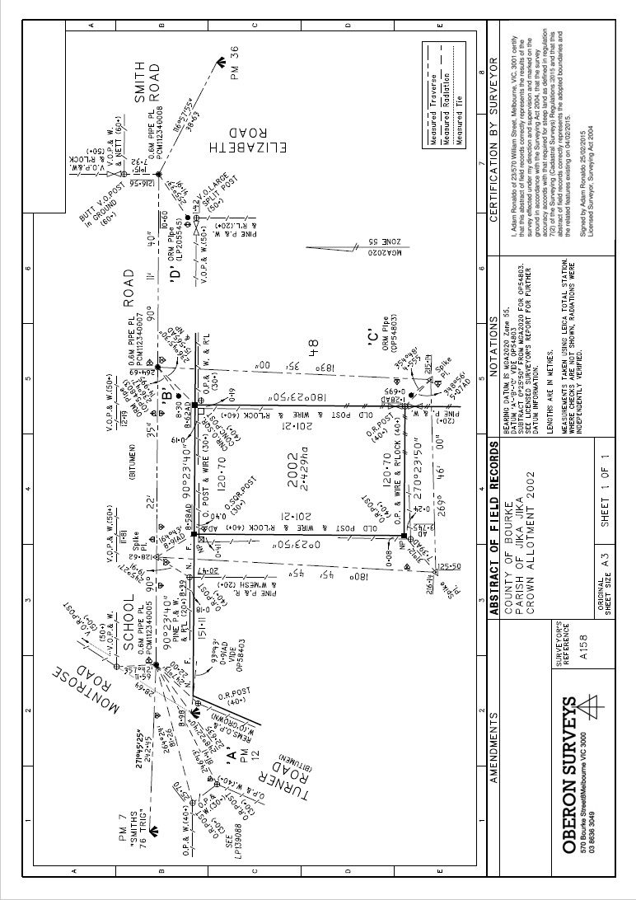
Example B – Abstract of Field Records (completed)

Abstract of Field Records - Front Sheet (template 4)
PS123456A
The following has been watermarked by SPEAR when the abstract of field records has been signed.

Certification by Surveyor - SPEAR will apply the certification by surveyor text in the designated space when the relevant information has been collected in SPEAR.

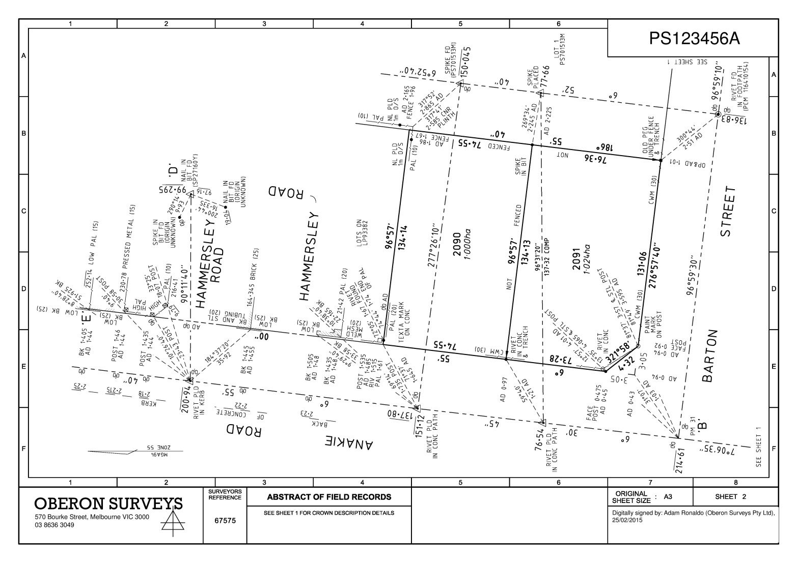
Abstract of Field Records - Subsequent Sheet (template 5)
The following has been watermarked by SPEAR when the abstract of field records has been signed.

Surveyor’s Signature - SPEAR will apply the digital signature to the designated space when the abstract of field records has been signed.

Example C – Surveyor’s Report (prepared)
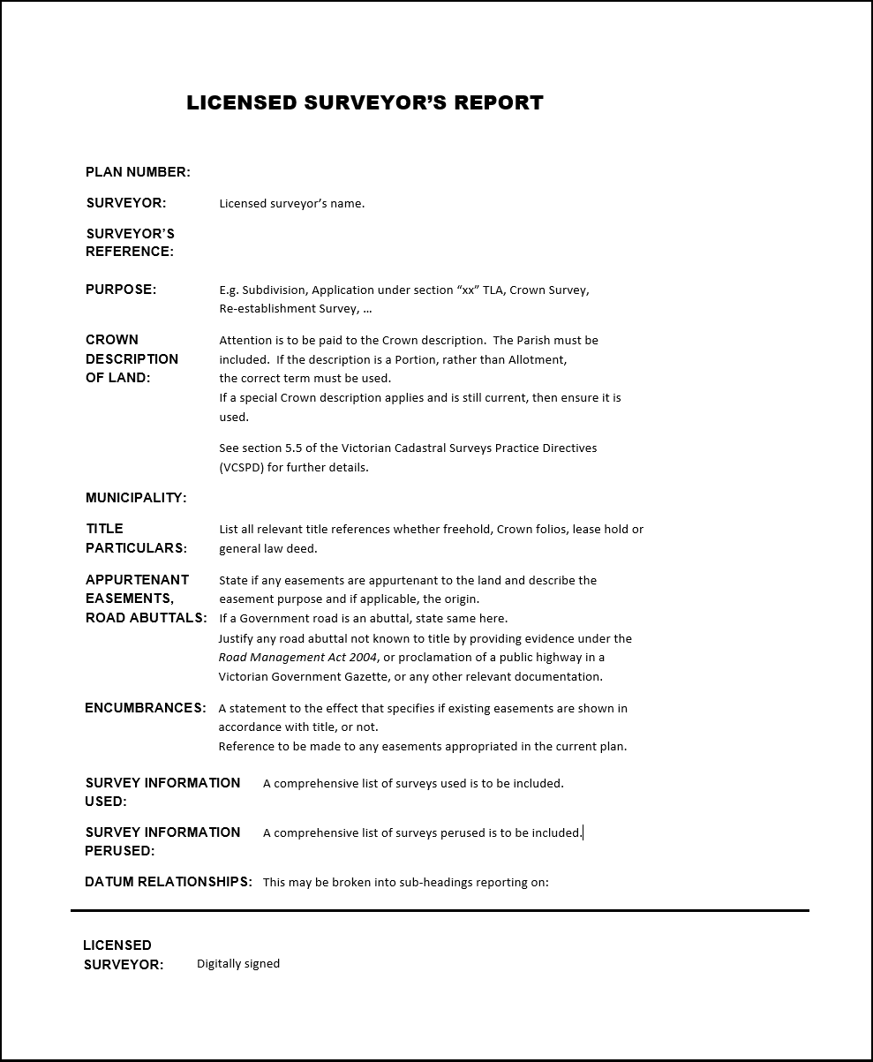

Surveyor’s Report
The following has been prepared by the applicant prior to uploading the surveyor’s report to SPEAR.

Surveyor’s Signature – The bottom 10mm margin has been left unobstructed by the applicant to accommodate the digital signature.

Dealing Number - A new plan number is being used and has been shown by the applicant in the designated space.
PS123456A

Example C – Surveyor’s Report (completed)
Digitally signed by: Bob Smith (Oberon Surveys) SPEAR Ref: S040160T 12/12/2014

Surveyor’s Report
The following has been watermarked by SPEAR when the surveyor’s report has been signed.

Surveyor’s Signature – SPEAR will apply the digital signature to the bottom 10mm margin when the surveyor’s report has been signed.
PS123456A

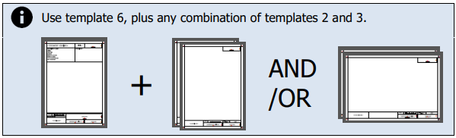
Example D – Boundary Plan (prepared)
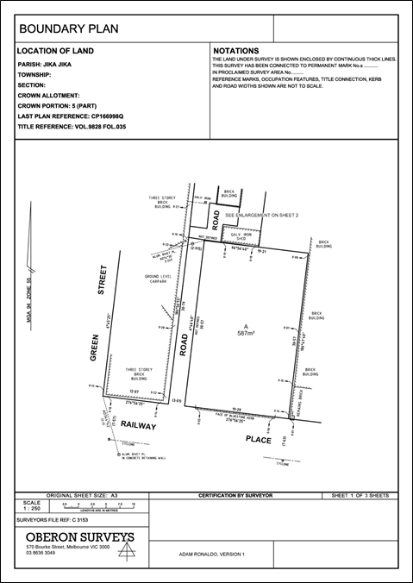

Boundary Plan – Front Sheet (template 6)
The following has been prepared by the applicant prior to uploading the plan to SPEAR.

Dealing Number – A dealing number will be supplied by Land Use Victoria upon lodgement. The designated space has been left blank by the applicant.

Document Heading – The text ‘<Document heading>’ has been replaced with ‘Boundary Plan’ by the applicant.

Organisation Logo - The organisation logo has been added by the applicant.
Additional reference information has been added to the box above the logo by the applicant and SPEAR will not apply a watermark over this.

Surveyor’s Signature - The surveyor’s name and version number has been shown by the applicant in the designated space.

Certification by Surveyor – The designated space has been left blank by the applicant.

Land Use Victoria Approval – The designated space has been left blank by the applicant.

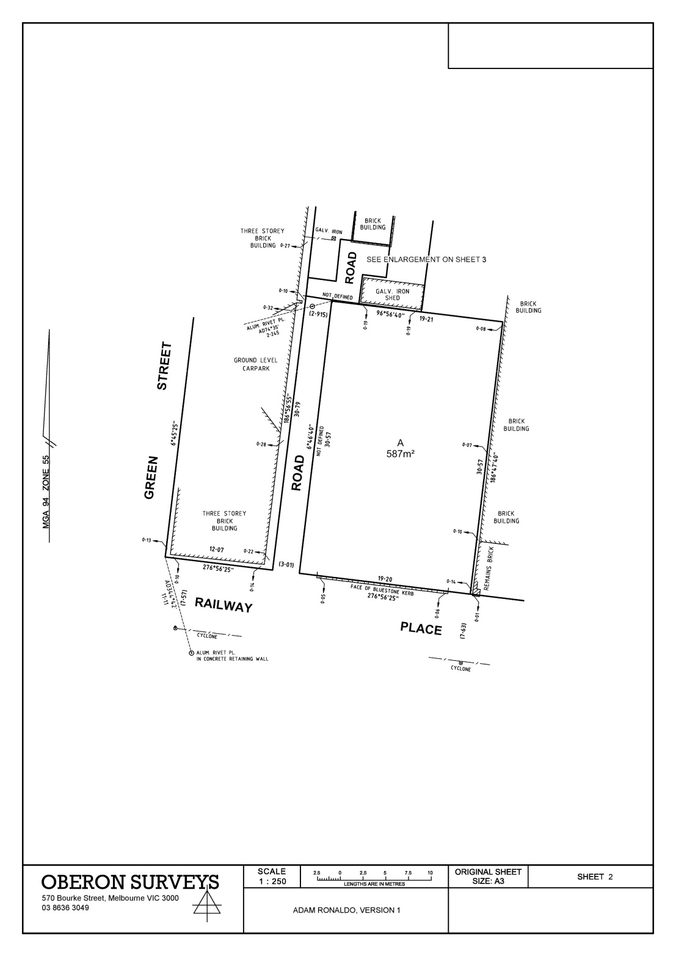

Boundary Plan – Subsequent Sheet (portrait - template 2)
The following has been prepared by the applicant prior to uploading the plan to SPEAR.

Dealing Number – A dealing number will be supplied by Land Use Victoria upon lodgement. The designated space has been left blank by the applicant.

Organisation Logo - The organisation logo has been added by the applicant.

Surveyor’s Signature - The surveyor’s name and version number has been shown by the applicant in the designated space.

Land Use Victoria Approval – The designated space has been left blank by the applicant.

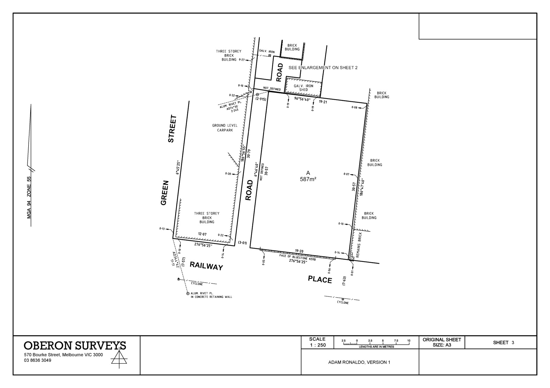

Boundary Plan – Subsequent Sheet (landscape - template 3)
The following has been prepared by the applicant prior to uploading the plan to SPEAR.

Land Use Victoria Approval – The designated space has been left blank by the applicant.

Dealing Number – A dealing number will be supplied by Land Use Victoria upon lodgement. The designated space has been left blank by the applicant.

Surveyor’s Signature - The surveyor’s name and version number has been shown by the applicant in the designated space.

Organisation Logo - The organisation logo has been added by the applicant.

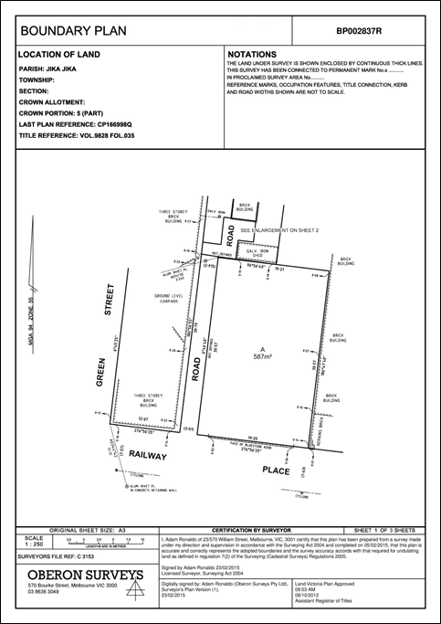
Example D – Boundary Plan (completed)

Boundary Plan – Front Sheet (template 6)
The following has been watermarked by SPEAR at or before approval of the plan.

Dealing Number – SPEAR will apply the dealing number in the designated space when the application is lodged at Land Use Victoria.

Surveyor’s Signature - SPEAR will apply the digital signature in the designated space when the plan is signed.

Certification by Surveyor - SPEAR will apply the certification by surveyor text in the designated space when the relevant information has been collected in SPEAR.

Land Use Victoria Approval - SPEAR will apply the Land Use Victoria approval details in the designated space when the plan is approved.

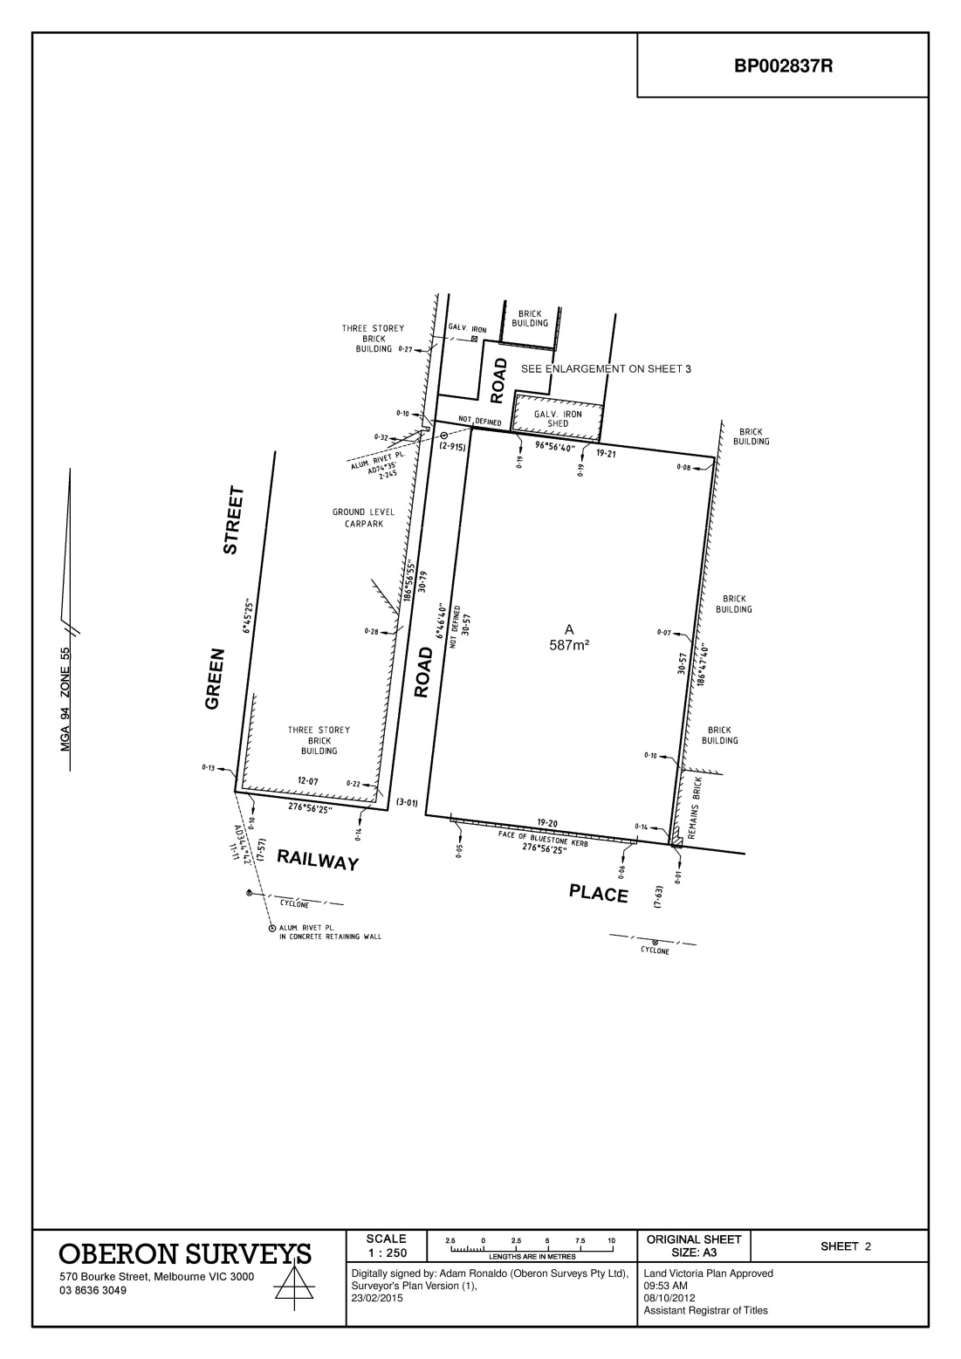

Boundary Plan – Subsequent Sheet (portrait - template 2)
The following has been watermarked by SPEAR at or before approval of the plan.

Dealing Number – SPEAR will apply the dealing number in the designated space when the application is lodged at Land Use Victoria.

Surveyor’s Signature - SPEAR will apply the digital signature in the designated space when the plan is signed.

Land Use Victoria Approval - SPEAR will apply the Land Use Victoria approval details in the designated space when the plan is approved.

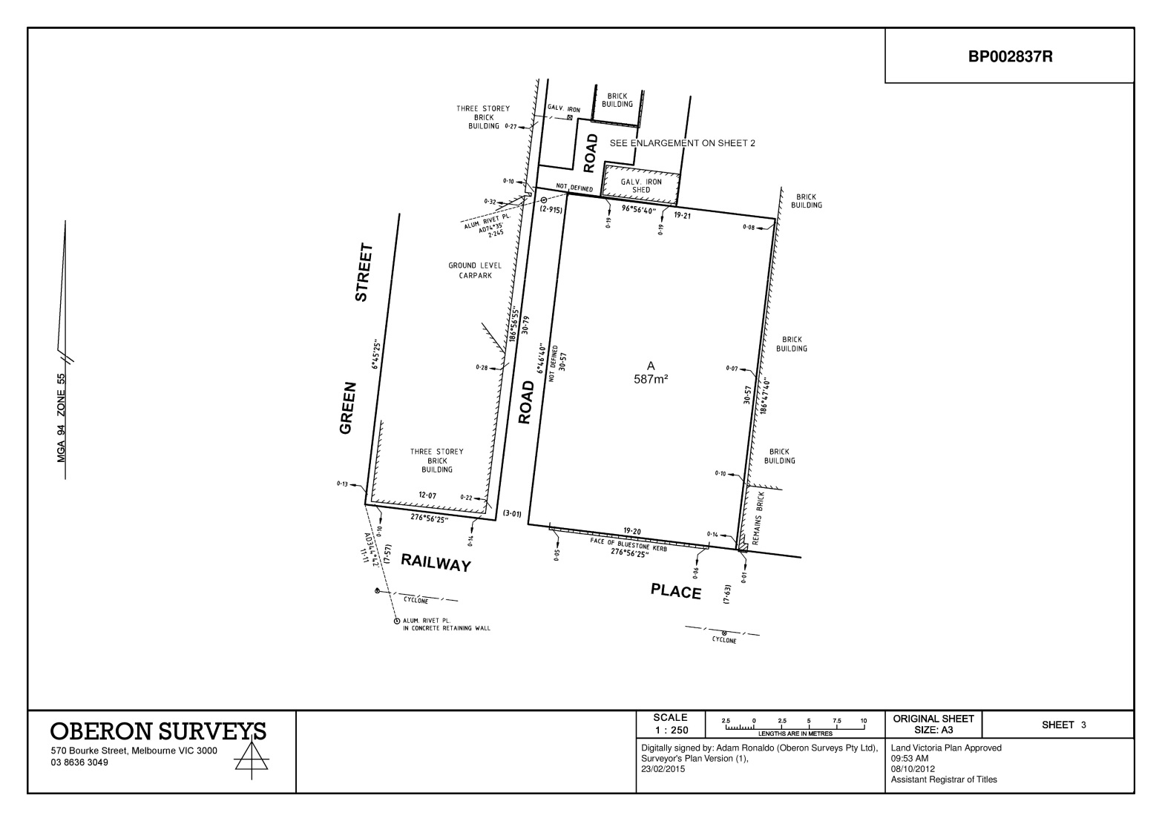

Boundary Plan – Subsequent Sheet (landscape - template 3)
The following has been watermarked by SPEAR at or before approval of the plan.

Land Use Victoria Approval - SPEAR will apply the Land Use Victoria approval details in the designated space when the plan is approved.

Dealing Number – SPEAR will apply the dealing number in the designated space when the application is lodged at Land Use Victoria.

Surveyor’s Signature - SPEAR will apply the digital signature in the designated space when the plan is signed.

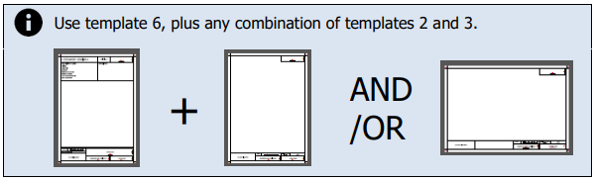
Example E – Plan of Survey (prepared)
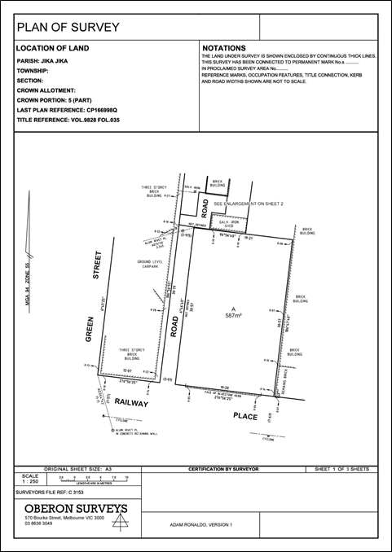

Plan of Survey (TLA) – Front Sheet (template 6)
The following has been prepared by the applicant prior to uploading the plan to SPEAR.

Dealing Number – A dealing number will be supplied by Land Use Victoria upon lodgement. The designated space has been left blank by the applicant.

Document Heading – The text ‘<Document heading>’ has been replaced with ‘Plan of Survey’ by the applicant.

Organisation Logo - The organisation logo has been added by the applicant.
Additional reference information has been added to the box above the logo by the applicant and SPEAR will not apply a watermark over this.

Surveyor’s Signature - The surveyor’s name and version number has been shown by the applicant in the designated space.

Certification by Surveyor – The designated space has been left blank by the applicant.

Land Use Victoria Approval – The designated space has been left blank by the applicant.

Plan of Survey (TLA) – Subsequent Sheet (portrait - template 2)
The following has been prepared by the applicant prior to uploading the plan to SPEAR.

Dealing Number – A dealing number will be supplied by Land Use Victoria upon lodgement. The designated space has been left blank by the applicant.

Organisation Logo - The organisation logo has been added by the applicant.

Surveyor’s Signature - The surveyor’s name and version number has been shown by the applicant in the designated space.

Land Use Victoria Approval – The designated space has been left blank by the applicant.

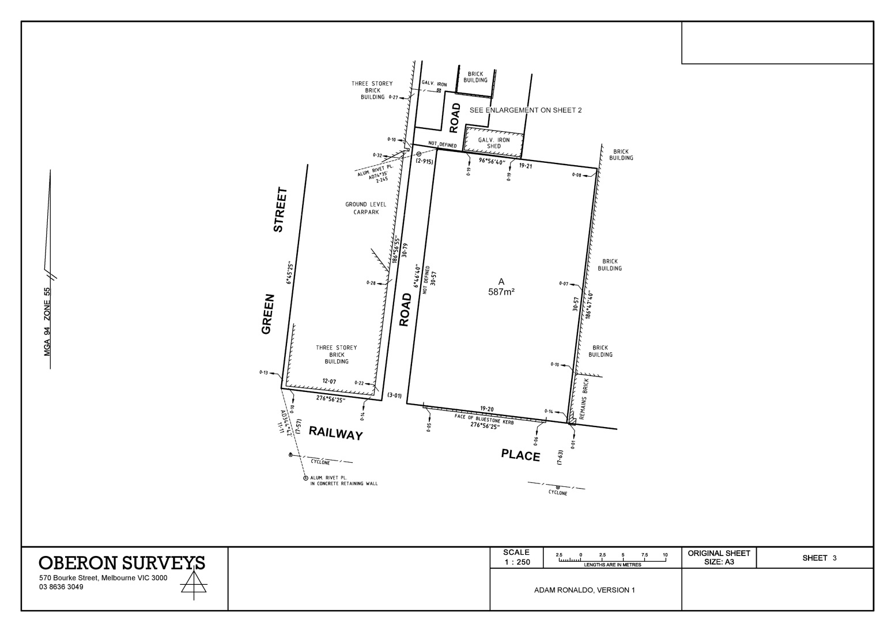

Plan of Survey (TLA) – Subsequent Sheet (landscape - template 3)
The following has been prepared by the applicant prior to uploading the plan to SPEAR.

Land Use Victoria Approval – The designated space has been left blank by the applicant.

Dealing Number – A dealing number will be supplied by Land Use Victoria upon lodgement. The designated space has been left blank by the applicant.

Surveyor’s Signature - The surveyor’s name and version number has been shown by the applicant in the designated space.

Organisation Logo - The organisation logo has been added by the applicant.

Example E – Plan of Survey (completed)
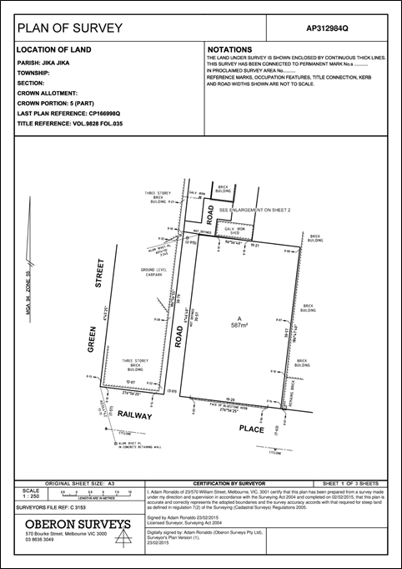

Plan of Survey (TLA) – Front Sheet (template 6)
The following has been watermarked by SPEAR at or before approval of the plan.

Dealing Number – SPEAR will apply the dealing number in the designated space when the application is lodged at Land Use Victoria.

Surveyor’s Signature - SPEAR will apply the digital signature in the designated space when the plan is signed.

Certification by Surveyor - SPEAR will apply the certification by surveyor text in the designated space when the relevant information has been collected in SPEAR.

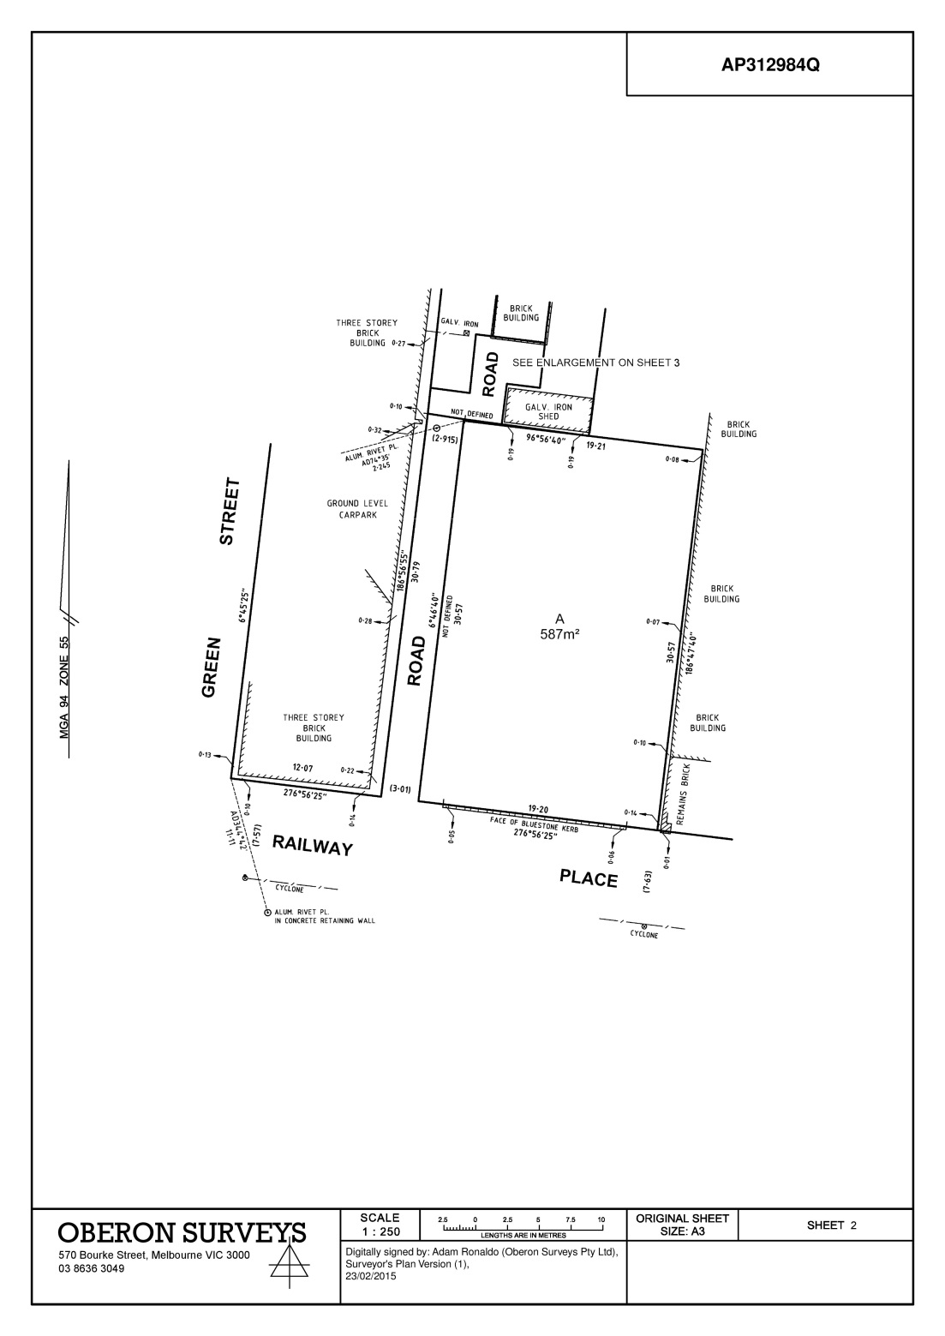

Plan of Survey (TLA) – Subsequent Sheet (portrait - template 2)
The following has been watermarked by SPEAR at or before approval of the plan.

Dealing Number – SPEAR will apply the dealing number in the designated space when the application is lodged at Land Use Victoria.

Surveyor’s Signature - SPEAR will apply the digital signature in the designated space when the plan is signed.

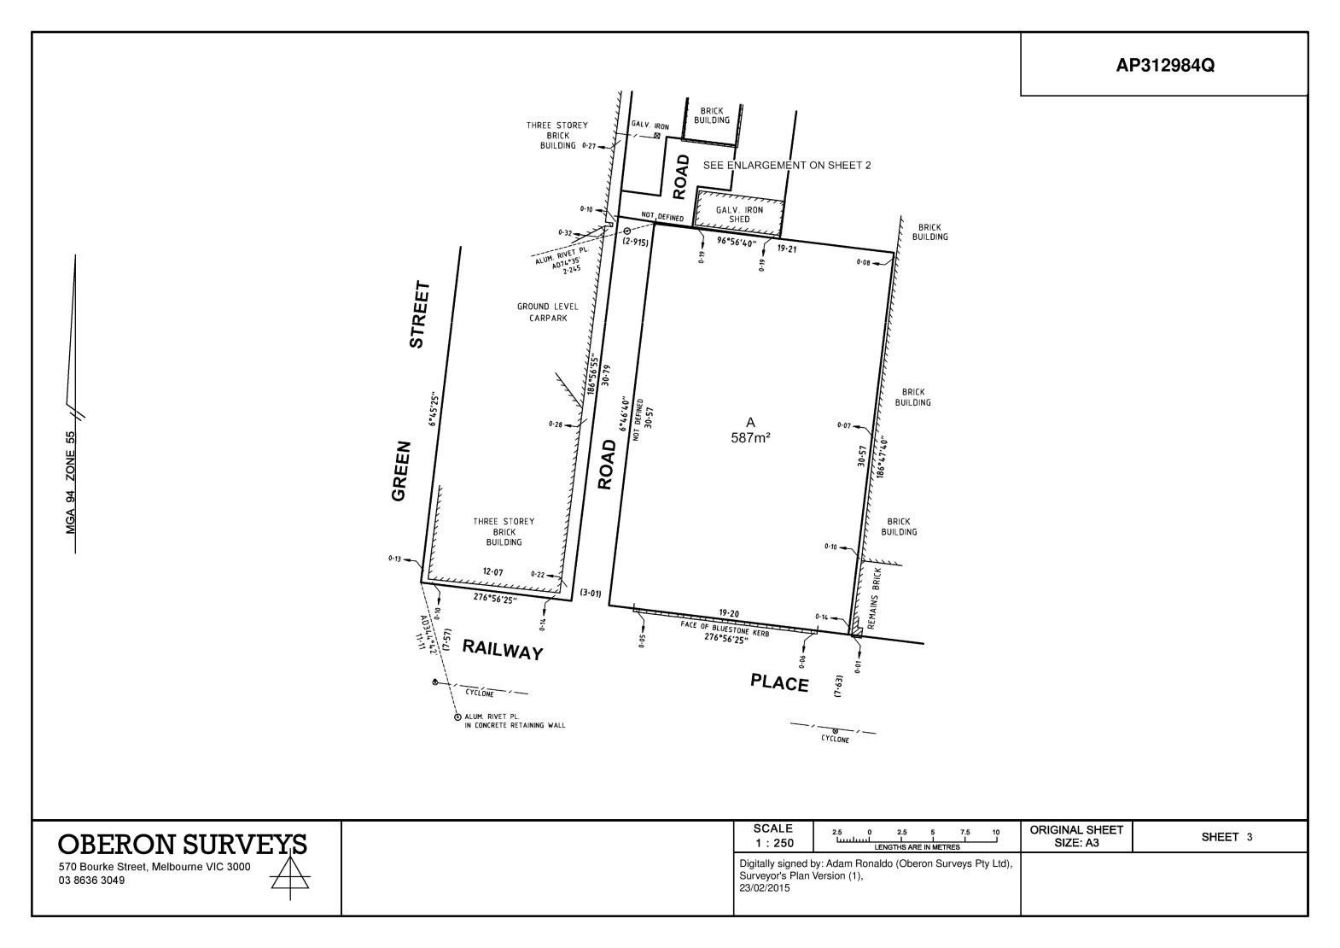

Plan of Survey (TLA) – Subsequent Sheet (landscape - template 3)
The following has been watermarked by SPEAR at or before approval of the plan.

Dealing Number – SPEAR will apply the dealing number in the designated space when the application is lodged at Land Use Victoria.

Surveyor’s Signature - SPEAR will apply the digital signature in the designated space when the plan is signed.

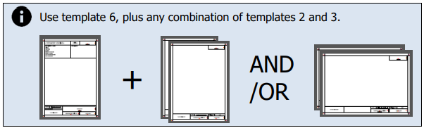
Example F - Plan of Crown Allotment (prepared)

Plan of Crown Allotment – Front Sheet (template 6)
The following has been prepared by the applicant prior to uploading the plan to SPEAR.

Dealing Number - The designated space has been left blank by the applicant.

Document Heading - The text ‘<Document heading>’ has been replaced with ‘Plan of Crown Allotment’ by the applicant.

Organisation Logo - In lieu of the organisation logo, Surveyor General Victoria details have been added by the applicant in a reduced space of 97mm x 20mm.
Additional reference information has been added to the box above this by the applicant and SPEAR will not apply a watermark over this. An ‘S’ has been shown by the applicant as the plan is supported by an Abstract of Field Records and Surveyor’s Report (otherwise this would be ‘NS’).

Surveyor’s Signature - The surveyor’s name and version number has been shown by the applicant in the designated space.

Certification by Surveyor – The designated space has been left blank by the applicant.

SGV Approval – The designated space has been left blank by the applicant.

Plan of Crown Allotment – Subsequent Sheet (portrait - template 2)
The following has been prepared by the applicant prior to uploading the plan to SPEAR.

Dealing Number - The designated space has been left blank by the applicant.

Organisation Logo - In lieu of the organisation logo, Surveyor General Victoria details have been added by the applicant.

Surveyor’s Signature - The surveyor’s name and version number has been shown by the applicant in the designated space.

SGV Approval – The designated space has been left blank by the applicant.

Plan of Crown Allotment – Subsequent Sheet (landscape - template 3)
The following has been prepared by the applicant prior to uploading the plan to SPEAR.

SGV Approval – The designated space has been left blank by the applicant.

Dealing Number - The designated space has been left blank by the applicant.

Surveyor’s Signature - The surveyor’s name and version number has been shown by the applicant in the designated space.

Organisation Logo - In lieu of the organisation logo, Surveyor General Victoria details have been added by the applicant.

Example F – Plan of Crown Allotment (completed)

Plan of Crown Allotment – Front Sheet (template 6)
The following has been watermarked by SPEAR at or before certification of the plan.

Dealing Number – SPEAR will apply the OP number in the designated space when it has been provided by the applicant in SPEAR.

Surveyor’s Signature - SPEAR will apply the digital signature in the designated space when the plan is signed.

Certification by Surveyor - SPEAR will apply the certification by surveyor text in the designated space when the relevant information has been collected in SPEAR.

SGV Approval - SPEAR will apply the Surveyor General Victoria certification details in the designated space when the plan is certified.

Plan of Crown Allotment – Subsequent Sheet (portrait - template 2)
The following has been watermarked by SPEAR at or before certification of the plan.

Dealing Number – SPEAR will apply the OP number in the designated space when it has been provided by the applicant in SPEAR.

Surveyor’s Signature - SPEAR will apply the digital signature in the designated space when the plan is signed.

SGV Approval - SPEAR will apply the Surveyor General Victoria certification details in the designated space when the plan is certified.

Plan of Crown Allotment – Subsequent Sheet (landscape - template 3)
The following has been watermarked by SPEAR at or before certification of the plan.

SGV Approval - SPEAR will apply the Surveyor General Victoria certification details in the designated space when the plan is certified.

Dealing Number – SPEAR will apply the OP number in the designated space when it has been provided by the applicant in SPEAR.

Surveyor’s Signature - SPEAR will apply the digital signature in the designated space when the plan is signed.

Example G - Title Plan (prepared)

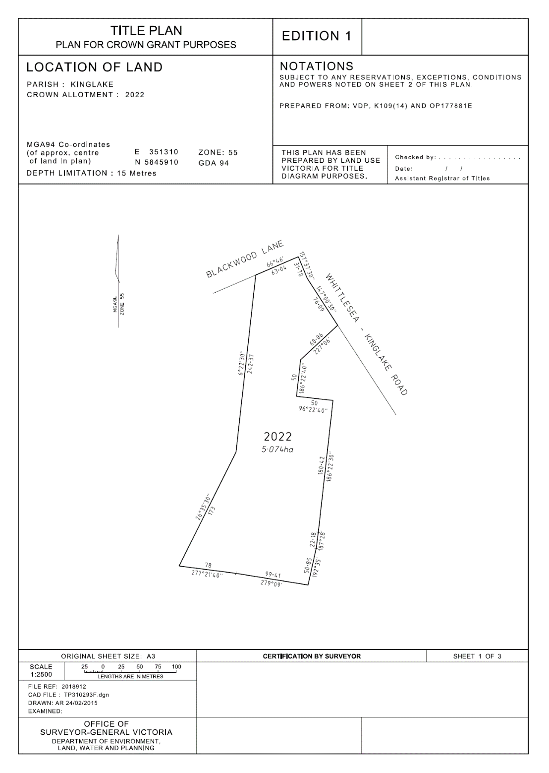
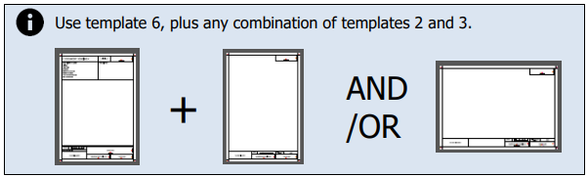

Title Plan – Front Sheet (template 6)
The following has been prepared by the applicant prior to uploading the plan to SPEAR.

Dealing Number - The designated space has been left blank by the applicant.

Document Heading - The text ‘<Document heading>’ has been replaced with ‘Title Plan’ by the applicant and ‘Edition 1’ has been added by the applicant. Additional items have been added at the bottom of the notations panel for use by Land Use Victoria.

Organisation Logo - In lieu of the organisation logo, Surveyor General details have been added by the applicant in a reduced space of 97mm x 20mm.
Additional reference information has been added to the box above this by the applicant and SPEAR will not apply a watermark over this.

Surveyor’s Signature - The surveyor’s name and version number has been shown by the applicant in the designated space.

Certification by Surveyor – The designated space has been left blank by the applicant.

SGV Approval – The designated space has been left blank by the applicant.

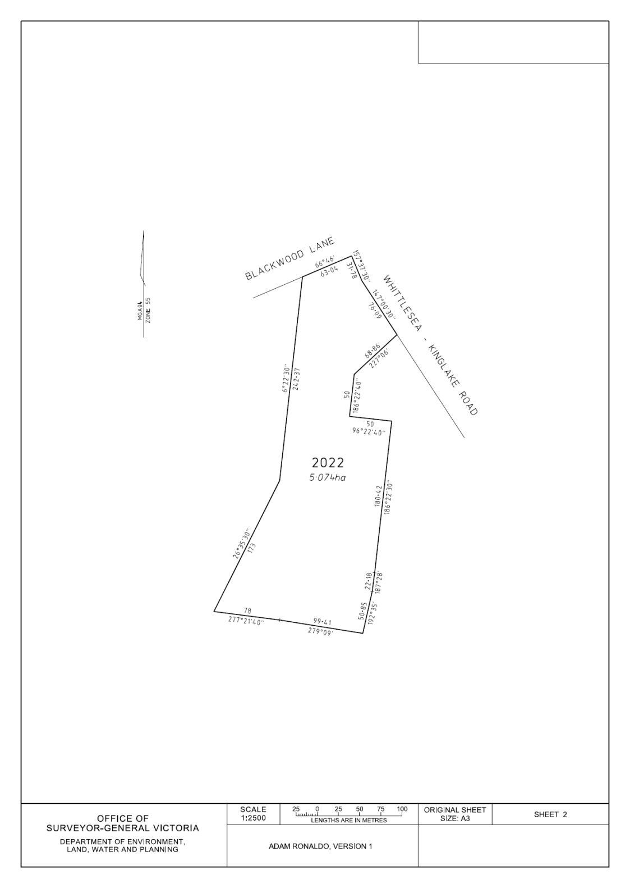

Title Plan – Subsequent Sheet (portrait - template 2)
The following has been prepared by the applicant prior to uploading the plan to SPEAR.

Dealing Number - The designated space has been left blank by the applicant.

Organisation Logo - In lieu of the organisation logo, Surveyor General Victoria details have been added by the applicant.

Surveyor’s Signature - The surveyor’s name and version number has been shown by the applicant in the designated space.

SGV Approval – The designated space has been left blank by the applicant.

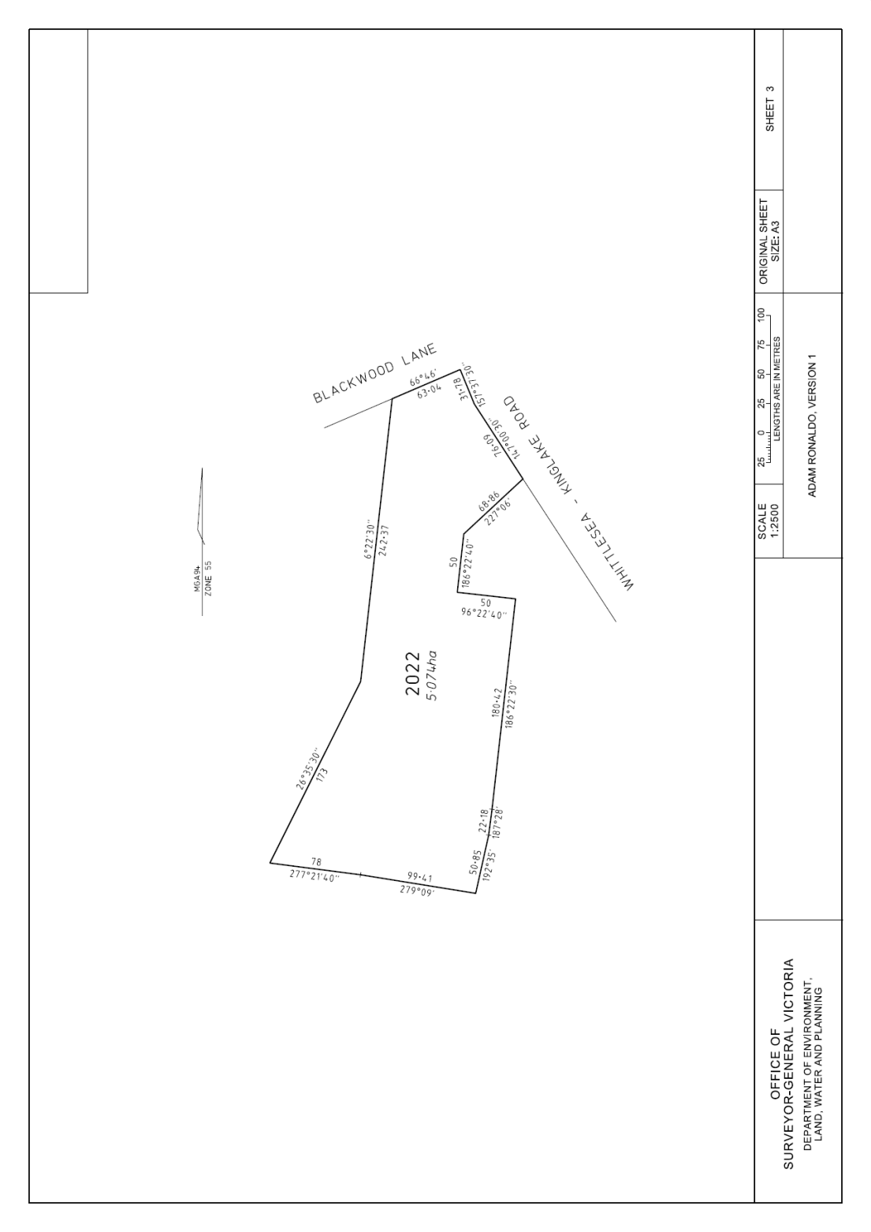

Title Plan – Subsequent Sheet (landscape - template 3)
The following has been prepared by the applicant prior to uploading the plan to SPEAR.

SGV Approval – The designated space has been left blank by the applicant.

Dealing Number - The designated space has been left blank by the applicant.

Surveyor’s Signature - The surveyor’s name and version number has been shown by the applicant in the designated space.

Organisation Logo - In lieu of the organisation logo, Surveyor General Victoria details have been added by the applicant.

Example G – Title Plan (completed)

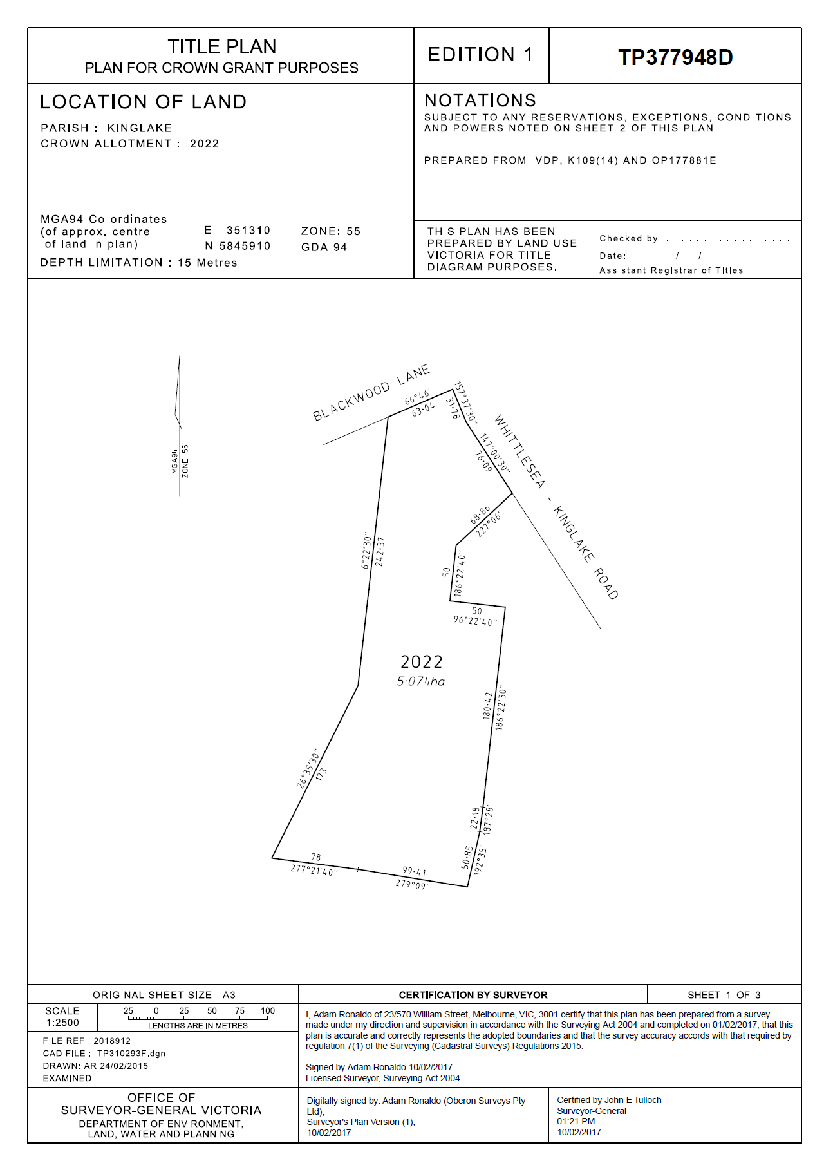

Title Plan – Front Sheet (template 6)
The following has been watermarked by SPEAR at or before certification of the plan.

Dealing Number – SPEAR will apply the TP number in the designated space when it has been provided by the applicant or Land Use Victoria in SPEAR.

Surveyor’s Signature - SPEAR will apply the digital signature in the designated space when the plan is signed.

Certification by Surveyor - SPEAR will apply the certification by surveyor text in the designated space when the relevant information has been collected in SPEAR.

SGV Approval - SPEAR will apply the Surveyor General Victoria certification details in the designated space when the plan is certified.

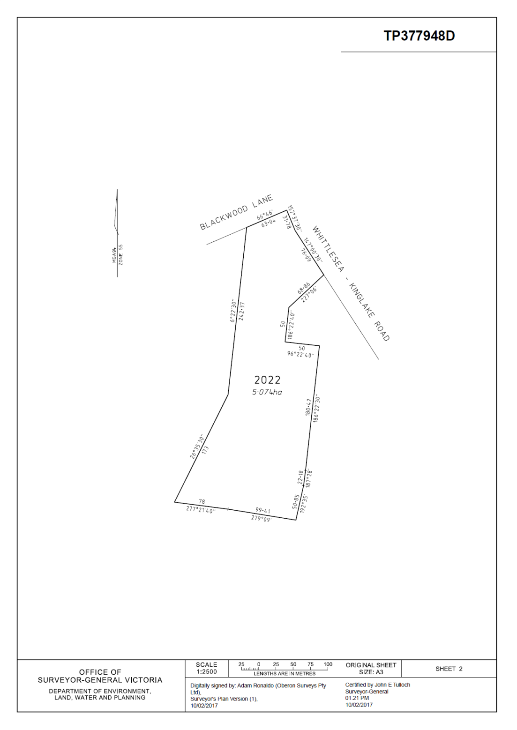

Title Plan – Subsequent Sheet (portrait - template 2)
The following has been watermarked by SPEAR at or before certification of the plan.

Dealing Number – SPEAR will apply the TP number in the designated space when it has been provided by the applicant or Land Use Victoria in SPEAR.

Surveyor’s Signature - SPEAR will apply the digital signature in the designated space when the plan is signed.

SGV Approval - SPEAR will apply the Surveyor General Victoria certification details in the designated space when the plan is certified.

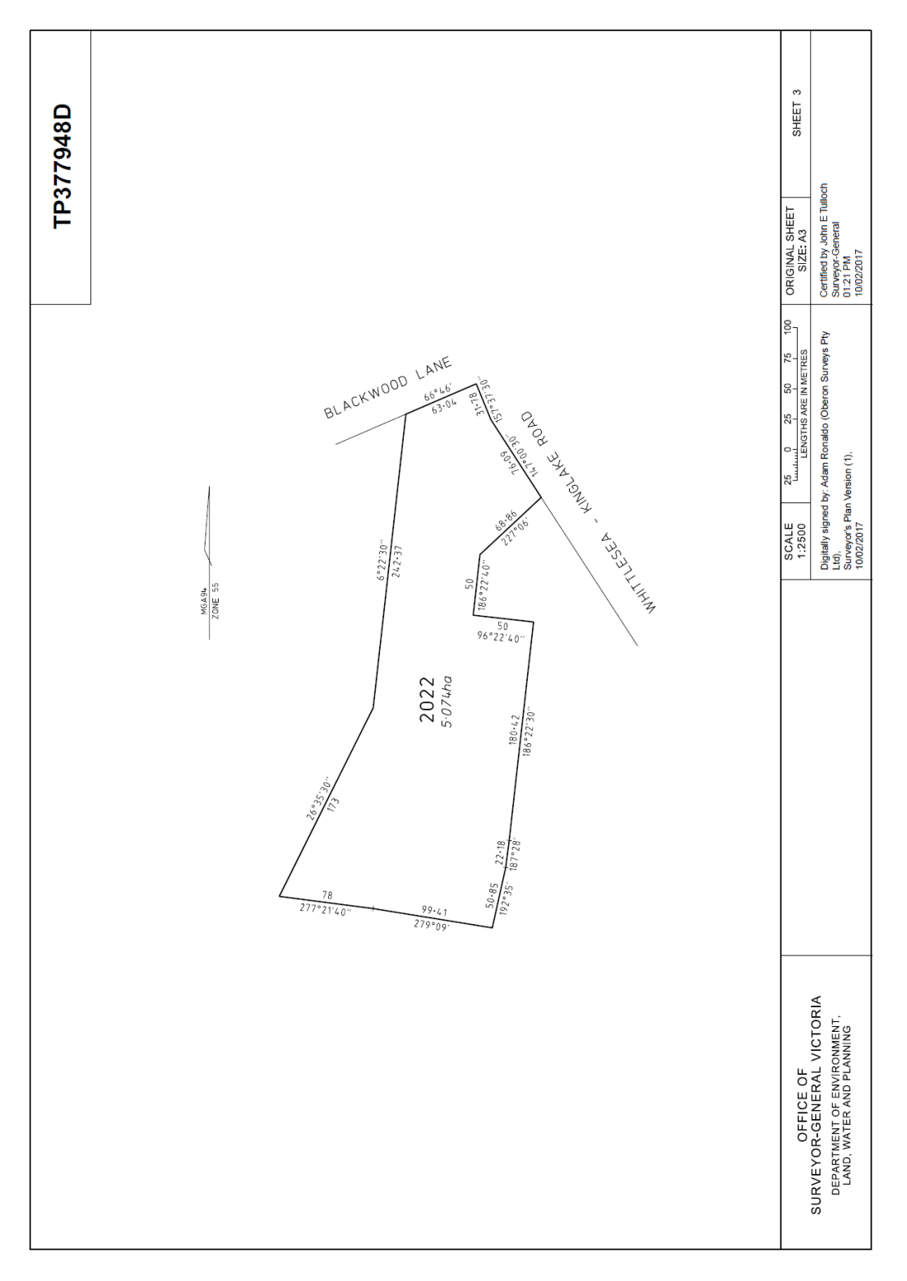

Title Plan – Subsequent Sheet (landscape - template 3)
The following has been watermarked by SPEAR at or before certification of the plan.

SGV Approval - SPEAR will apply the Surveyor General Victoria certification details in the designated space when the plan is certified.

Dealing Number – SPEAR will apply the TP number in the designated space when it has been provided by the applicant or Land Use Victoria in SPEAR.

Surveyor’s Signature - SPEAR will apply the digital signature in the designated space when the plan is signed.

Example H – Record of Having Re-Established a Cadastral Boundary (prepared)

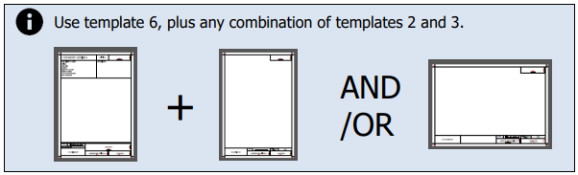
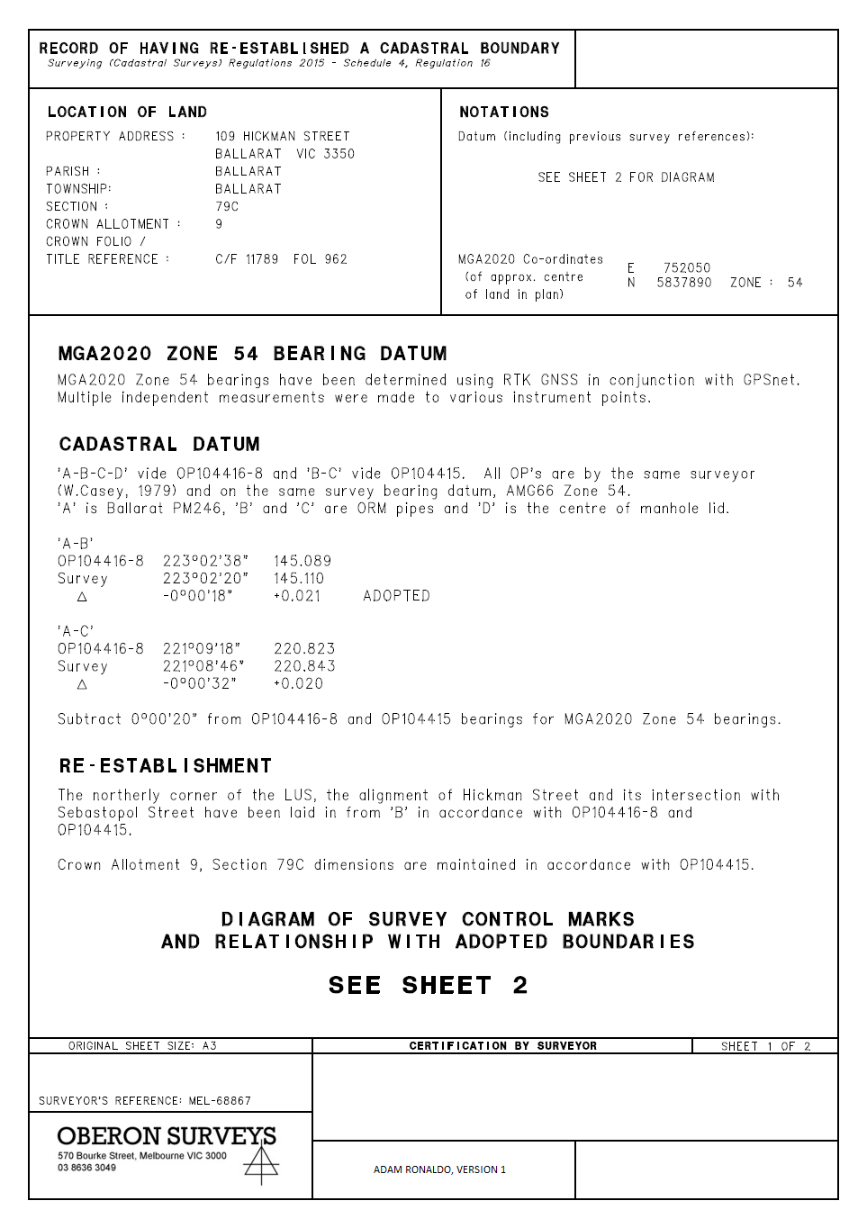

Record of Having Re-Established a Cadastral Boundary – Front Sheet (template 6)
The following has been prepared by the applicant prior to uploading the document to SPEAR.

Dealing Number - The designated space has been left blank by the applicant.

Document Heading - The text ‘<Document heading>’ has been replaced with ‘Record of Having Re-Established a Cadastral Boundary’ and the relevant regulations by the applicant.

Organisation Logo - The organisation logo has been added by the applicant.
Additional reference information has been added to the box above the logo by the applicant and SPEAR will not apply a watermark over this.

Surveyor’s Signature - The surveyor’s name and version number has been shown by the applicant in the designated space.

Certification by Surveyor – The designated space has been left blank by the applicant.

SGV Approval – The designated space has been left blank by the applicant.

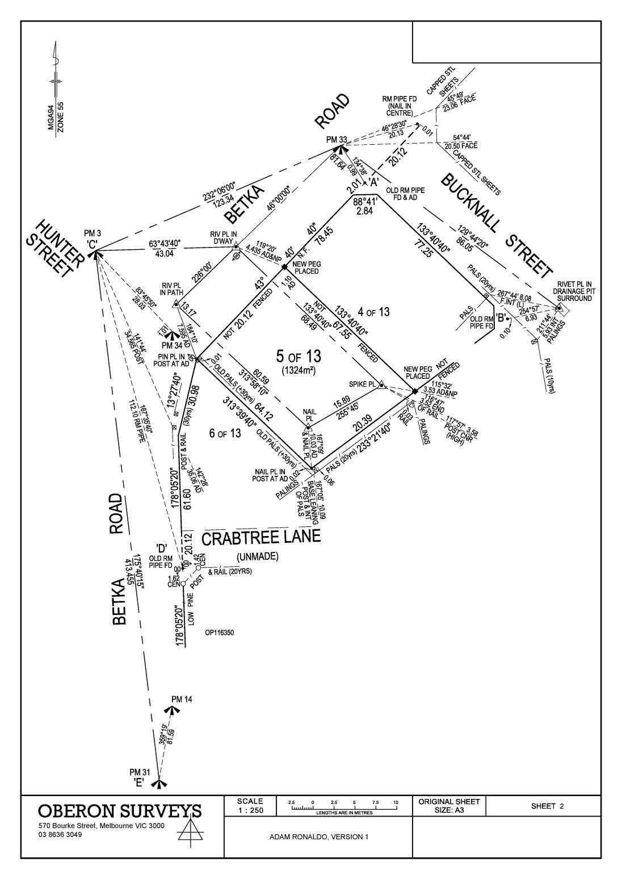

Record of Having Re-Established a Cadastral Boundary – Subsequent Sheet
(portrait - template 2)
The following has been prepared by the applicant prior to uploading the document to SPEAR.

Dealing Number - The designated space has been left blank by the applicant.

Organisation Logo - The organisation logo has been added by the applicant.

Surveyor’s Signature - The surveyor’s name and version number has been shown by the applicant in the designated space.

SGV Approval – The designated space has been left blank by the applicant.

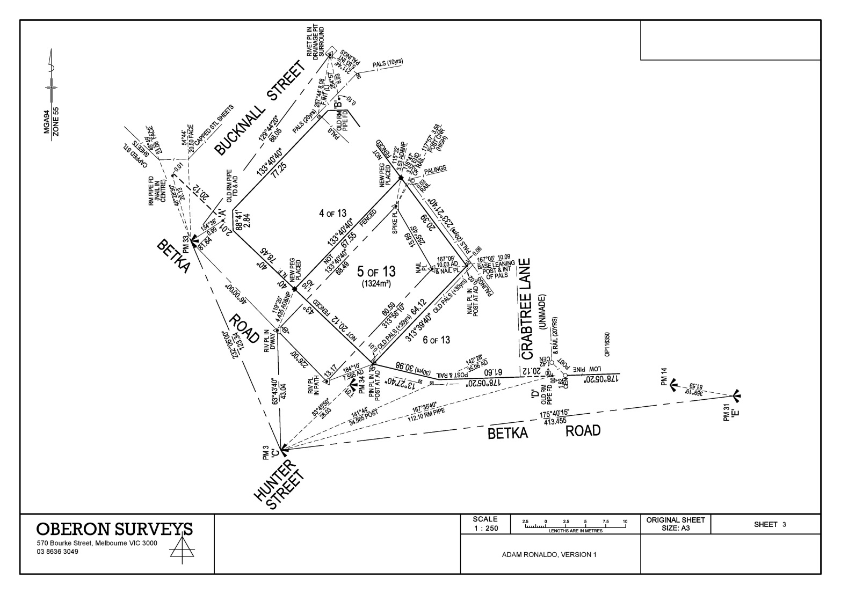

Record of Having Re-Established a Cadastral Boundary – Subsequent Sheet
(landscape - template 3)
The following has been prepared by the applicant prior to uploading the document to SPEAR.

SGV Approval – The designated space has been left blank by the applicant.

Dealing Number - The designated space has been left blank by the applicant.

Surveyor’s Signature - The surveyor’s name and version number has been shown by the applicant in the designated space.

Organisation Logo - The organisation logo has been added by the applicant.

Example H – Record of Having Re-Established a Cadastral Boundary (completed)

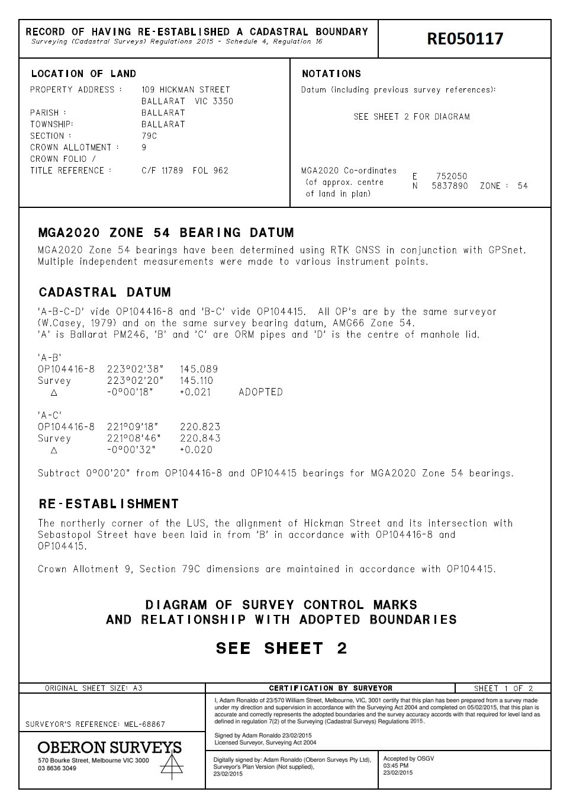

Record of Having Re-Established a Cadastral Boundary – Front Sheet (template 6)
The following has been watermarked by SPEAR at or before SGV acceptance.

Dealing Number – SPEAR will apply the RE number in the designated space when the application has been accepted by Surveyor General Victoria.

Surveyor’s Signature - SPEAR will apply the digital signature in the designated space when the document is signed.

Certification by Surveyor - SPEAR will apply the certification by surveyor text in the designated space when the relevant information has been collected in SPEAR.

SGV Approval - SPEAR will apply the Surveyor General Victoria acceptance details in the designated space when the application is accepted.

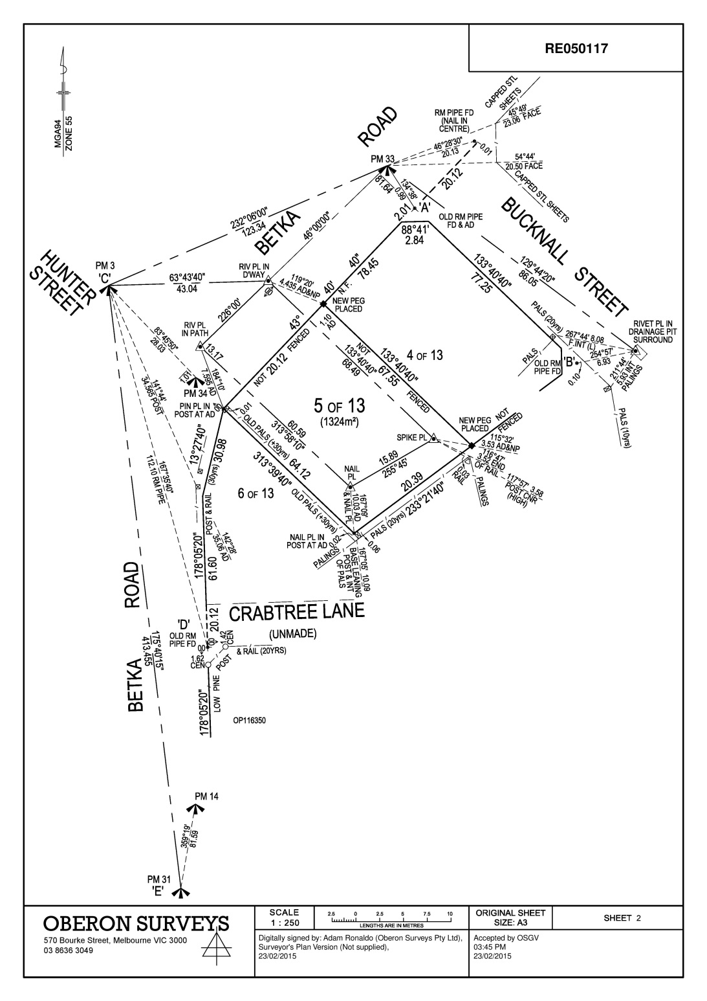

Record of Having Re-Established a Cadastral Boundary – Subsequent Sheet
(portrait - template 2)
The following has been watermarked by SPEAR at or before SGV acceptance.

Dealing Number – SPEAR will apply the RE number in the designated space when the application has been accepted by Surveyor General Victoria.

Surveyor’s Signature - SPEAR will apply the digital signature in the designated space when the document is signed.

SGV Approval - SPEAR will apply the Surveyor General Victoria acceptance details in the designated space when the application is accepted.

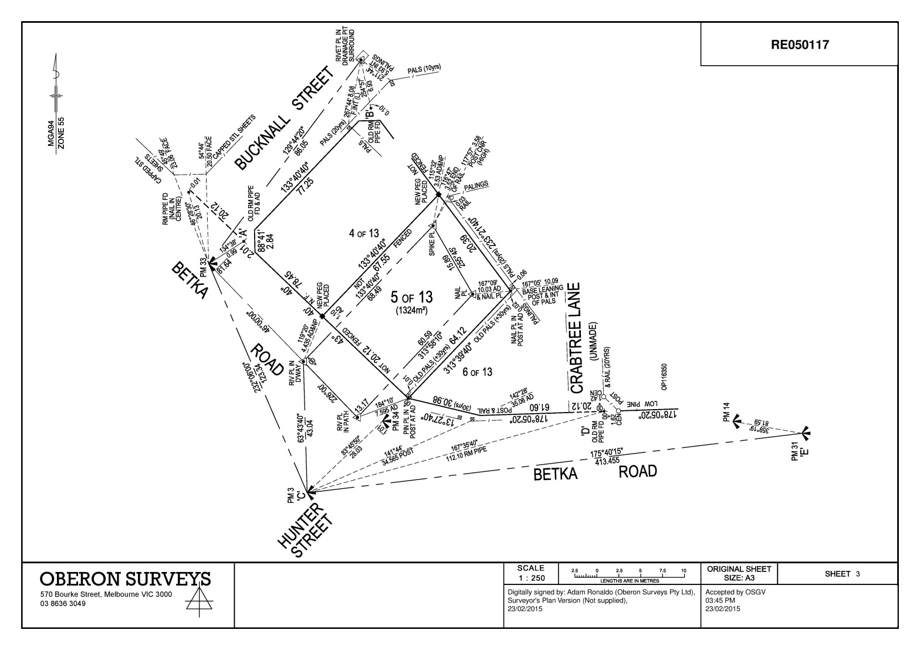

Record of Having Re-Established a Cadastral Boundary – Subsequent Sheet
(landscape - template 3)
The following has been watermarked by SPEAR at or before SGV acceptance.

SGV Approval - SPEAR will apply the Surveyor General Victoria acceptance details in the designated space when the application is accepted.

Dealing Number – SPEAR will apply the RE number in the designated space when the application has been accepted by Surveyor General Victoria.

Surveyor’s Signature - SPEAR will apply the digital signature in the designated space when the document is signed.

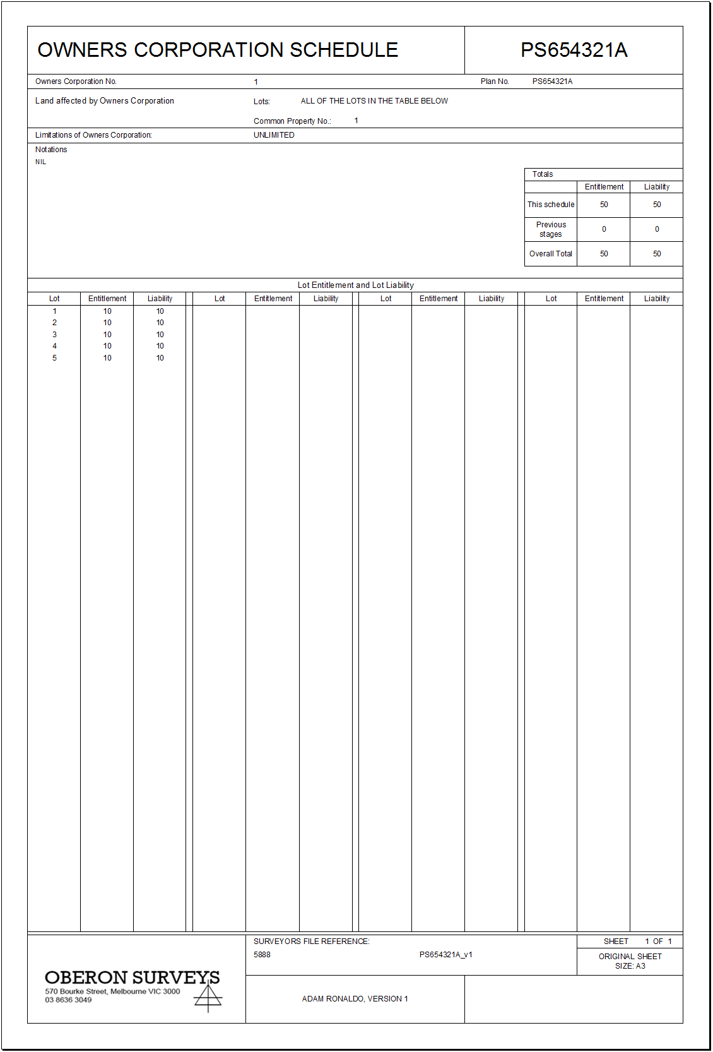
APPENDIX 4: Owners Corporation schedules

From 1 January 2020, Applicants must supply their Owners Corporation (OC) data onto a spreadsheet and upload it into SPEAR. Once supplied, SPEAR will validate and generate the OC schedule from the data and attach it to the plan PDF. This will remove the requirement to include the OC schedule with the plan PDF.
The spreadsheet template has been developed in consultation with the surveying industry and Land Use Victoria.
NOTE: Plans created in SPEAR before November 2015 must continue to include the OC schedules with the plan PDF (including any new versions).
The OC schedule spreadsheet template is available within SPEAR and on the SPEAR website. It has been designed to look like an OC schedule and can be printed and provided to your client if required (as pictured).
Applicants are required to complete the spreadsheet by inserting OC schedule and organisation data before uploading the spreadsheet to SPEAR. Applicants can insert their logo for printing purposes, although this is not required for SPEAR.
NOTE: A separate Excel spreadsheet is required for each OC schedule.
Once the OC data has been uploaded into SPEAR, the system will visualise the OC schedule and attach it to the plan PDF to be digitally signed. It will be watermarked in the same locations as the subsequent sheets of a Plan of Subdivision. SPEAR will apply your organisation logo as stored in the system.

Using the OC schedule spreadsheet template
Applicants should enter the following data into the white fields:
- Owners Corporation Number
- Plan Number (including stage number for stage 2+)
- Lots affected by Owners Corporation (selected from drop down list or entered directly)
- Common Property affected by Owners Corporation (selected from drop down list or entered directly)
- Limitations of Owners Corporation (selected from drop down list)
- Notations (selected from drop down list or entered directly)
- Balance of existing OC (if applicable when modifying an existing OC)
- Lot entitlement and lot liability table
- Organisation logo (optional)
- Surveyors file reference
- Sheet number (commencing at sheet 1)
- Surveyor’s name and version number
Sheets
The template includes a front sheet and a subsequent sheet.
If an OC schedule contains only one sheet (up to 200 lots) then the second sheet must be deleted from the workbook in Excel.
The subsequent sheet accommodates 260 lots. If an OC schedule requires a third sheet (over 460 lots), a copy of the second sheet can be added to the workbook.
Printing
If printing an OC schedule with multiple sheets from Excel, ensure ‘Print Entire Workbook’ is selected within the print settings.
