
9
SPEAR

Surveying and Planning through Electronic Applications and Referrals



SPEAR Release Notes

Release 5.18

The following functional changes to SPEAR have been included in Release 5.18:
 | Users Impacted | Feature | Description
 | Applicant contacts | Pre-populate survey type data from ePlan  - CR 5164 | The following data from an ePlan will now be pre-populated on the Abstract of Field Records screen in SPEAR:  - Survey type radio button selection  - Survey date (if applicable)  - Prior plan reference (if applicable)  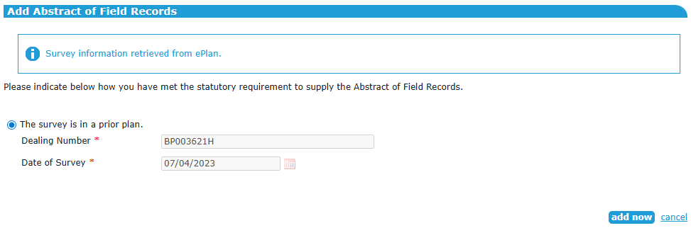  This applies to applications for certification, as well as joint applications for certification and planning permit. For Boundary Plan applications, this data will be populated on the Survey Declaration screen.  Applicant contacts should ensure their ePlan data is accurate so that the correct values are populated in SPEAR. Any changes required to this data can be made by editing the ePlan using the ePlan Portal and then adding the new version of the ePlan to SPEAR.
 | Applicant contacts, responsible authorities, Land Use Victoria | Identify 3D plans and subdivisions of undeveloped land  - CR 5872 | When releasing for lodgement in SPEAR, applicant contacts will now indicate whether a plan of subdivision:  - contains building boundaries; and/or  - requires cross sections; and/or  - is classified as ‘multi storey’  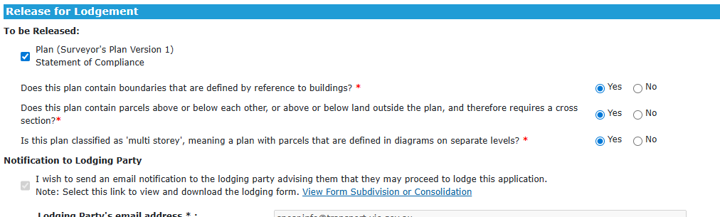  Additionally, when creating a subdivision application, applicant contacts will indicate whether the plan is a subdivision of undeveloped land.  