Christmas and new year closure
Welcome to first issue of the SPEAR Bulletin for SPEAR Electronic Lodgment Network (ELN) users. This will be a periodic newsletter to provide you with handy hints on how to use the SPEAR ELN effectively and to keep up to date with other resources available to assist you in your work.
If you would like us to focus on a specific area in our next issue please let us know by contacting the SPEAR Service Desk team spear.info@delwp.vic.gov.au.

SPEAR Bulletin for
Lodging Party users

  - January 2021

Video tutorials
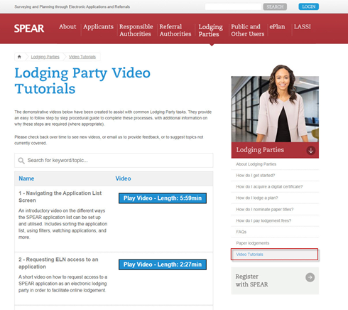
The SPEAR website provides resources to assist with your day to day use of the SPEAR ELN. The SPEAR Service Desk team has created 15 video tutorials which provide an easy to follow step by step procedural guide to help you navigate through the system.
The video tutorials are accessed in the About Lodging Parties webpage from the sidebar menu on the right of the screen and we suggest you bookmark this page for future reference.
The tutorials range from 1 to 6 minutes long and should be your first reference when experiencing an issue, as you probably have the answer at your fingertips! If not, please contact the SPEAR Service Desk team spear.info@delwp.vic.gov.au.

Handy hints

SPEAR ELN access vs. guest access
As lodging parties in SPEAR, you are encouraged to phase out the use of guest accounts by ensuring you are using your SPEAR ELN access to manage applications. As a SPEAR ELN user, you should no longer be invited into an application as a guest by the surveyor. Maintaining a guest account in addition to an ELN account is confusing as the two types of access are not linked, and their functionality is very different:
SPEAR ELN access is granted to the firm (and all their SPEAR users) on successful completion of the SPEAR ELN sign up process. Once the firm is ELN enabled, users are assigned a login (username and password). The username is typically in the format of: phismi44 (example).
SPEAR ELN users have complete access to all applications associated with their firm and can use the system to build lodging forms, supply other supporting information, digitally sign documents, and lodge applications to Land Use Victoria (LUV).
Guest access is ‘view only’ and limited specifically to the individual whose email address was used in the invitation from the surveyor. The username for a guest is their email address, as opposed to the system generated username described above.
Guest accounts are not linked within an organisation, meaning multiple users at the same firm cannot see applications that other staff have been granted guest access to. Guests are also unable to view applications in SPEAR past the point of ‘Lodged at Land Use Victoria’.

How to request lodging party access
Lodging parties can request access to applications in SPEAR to enable electronic lodgment at LUV by clicking the ‘Request lodging party access’ link, found in the top right hand corner of the Application List screen.
If you are not sure of the SPEAR reference number, use the ‘Public Search’ function which is available from the top left hand section of the SPEAR banner. Search for the property/application, take note of the SPEAR reference and click ‘Return to Application List’ to perform the request.
After you have completed the request, a notification is sent to the surveyor with a mandatory action to respond. When the request is approved, you will be notified, and the application will appear in your Application List.

Easement and restriction applications can't use the same Volume/Folios in servient/burdened and dominant/benefited land sections
When creating an easement, the application lodgment form cannot contain the same Volume/Folio reference in both the servient and dominant land sections. This also applies to the burdened and benefited land sections when creating a restriction. In these cases, SPEAR will display the following error message:

“Unable to verify the Volume/Folio(s) with VOTS. Please try again later”

Users receiving this error message should remove the duplicated Volume/Folio and replace it with a different Volume/Folio or, for an easement in gross, the relevant authority name.
There are rare instances where you may be creating an easement or restriction under Section 23 of the Subdivision Act 1988 across multiple lots on the same Volume/Folio. If this is the case, please contact the SPEAR Service Desk for advice on 03 9194 0612 or spear.info@delwp.vic.gov.au.

How to review and respond to a LUV requisition
When LUV requires changes to a lodged application, the LUV plan examiner will submit a requisition notice through SPEAR. An email will be sent to the lodging party notifying them of this, along with a direct link to the application.
If changes are required from the lodging party, a new mandatory action ‘Submit Response to LUV Requisition' will be displayed on the Details tab of the application, as shown below:
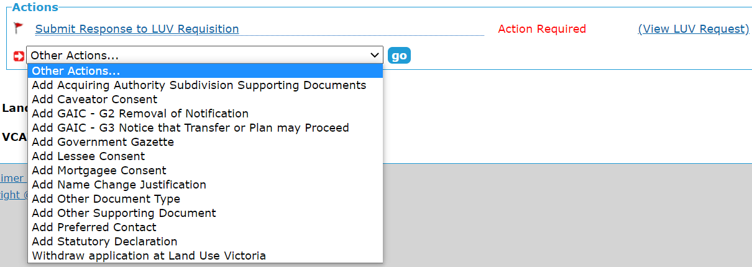
If LUV requires supporting documents to be added, removed or modified as part of the requisition, then those document changes should be made first, before the ‘Submit Response to LUV Requisition’ action is completed. Otherwise, if the request is only seeking a textual response, the ‘Submit Response to LUV Requisitions’ action can be completed without making any changes to documents.

Support
The SPEAR team wants to ensure your questions and issues are resolved quickly.
Contact the SPEAR Service Desk on (03) 9194 0612:
• Press 1 for SPEAR assistance
• Press 2 for Land Use Victoria subdivision lodgment enquiries
• Press 3 for ePlan enquiries
Alternatively, you can send your enquiry by email to spear.info@delwp.vic.gov.au

Contact SPEAR
T: 03 9194 0612

E: spear.info@delwp.vic.gov.au

W: www.spear.land.vic.gov.au

