

SPEAR Bulletin for Lodging Parry users
Image of woman in office

April 2021

|  |
| --- |
| Welcome to the April issue of the SPEAR Bulletin for SPEAR Electronic Lodgment Network (ELN) users.  This bulletin provides information on how to use the SPEAR ELN effectively and updates you on other resources available. |

# News and updates

## Supplying council consent in a creation of easement

In some cases, an Applicant Contact (surveyor) will not be involved in a Transfer of Land Act section 45 application (e.g. where the easement is over the whole of a folio and a plan is not required). To cater for this possibility, SPEAR requires the lodging party to provide the council consent letter in **all cases**.

As a result, the ‘Add Council Consent Letter’ action is only available to, and must be supplied by, the lodging party. If an Applicant Contact has obtained the council consent (outside of SPEAR), they should provide this to the lodging party to upload into SPEAR using the ‘Add Council Consent Letter’ action.

If the council consent letter is not supplied by the lodging party using ‘Add Council Consent Letter’, delays will be incurred at the time of lodgment.

The ‘Add Council Consent Letter’ action is found in the ‘Other Actions’ drop-down list in SPEAR (refer to image below).

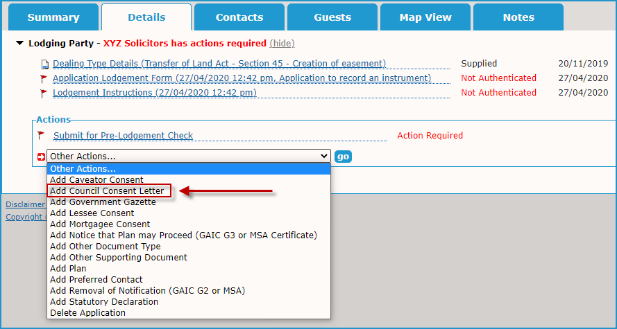

## Ensuring an MSA-affected application is assigned to the consenting party

A small number of SPEAR applications affected by a Melbourne Strategic Assessment (MSA) notice are unable to be automatically assigned to the DELWP MSA team as they contain parent folios cancelled prior to the introduction of the Melbourne Strategic Assessment (Environment Mitigation Levy) Act on 1 July 2020.

Land Use Victoria will further streamline the MSA process in a future release of SPEAR by introducing an additional check on the current folio details entered in the SPEAR workspace by the lodging party.

In the meantime, lodging parties who know their application is MSA-affected should check whether the ‘Consenting Parties’ section appears in the SPEAR workspace (as per the image below). If no ‘Consenting Parties’ section appears, please advise the SPEAR Service Desk as soon as possible. The application will be manually assigned to the DELWP MSA team to minimise delays at lodgment.

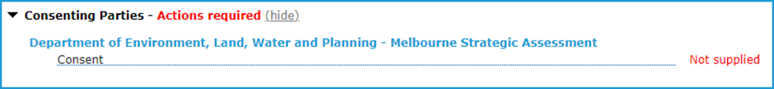

## Easement and restriction applications can't use the same Folio references in servient/burdened land dominant/benefited land sections

REMINDER: Due to continued enquiries and issues, we are sharing this handy hint again to assist users.

When creating an easement, the application lodgment form cannot contain the same Folio reference in both the servient and dominant land sections. This also applies to the burdened and benefited land sections when creating a restriction. In these cases, SPEAR will display the following error message:

**“Unable to verify the Volume/Folio(s) with VOTS. Please try again later”**

Users receiving this error message should remove the duplicated Folio reference and replace it with the correct Folio reference or, for an easement in gross, the relevant authority name. Please note, this error message is being reworded in the next release of SPEAR to better assist the lodging party with this issue.

There are rare instances where you may be creating an easement or restriction under Section 23 of the Subdivision Act 1988 **across multiple lots on the same Folio**. If this is the case, please contact the SPEAR Service Desk for advice on 03 9194 0612 or email [spear.info@delwp.vic.gov.au](mailto:spear.info@delwp.vic.gov.au).

## Update to current registration processing times

Land Use Victoria maintains a list of 'Current registration processing times' on the SPEAR website. This list previously displayed an indicative number of days from lodgment to registration for plans of subdivision. The suggested timeframes were based on several factors, such as the number of plans lodged and their complexity.

The processing times for plans of subdivision on the SPEAR website has been updated and now displays the lodgment date of plans being examined. This helps lodging parties identify when a lodged plan is due for examination.

SPEAR users are reminded the SPEAR Service Desk **cannot** provide updates on plan examination or information regarding lodged applications. If you would like to be notified when a plan is picked up for examination, you can subscribe to a Property Transaction Alert using LANDATA. For more information, see the ‘[Current registration processing times](https://www.spear.land.vic.gov.au/spear/pages/about/contact-us/land-victoria.shtml)’ on the SPEAR website.

# Reminder: video tutorials

SPEAR ELN video tutorials are available on the SPEAR website and provide an easy to follow step by step procedural guide to help you navigate through the SPEAR system. The latest tutorial (No.16) covers how a lodging party can create applications in SPEAR.

Access the SPEAR ELN video tutorials [here](https://www.spear.land.vic.gov.au/spear/pages/lodging-parties/video-tutorials.shtml)

# Training

The following training dates have been scheduled for our quarterly online training sessions. These sessions are geared to new SPEAR ELN users or users who require a refresher of the system. If you wish to attend, please register for an online session by contacting the SPEAR Service Desk on (03) 9194 0612.

### Wednesday 12 May, Wednesday 4 August, Wednesday 10 November

Additional training sessions can be arranged if new staff commence between the scheduled quarterly training sessions.

# Support

The SPEAR team wants to ensure your questions and issues are resolved quickly.

Contact the SPEAR Service Desk on (03) 9194 0612:

* Press 1 for SPEAR assistance
* Press 2 for Land Use Victoria subdivision lodgment enquiries
* Press 3 for ePlan enquiries

Alternatively, you can send your enquiry by email to [spear.info@delwp.vic.gov.au](mailto:spear.info@delwp.vic.gov.au)

|  |
| --- |
| Contact SPEAR  **T:** 03 9194 0612  **E:** [spear.info@delwp.vic.gov.au](mailto:spear.info@delwp.vic.gov.au)  **W:** www.spear.land.vic.gov.au |

© The State of Victoria Department of Environment, Land, Water and Planning 2021

The Creative Commons License CC BY: This license allows reusers to distribute, remix, adapt, and build upon the material in any medium or format, so long as attribution is given to the creator. The license allows for commercial use.
CC BY includes the following elements: BY  – Credit must be given to the creator

This work is licensed under a Creative Commons Attribution 4.0 International licence. You are free to re-use the work under that licence, on the condition that you credit the State of Victoria as author. The licence does not apply to any images, photographs or branding, including the Victorian Coat of Arms, the Victorian Government logo and the Department of Environment, Land, Water and Planning (DELWP) logo. To view a copy of this licence, visit http://creativecommons.org/licenses/by/4.0/

Disclaimer

This publication may be of assistance to you but the State of Victoria and its employees do not guarantee that the publication is without flaw of any kind or is wholly appropriate for your particular purposes and therefore disclaims all liability for any error, loss or other consequence which may arise from you relying on any information in this publication.

Accessibility

If you would like to receive this publication in an alternative format, please telephone the DELWP Customer Service Centre on 136186, email [customer.service@delwp.vic.gov.au](mailto:customer.service@delwp.vic.gov.au), or via the National Relay Service on 133 677 [www.relayservice.com.au](http://www.relayservice.com.au). This document is also available on the internet at [www.spear.land.vic.gov.au](http://www.spear.land.vic.gov.au).