User Guide 31 Enrolling your organisation for a DigiCert Account
Purpose of this User Guide
The purpose of this User Guide is to provide the first step in the process of acquiring a Digital Signing Certificate for use in SPEAR.

Notes to help you through the process of acquiring a Digital Signing Certificate:
1. You are required to enter several passwords. Keep them secure and know where you have them stored as neither DigiCert nor SPEAR have access to your digital certificate passwords and cannot retrieve them for you. Try to nominate the same password to as many of the required passwords as possible.
If you cannot remember your password, you will need to contact your Certificate Manager or Digicert.
2. Persevere through the process. If you experience any problems, please contact the SPEAR Service Desk.

Preparation for your enrolment:
You will require your organisation’s Australian Business Number (ABN).
This must be the ABN that belongs to your entity name which may differ from your trading name. This number and name must be used consistently throughout the entire process or your application may be rejected by DigiCert. If you do not know your organisation’s entity name and ABN you may search it on the Australian Business Register (ABR) at www.abr.gov.au.
You will be required to use a credit card or create a purchase order to pay the Gatekeeper Account Setup fee. Digital certificate pricing is available from DigiCert at https://gatekeeper.digicert.com/price.

31.1 Commence Online Enrolment:
Go to the DigiCert website https://gatekeeper.digicert.com/spear
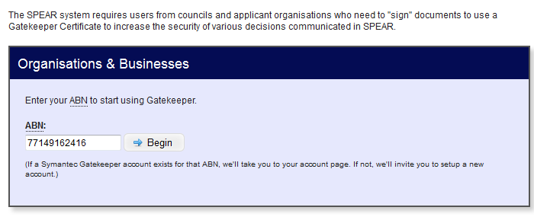
Type your organisation’s ABN number* (without spaces) into the box provided and click ‘Begin’.
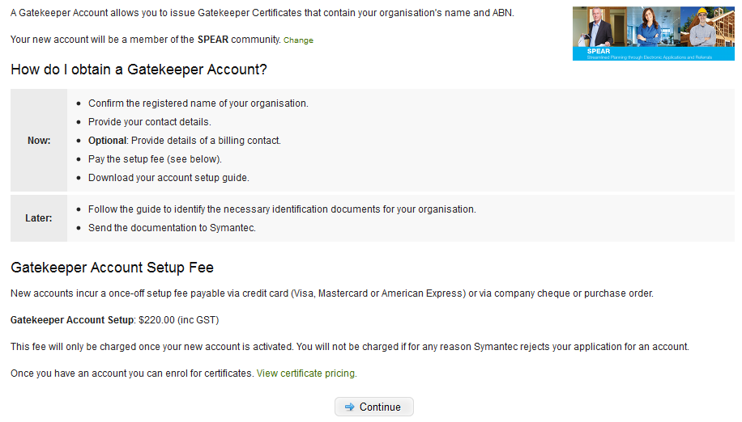
This window displays the cost of your digital certificate account activation. Click ‘Continue’.
Review the enrolment instructions.
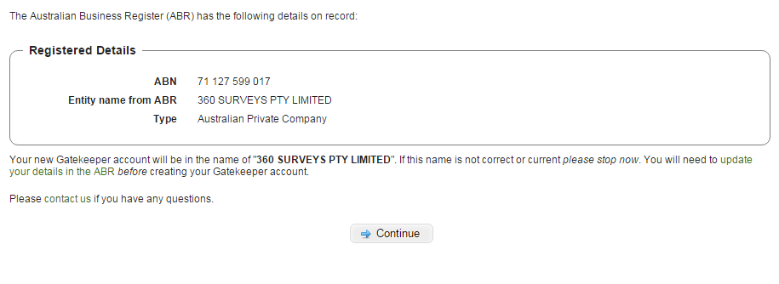
DigiCert will retrieve your organisation details from ABR. Confirm these are correct then click ‘Continue’.

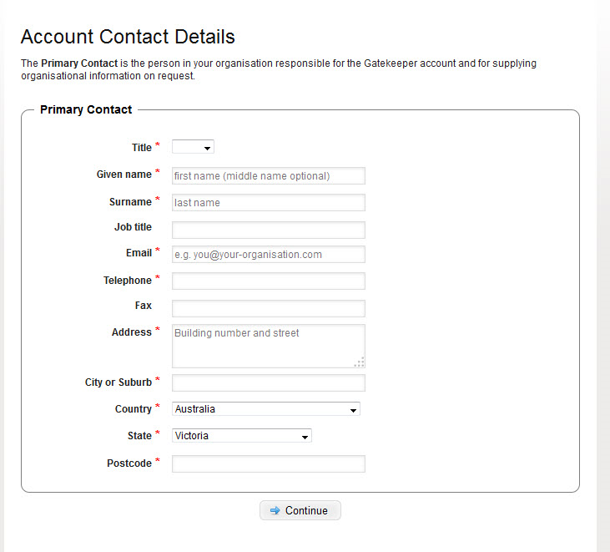
Enter details of your organisation’s contact person. NOTE: This does not have to be the person obtaining the digital certificate, but it can be. Click ‘Continue’.
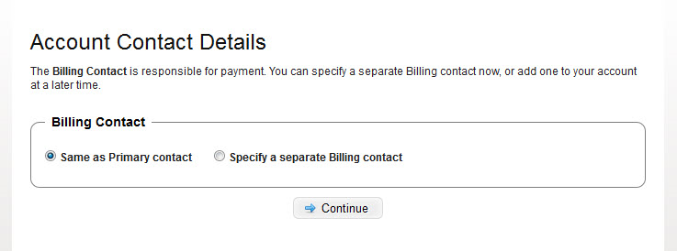
Choose an option for Billing Contact. Click ‘Continue’.

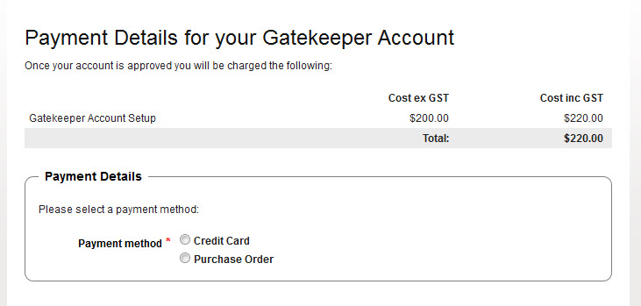
Enter payment method – either by credit card
OR enter a Purchase Order number.
Purchase Order is to be faxed to DigiCert. Click ‘Continue’.
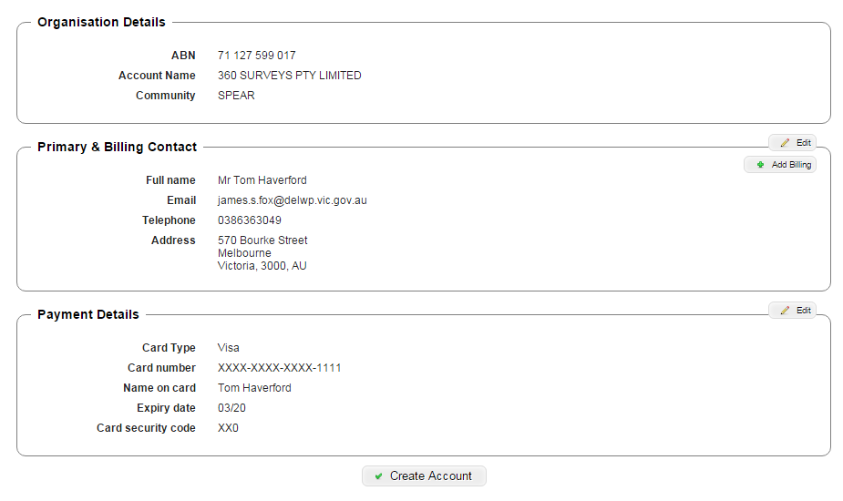
If details are correct click ‘Create Account’.
If the details are incorrect click ‘Edit’.
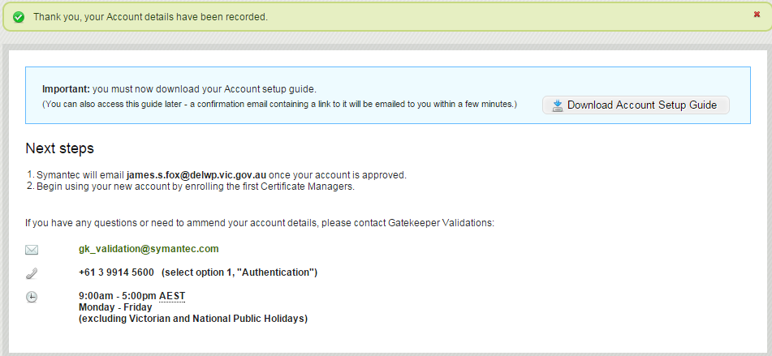
The next step is to download the Account Setup Guide either from the screen above or from the email DigiCert will send to you. This will provide instructions on the Evidence of Identity information required for your organisation as well as certifying copies of those documents.
These documents must be sent to DigiCert either by mail or email for them to verify your organisation details. Once DigiCert have verified your organisation details they will approve the account creation and notify you via email. You can then enrol for your initial Certificate Manager Digital Certificate (see user guide 32).
Need more information?
Further information on this topic can be found by:
- Visiting the SPEAR website www.spear.land.vic.gov.au/SPEAR.
- Contacting the SPEAR Service Desk on 9194 0612 or email spear.info@delwp.vic.gov.au

