User Guide 3 Referring an application to referral authorities
Purpose of this User Guide
The purpose of this User Guide is to assist Responsible Authorities in referring an application to a referral authority. This includes statutory referral authorities and may also include internal referral authorities within a Responsible Authority, such as a council engineering department.
NOTE: Details on sending notification of an application to a referral authority (pursuant to s.52 and 57B of the Planning and Environment Act 1987) can be found in User Guide 4 – Advertising an application.
Who should read this?
Primary audience: Responsible Authorities
For information: Referral Authorities and Applicant Contacts
NOTE: It is recommended that referral authorities read User Guide 14 – Responding to a referral request.
Introduction
Faster and transparent referral requests and responses is one of the key benefits of using SPEAR. The SPEAR system is pre-configured to present to the Responsible Authority a comprehensive list of their referral authorities. One of the key features of SPEAR is that the Applicant Contact is notified by SPEAR when the referral request is made, and a response provided. This enables the Applicant Contact to promptly address issues arising from the referral process.
Referral authorities that have not responded to a referral request after 20 days will be sent an automatic reminder email from SPEAR.
Where a response has not been received after 28 days, Responsible Authorities can override a referral response to progress the application.
SPEAR will accept pre-approved letters of consent from a referral authority and, in these cases, SPEAR highlights that no further referral to the referral authority is required.
3.1 How does a Responsible Authority user refer an application in SPEAR?
Once an application has been accepted into SPEAR by the Responsible Authority, it has a status of ‘Lodged at Responsible Authority’. The Responsible Authority is then required to consider whether to refer the application to referral authorities for approval, comment or just for their information. Once the Responsible Authority has decided to refer the application (and to whom), they complete the ‘Add Referral Request’ action in SPEAR, which then sends a notification email to each of the selected referral authorities.
To do this, from the Details tab select the mandatory action ‘Add Referral Request’. The Responsible Authority user is then presented with a screen that displays all referral authorities relevant to that Responsible Authority. The Responsible Authority’s Local Administrator may modify the list of default referral authorities at any time.
For each statutory referral authority, a Responsible Authority user must select the nature of the referral from the following options: ‘Don’t Refer’, ‘Section 55’, ‘Section 8’, ‘Section 55 & Section 8’, ‘For Comment’ and ‘For Information Only’.
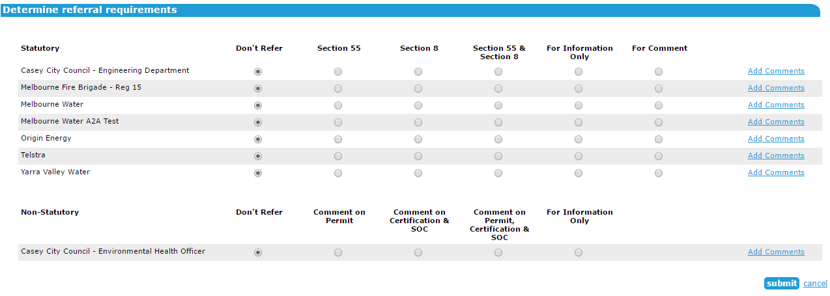
For each non-statutory referral, a Responsible Authority user must select the nature of the referral from the following options: ‘Don’t Refer’, ‘Comment on Permit’, ‘Comment on Certification & SOC’, ‘Comment on Permit, Certification & SOC’, and ‘For Information Only’.

NOTE: Where the Applicant Contact has amended an application, and the amendment is accepted by the Responsible Authority, the application will be referred under Section 57C of the Planning & Environment Act in lieu of Section 55.
Where a new plan version for re-certification is supplied by the applicant, and the re-certification request is accepted by the Responsible Authority, the application will be referred under Section 11 of the Subdivision Act in lieu of Section 8.
Comments to each referral authority may also be added by the Responsible Authority to accompany each referral request. Comments are mandatory for referrals made under section 55 (57C for amended applications). Responsible Authorities will also be required to select if the referral is ‘Determining’ or ‘Recommending’ when adding comments for these sections. For all other referral types the comments are optional.
Once the Responsible Authority user has selected, click the ‘submit’ button. A confirmation screen appears confirming the selection, the time the referral was made and the relevant comments that were made.

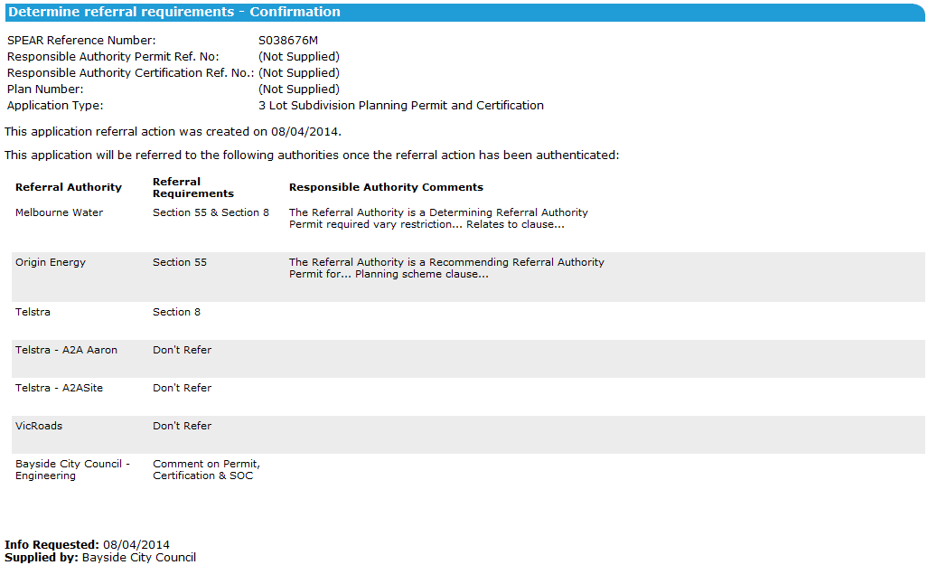
The referral request will need to be authenticated from the Details screen. Upon authentication, notifications are sent by email to each referral authority and to the Applicant Contact to advise them that the application has been referred.
If a ‘For Comment’ referral response is outstanding, and the Responsible Authority wishes to make a key decision, a warning appears alerting the Responsible Authority that all outstanding ‘For Comment’ referrals will be closed. Clicking ‘OK’ will allow the Responsible Authority to proceed to make the key decision.
3.2 Providing a pre-approved letter of consent from a referral authority?
If an Applicant Contact has liaised with a referral authority before lodging the application with the Responsible Authority, the Applicant Contact can add a pre-approved letter of consent from a referral authority in SPEAR prior to submitting the application to the Responsible Authority.
When the Responsible Authority refers the application in SPEAR, referral authorities for which the Applicant Contact has attached a Pre-approved Consent will be flagged with ‘Pre-approved referral authority Consent’ during the referral process for Responsible Authority users. Leaving the referral request on ‘Don't Refer’ will result in the referral authority not being provided with access to this application. Select ‘For information only’ if you wish to provide access to the application for the referral authority but do not require a statutory response.
3.3 Referring an application more than once
A Responsible Authority can select to perform a new referral request at any time after the initial referral request is made by selecting the optional action ‘Perform Referral Request’ from the ‘Other Actions’ drop-down list on the Details tab. The Responsible Authority must decide whether the application should be re-referred to any of the previously referred to referral authorities again and/or whether to include new referral authorities in the referral request.
A Responsible Authority will also be prompted to ‘Recheck’ their previous referral request(s) if an Applicant Contact amends their application. SPEAR will determine the relevant Section of the Planning and Environment Act or the Subdivision Act.
If the referral request is a subsequent request, then the previous referral request will remain displayed on the Details tab with the date of the original request. A second referral request will then be added to the Details tab with the date of the second referral request.
Responses from referral authorities for an application previously referred will be shown as ‘supplied’ in the Details tab. Those referral authorities that did not respond to the previous referral request and are re-referred to will have the previous request closed by the system, and a new request opened. If a referral authority is not referred to in the re-referral process, then any outstanding issues from the previous request will remain outstanding.
3.4 What happens to referrals that are outstanding after 20 days?
SPEAR will send a courtesy notification to those referral authorities identified as not having responded after 20 days since the Responsible Authority made the initial referral request. The notification is a courtesy reminder that they have an outstanding referral response to provide. After the initial 20 day reminder, additional reminders will continue to be sent every 7 days until the referral authority completes an action on the application or the Responsible Authority responds on their behalf (see below).
3.5 Can a Responsible Authority user respond to a referral request on behalf of a referral authority?
The Responsible Authority may respond to a referral request on behalf of a referral authority if the referral authority has not responded within the statutory timeframe. To respond on behalf of the referral authority, the Responsible Authority can select ‘Add RA response’ from the ‘Other Actions’ drop-down list.
The Responsible Authority must select the relevant referral authority from a list of referral authorities that have not yet responded. Select the relevant section of legislation and provide a response on their behalf. This will set the referral authority response to ‘Supplied’ and ‘Closed by the Responsible Authority’. When the referral authority views the application, there will no longer be an outstanding action to respond to referral request, and they can no longer respond to the application under the overridden legislation.
3.6 What happens when compliance conditions have been satisfied?
Consent is the only response that can be made for Statement of Compliance after certification has been consented to, however the timing of the consent to Statement of Compliance is the decision of the referral authority.
3.7 How do I know what referral authority response is outstanding?
For every outstanding referral authority response not supplied in SPEAR a ‘Not supplied’ will appear on the right-hand side of that referral authority section. The outstanding components of the referral will be listed underneath each referral authority name (Section 55/57C, Certification or SOC for statutory referrals, and Comment).
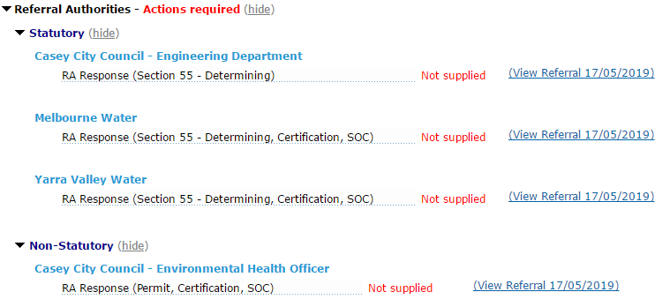
3.8 How does a statutory referral differ from a non-statutory referral?
A Responsible Authority cannot refer an application to a non-statutory authority under a section of the Planning and Environment or Subdivision Act. To cater for non-statutory referrals, SPEAR provides a category of referral called ‘For Comment’. Comments can be provided for the Permit, Certification and SOC.
Responsible Authority Local Administrators can specify whether their internal referral authorities are sent statutory or non-statutory referrals. This is done within the ‘Create/Manage Organisations, Sites and Users’ function. Click on the main Responsible Authority organisation then click ‘edit’.
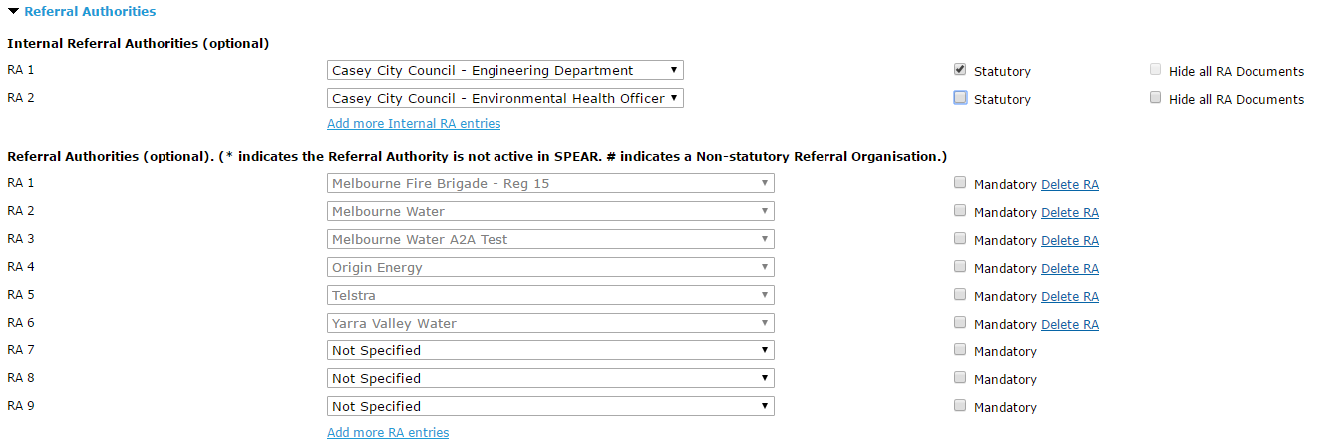
The Responsible Authority Local Administrator can also choose to hide documents uploaded by their non-statutory internal referral authorities. If the documents are hidden, parties to that application will be able to see whether or not a response has been made and the nature of that response, but the attached documents will not be accessible by any other organisation within that application.

Need more information?
Further information on this topic can be found by:
- Visiting the SPEAR website www.spear.land.vic.gov.au/SPEAR
- Contacting the SPEAR Service Desk on 9194 0612 or email spear.info@delwp.vic.gov.au
- Selecting the Help link in the relevant area of the system.

